Modifications of escc 9512/003 issue 1

1- Change page 8:
Replace the functional diagram of §1.8 by the following one :
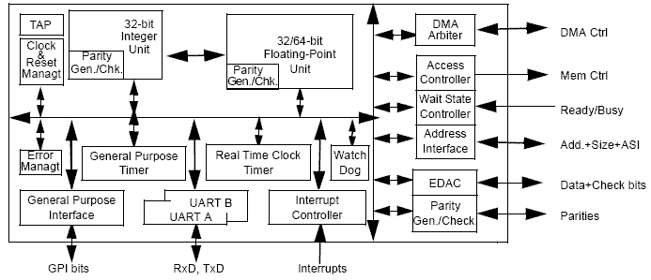
Reason of change :
New diagram is more complete ( right arrow direction, ‘parity generation and checking’ added in IU and FPU).

2-Change page 16:
Replace the figure ‘ram load with correctable error – 0 waitstate’ by the following one :
Reason of change :
The new timing waveform includes the ‘data correction made inside’ position.

3- Change page 19:
- Replace the timing waveform title by the following one :
‘I/O store sequence with BUSRDY*and n waitstates (timing for 0 waitstate = timing for 1 waitstate)’
- Replace the timing waveform by the following one (start at 1 cycle : (n-1) instead of (n-2) cycle in the diagram.
Reason of change :
Typo error

4- Change page 20:
- Replace the timing waveform title by the following one :
‘I/O load sequence with BUSRDY*and n waitstates (timing for 0 waitstate = timing for 1 waitstate)’
Replace the timing waveform by the following one (start at 1 cycle : (n-1) instead of (n-2) cycle in the diagram
Reason of change :
Typo error

5- Change page 22:
Replace the figure ‘exchange ram load with BUSRDY*and n waistates’ by the following one
Reason of change :
Show the correct position of LD1 against BUSRDY* up

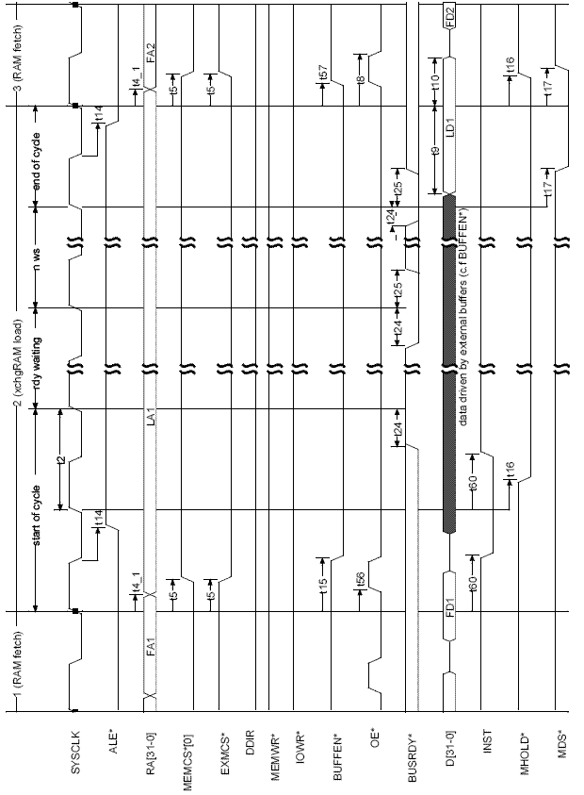

6- Change page 31:
Input capacitance = 7 pF instead of 10 pF.
Reason of change :
Confusion/Typo error.

7-Change page 34:
Add one note to Room temperature electrical measurement : ‘All timings are measured in reference to sysclk. In order to calculate timings in reference to clk2, output delays of sysclk in reference to clk2, T69 and T70 timings, are recorded.
Reason of change
Explain t69 and t70 recorded timings (timing not listed in table IA, because no limit is applicable)

