DCR Figure 2
1- Change Figure 2(a) to the following :
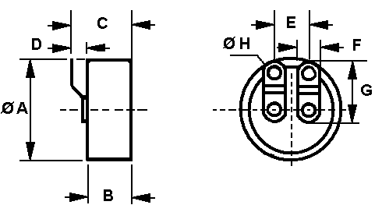
2- Change Figure 2(b) to the following :
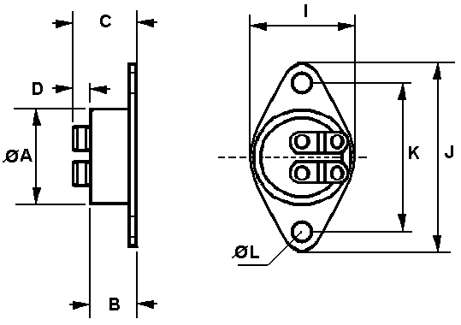

3- Change Figure 3(c) to the following :
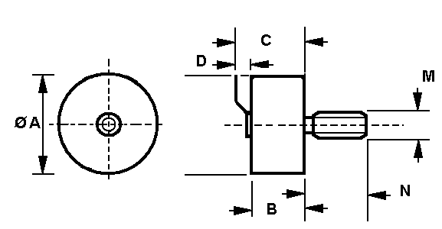

4- Add the following table :

SYMBOL | Variant 01 |  | Variant 02 |  | Variant 03
 | Min | Max | Min | Max | Min | Max
ΦA  B  C  D  E  F  G  ΦH  I  J  K  ΦL  M  ΦN | 15.3  7.3  2.5  6.25  3.8  1.9 | 15.5  7.5  11  6.45  4  10  2.1 | 15.3  7.8  2.5  6.25  3.8  1.9  16  30  23.7  3.5 | 15.5  8  11.5  6.45  4  10  2.1  16.2  30.2  23.9  3.7 | 15.3  12.2  2.5  6.25  3.8  1.9  M4  4.9 | 15.5  12.6  11.8  6.45  4  10  2.1  M4  5.1

