Radiography of ESCC 4006/014/08

TO: John Howley Enterprise Ireland.

From: Jude Neylon Betatherm / Measurement Specialties.

CC: John Wong ESTEC

Dated: March 26TH 2007

-------------------------------------------------------------------------------------------------------------

Purpose:

The purpose of this report is to outline the case for removal of the “Second Plane X Ray” as defined in ESCC 2094000 “Radiographic Inspection of Resistors”, for the Betatherm thermistors that are manufactured to the requirement of ESCC 4006/014.

Background:

ESCC 2094000 “Radiographic Inspection of Resistors”; which is a component of the controlling specifications for the inspection of thermistors to component specification ESCC 4006/014; mandates a radiograph in each of the two directions shown in Figure 5.1 of the specification, specifically for wire wound resistors. This requirement has historically been applied to the radiography of thermistors, to component specification ESCC 4006/014.

The During the ESCC Qualification Kick Off Meeting, relating to Variant 08 of ESCC 4006/014, at Betatherm on March 21st 2006 the following was agreed.

“ACTION 2: Betatherm to investigate the value of the second X Ray and to make a proposal to ESCC for its elimination with back up information. If accepted this would result in a DCR to the Detail Specification for the exclusion of the second view. The analysis will be conducted on the qualification batch.”
Analysis Part 1:

As agreed the analysis was carried out on the G15K4D489 qualification batch
(Date Code 0532A). The qualification batch of Variant 08 was radiographed in 2 planes as per specification. This was done using the conventional film method at Microsemi in Ennis.
Two X Ray images were taken at random and enlarged in a digital format. These images are typical of the radiographs in each of the two planes.

The images of these two samples illustrate the main justification for the proposed removal of the x ray in the second plane.

Component A:
View A1 View A2
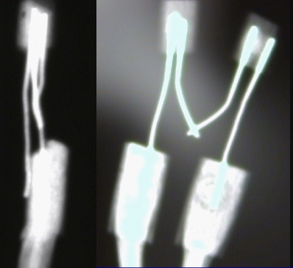

Component A

View A1 is taken at 90° to the aluminum housing.
View A2 is taken parallel to the aluminum housing.

View A2 gives a clear indication of the geometry of the platinum wires.
View A1 does not add any information to that obtained in View A2. It is not possible to make any determination, from this plane view, of the defined failure mechanisms.

Component B:

View B1 View B2
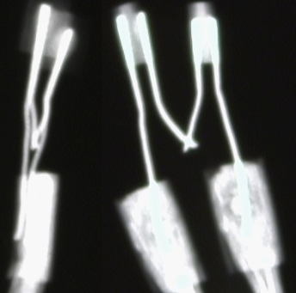

Component B

View B1 is taken at 90° to the aluminum housing.
View B2 is taken parallel to the aluminum housing.

View B2 gives a clear indication of the geometry of the platinum wires.
View B1 does not add any information to that obtained in View B2. It is not possible to make any determination, from this plane view, of the defined failure mechanisms.
.

CONCLUSION:

The image where the aluminum housing is parallel to the x ray film is far superior.

The other (90° plane) image does not add any information.

Analysis Part 2:

Betatherm has been manufacturing the 4006/014 type probe since 1994.We have never detected a failure or potential failure by the x ray method. Since we started to manufacture variant 08 (G15K4D489) we have shipped in excess of 7,000 probes.

The nature of the construction, i.e. platinum leads encased in solid epoxy 2850, make it virtually impossible for the wires to move and cause shorts .The resistance testing at hi and low temperatures is a very good potential method of identifying failures.
The standard of assembly is such that the testing does not detect any failures.

SUMMARY:

The X ray in the plane parallel to the film / housing gives a very good indication of the quality of the assembly.

The image in the plane at 90° does not give additional information on the assembly and is unnecessary.

PROPOSAL:

BETATHERM propose that the second x ray image does not add value and should be removed from all the variants of 4006/014 that Betatherm manufacture.

