 |  |  |  |  | ‘DOCUMENT CHANGE REQUEST

TO BE COMPLETED BY ORIGINATOR |  |  |  |  |  |  |  |  |  | Change request No. (4)
Originator (1) | Originator signature (2) |  |  |  |  |  | NSA or ESA representative signature (3)
Jude Neylon | 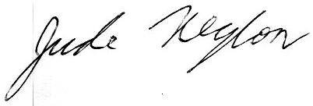 |  |  |  |  |  | 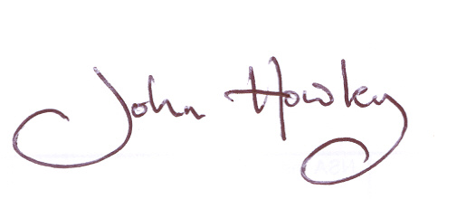
Affiliation | Date: 18 APRIL 2007 |  |  |  |  |  | Date: 23 APRIL 2007 |  |  | Page 1 of [3) (5)
Betatherm Ireland Ltd.
DOCUMENT AFFECTED |  |  |  |  |  |  |  |  | Other documents affected (10)
Doc. No. (6) |  | Status (7) |  |  |  | Title (8)
‘44006/014 |  | ‘Issue 4, Jul-05 |  |  |  | THERMISTORS (THERMALLY SENSITIVE RESISTORS), NCT, RANGE 2 000 TO 100 000 OHMS AT + 25^{O}C WITH A TEMPERATURE RANGE OF – 60 TO + 160 ^{O}C
Paragraph(s) and page(s) affected (9) |  |  |  |  |  |  |  |  | NONE
Page 8: FIGURE 2 – PHYSICAL DIMENSIONS / NOTE 1

‘PROPOSED WORDING OF CHANGE (11)
x

Continuation sheet(s) attached: Yes No

‘JUSTIFICATION (12)
x

Continuation sheet(s) attached: Yes No
‘Changes required for: Procurement (project) Qualification MRB decision (13)

A General Improvement of Spec. Other
X

‘RESERVED FOR USE BY SCC SECRETARIAT
Date of registration |  |  |  | Order of priority for Appr. / Impl.: 1 (high) 2 (medium) 3 (low)
Attachments |  |  |  | Qualification status: Qualified In process of qualification

‘RESERVED FOR USE BY APPROVING AUTHORITY
Approved |  |  | Date and signature |  |  |  |  | Reference to SCCG decision
Yes No
Priority

‘Approved wording, if different from box 11 or reason for rejection (14)
X

Continuation sheet(s) attached: Yes No

 | ‘DOCUMENT CHANGE REQUEST
CONTINUATION SHEET FOR BOX [ ] |  | Change request No.)
 |  | Page 2 of [3]
‘ |  | Page 2 of [3]
PROPOSED WORDING OF CHANGE FOR FIGURE 2:

CHANGE FIGURE 2 FROM:

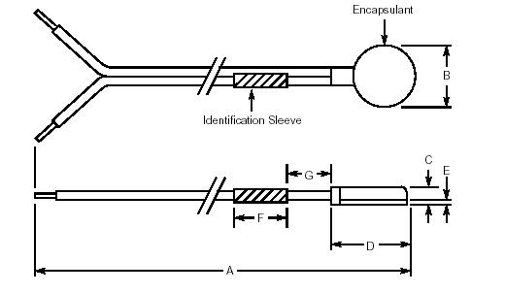

CHANGE FIGURE 2 TO:
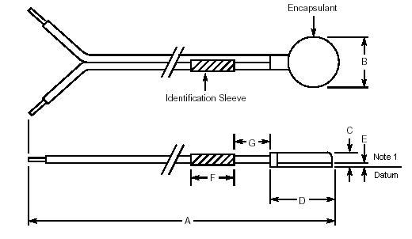

JUSTIFICATION FOR CHANGE TO FIGURE 2:

Existing ESCC Detail specification 4006/014 does not adequately specify the Flatness of the Component. Components with inadequate flatness will cause problems when they are assembled by customers.

Reference Document: Betatherm document of April 18th 2007 / J.Neylon “ Flatness of ESCC 4006/014 Probes”

 | ‘DOCUMENT CHANGE REQUEST
CONTINUATION SHEET FOR BOX [ ] |  | Change request No.)
 |  | Page 3 of [3]
‘ |  | Page 3 of [3]
PROPOSED WORDING OF CHANGE FOR NOTE 1:

CHANGE NOTE 1 FROM:

- The leads shall not be bent, or the means of fastening them cause bending in any direction from the place of the thermistor fastening disc within a distance of 15mm from the centre of the Thermistor.

CHANGE NOTE 1 TO:

1. The housing /crimp that is used to fasten the leads shall not protrude 0.13mm(maximum) below the Datum line. This tolerance is inspected on a GO/NO GO basis.

JUSTIFICATION FOR CHANGE TO NOTE 1:

The wording of current Note 1 is ambiguous .Existing ESCC Detail specification 4006/014 does not adequately specify the Flatness of the Component .Components with inadequate flatness will cause problems when they are assembled by customers.

Reference Document: Betatherm document of April 18th 2007 / J.Neylon “ Flatness of ESCC 4006/014 Probes”

