Flatness of ESCC 4006/014 probes.

TO: John Howley Enterprise Ireland.

From: Jude Neylon Betatherm / Measurement Specialties.

CC: John Wong ESTEC
Olivier Perat CNES

Dated: April 16TH 2007

-------------------------------------------------------------------------------------------------------------

Purpose:

The purpose of this report is to highlight an issue with the flatness of the ESCC 4006/014/08 components and to propose a remedy.

Background:

Since the introduction of the ESCC 4006/014/08 component in 2005.(G15K4D489) over 7,000 flight probes have been shipped with no complaints other than the “Capillary Effect” .However in recent weeks CNES have indicated that they had an issue with the flatness of 2 components.

In 2006 Betatherm shipped 30 parts of G15K4D489 to CNES. They discovered two parts that had housings which they considered not to be flat.
(Date Code 0629A)

There is no Specification of Flatness in the ESCC Detail Specifications (4006/014).

Date Code 0629A:

The two components that were found at CNES showed bending where the housing crimps the cable. Betatherm agree that the flatness of these two components is insufficient to allow normal bonding.

Flatness Definition:

As stated previously “Flatness” is not adequately defined in ESCC 406/014 but can be found in old MMS specifications. The Flatness Specification is set at 0.005”Maximum Deviation.

This means that the part of the housing that is crimping the cable must not drop in excess of 0.005” from the Datum .

Matra Marconi Secification.:

C
0,095 max

E
DATUM
0,406
WIRE OF
0,005 max BELOW DATUM
NOTE 1

NOTES :
- The means of fastening the leads must not drop below the mounting plane of the disc by more than 0.005’’.

Measurement:

Over the years “Flatness” was discussed many times during Customer Source Inspections but the main issue was to develop an efficient method of measurement. Betatherm have now done this .Basically it involves the use of a Vernier Calipers in two stages.

- Measure height of housing ( Fig A) ( crimp part not included)

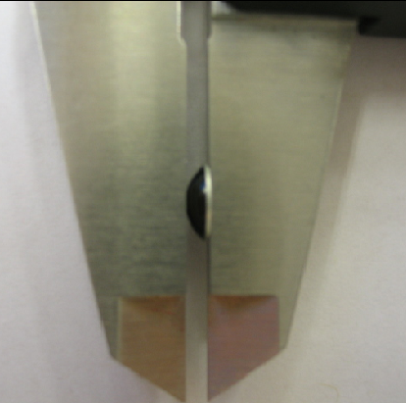

- Measure height of housing (Fig B ) (crimp part include)

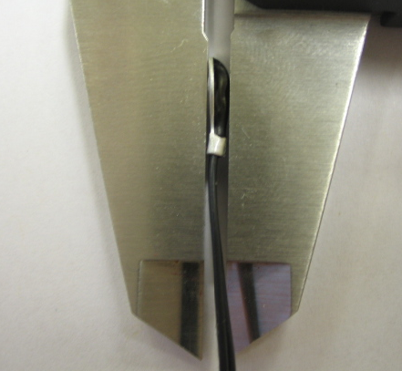

- Do not zero calipers between first and second measurement
- Difference between measurements is = flatness measurement.

.
Investigation:

Betatherm has checked the WIP and the process flow and are confident that this specific issue occurred when the housing was attached to the stranded / insulated wire. It is not associated with distorted housings in their un assembled stage.

A batch of parts (Date Code 0709A) was measured 100% and all housings were within a flatness of 0.002”

Other smaller lots were also measured and were also found to be within 0.002”

SUMMARY:

The parts that CNES discovered would appear to be a one off occurrence but there is a need to set a “Flatness Specification” and introduce a check in the Manufacturing Process.
The specification of 0.005” would appear to be sufficient and the Betatherm method of measuring this is accurate and easy to use.

PROPOSAL:

Issue DCR to add Flatness specification of 0.005” to all ESCC 4006/014 variants.

Betatherm have added the “Flatness Checks” to the following specifications.

WS-60-71 ” External Visual Inspection of 4006/014 Components”
MFG-11-72-20 ” External Visual Inspection of 4006/014 Components”

These checks will occur after the potting stage.

