

Page 1 of 23

FAST-LOCKING SCREW LOCK ASSEMBLIES FOR RECTANGULAR CONNECTORS 3401/001, 3401/002 AND CONNECTOR SAVERS 3401/020, 3401/080
ESCC Detail Specification No. 3401/085
Issue 3 Draft D | September 2015



Document Custodian: European Space Agency – see https://escies.org

Legal Disclaimer and Copyright
European Space Agency, Copyright © 2015. All rights reserved.
The European Space Agency disclaims any liability or responsibility, to any person or entity, with respect to any loss or damage caused, or alleged to be caused, directly or indirectly by the use and application of this ESCC publication.
This publication, without the prior permission of the European Space Agency and provided that it is not used for a commercial purpose, may be:
- copied in whole, in any medium, without alteration or modification.
- copied in part, in any medium, provided that the ESCC document identification, comprising the ESCC symbol, document number and document issue, is removed.

DOCUMENTATION CHANGE NOTICE
(Refer to https://escies.org for ESCC DCR content)
DCR No. | CHANGE DESCRIPTION
915 | Specification upissued to incorporate editorial and technical changes per DCR.

TABLE OF CONTENTS

1 GENERAL 6
1.1 SCOPE 6
1.2 COMPONENT TYPE VARIANTS AND RANGE OF COMPONENTS 6
1.3 MAXIMUM RATINGS 6
1.4 PARAMETER DERATING INFORMATION 6
1.5 PHYSICAL DIMENSIONS 6
2 APPLICABLE DOCUMENTS 6
3 TERMS, DEFINITIONS, ABBREVIATIONS, SYMBOLS AND UNITS 6
4 REQUIREMENTS 11
4.1 GENERAL 11
4.2 DEVIATIONS FROM GENERIC SPECIFICATION 11
4.2.1 Deviations from Special In-Process Controls 11
4.2.2 Deviations from Final Production Tests (Chart II) 11
4.2.3 Deviations from Burn-in and Electrical Measurements (Chart III) 11
4.2.4 Deviations from Qualification Tests (Chart IV) 12
4.2.5 Deviations from Lot Acceptance Tests (Chart V) 13
4.3 MECHANICAL REQUIREMENTS 14
4.3.1 Dimension Check 14
4.3.2 Weight 14
4.3.3 Maximum Torque Application 14
4.3.3.1 Coupling Nut Unlocking Torque 14
4.3.4 Locking/Unlocking Forces 14
4.3.5 Life Test Locking – Unlocking 15
4.3.6 Fast-Locking Screw Lock Retention on Shells 16
4.3.7 Clip Retention Inside Bushing 16
4.3.8 Pull Test on Mated Screw Lock Assemblies 17
4.3.9 Security Pin Retention in Male Fast-Locking Screw Lock Assemblies 18
4.3.10 Mechanical Sequence 18
4.3.11 Environmental Sequence 19
4.4 MATERIALS AND FINISHES 19
4.4.1 Fast-Locking Screw Lock Assemblies 19
4.4.2 Magnetism Level 19
4.5 MARKING 20
4.5.1 General 20
4.5.2 The ESCC Component Number 20
4.5.2.1 Characteristics 20
4.5.3 Traceability Information 20
4.6 ELECTRICAL MEASUREMENTS 20
4.7 BURN-IN AND ELECTRICAL MEASUREMENTS 20
4.8 ENVIRONMENTAL AND ENDURANCE TESTS 20
4.8.1 Measurements and Inspections on Completion of Environmental Tests 20
4.8.2 Measurements and Inspections at Intermediate Points During Endurance Tests 20
4.8.3 Measurements and Inspections on Completion of Endurance Tests 21
4.8.4 Conditions for Operating Life Test (Part of Endurance Testing) 21
4.8.5 Electrical Circuits for Operating Life Test 21
4.8.6 Conditions for High Temperature Storage Test (Part of Endurance Testing) 21

GENERAL

SCOPE
This specification details the ratings, physical and mechanical characteristics, test and inspection data for Fast-Locking Screw Lock Assemblies for Rectangular Connectors (D*M and D*MA) and Connector Savers (D*BM and D*BMA). It shall be read in conjunction with ESCC Generic Specification No. 3401, the requirements of which are supplemented herein, and ESCC Detail Specifications Nos. 3401/001, 3401/002, 3401/020, 3401/022, 3401/072 and 3401/080.

COMPONENT TYPE VARIANTS AND RANGE OF COMPONENTS
The type variants of accessories covered by this specification are given in Table 1(a).

MAXIMUM RATINGS
The maximum ratings, which shall not be exceeded at any time during use or storage, applicable to the accessories specified herein, are given in Table 1(b).

PARAMETER DERATING INFORMATION
Not applicable.

PHYSICAL DIMENSIONS
The physical dimensions of the accessories specified herein are shown in Figure 2.

APPLICABLE DOCUMENTS
The following documents form part of this specification and shall be read in conjunction with it:
          - ESCC Generic Specification No. 3401, Connectors, Electrical, Non-Filtered, Circular and Rectangular.
          - ESCC Detail Specification No. 3401/001, Connectors, Electrical, Rectangular, Miniature, Non-removable Solder Bucket, PCB and Wire-Wrap Contacts and Removable Coaxial and Power Contacts, based on Type D*M.
          - ESCC Detail Specification No. 3401/002, Connectors, Electrical, Rectangular, Removable Crimp Contacts, based on Type D*MA.
          - ESCC Detail Specification No. 3401/020, Connector Savers, Electrical, Rectangular, Miniature, Removable Contacts, based on Type D*BMA.
          - ESCC Detail Specification No. 3401/022, Accessories for Rectangular Connectors 3401/001, 3401/002 and Connector Savers 3401/020, 3401/080.
          - ESCC Detail Specification No. 3401/072, Lightweight Accessories for Rectangular Connectors 3401/001 and 3401/002.
          - ESCC Detail Specification No. 3401/080, Connector Savers, Electrical, Rectangular, Miniature, Non-removable Signal Contacts and Removable Coaxial and Power Contacts, based on Type D*BM.
          - MIL-DTL-81969/39, Detail Specification Sheet, Installing And Removal Tool, Connector Electrical Contacts, Type III, Class 2, Composition B.

TERMS, DEFINITIONS, ABBREVIATIONS, SYMBOLS AND UNITS
For the purpose of this specification, the terms, definitions, abbreviations, symbols and units specified in ESCC Basic specification No. 21300 shall apply.

TABLE 1(a) – TYPE VARIANTS
Variant | Description | Weight  Max  (g)
01 | Male Fast-Locking Screw Lock Assembly, For Connectors without Back Shell, Brass | 1
02 | Male Fast-Locking Screw Lock Assembly, For Connectors with Back Shell, Brass (1) | 1
03 | Female Fast-Locking Screw Lock Assembly, Brass | 1.5
04 | Fast-Locking Screw Lock Assembly, For Saver Connectors, Brass | 1.2
05 | Fast-Locking Screw Lock Assembly, For Hybrid Saver Connectors, Brass | 1.2
06 | Security Pin For Male Fast-Locking Screw Lock Assemblies | 0.3
NOTES:
            - Backshells compatibles with Male Fast-Locking Screw Lock Assembly (Variant 02) are listed below :
- ESCC Detail Specification No. 3401/022: Variants 17 to 38, Variants 81 to 83 and Variants 90 to 94.
- ESCC Detail Specification No. 3401/072: Variants 05 to 14, Variants 35 to 39, Variants 46 to 50 and Variants 61 to 65
TABLE 1(b) – MAXIMUM RATINGS
No. | Characteristic | Symbol | Maximum Ratings | Unit | Remarks
1 | Operating Temperature Range | T_{op} | -55 to +125 | °C | T_{amb}
2 | Storage Temperature Range | T_{stg} | -55 to +125 | °C
3 | Locking Force  Variants 01, 02, 04: | F_{LO} | 15 | N
4 | Unlocking Force  Variants 01, 02, 04: | F_{UN} | 30 | N
5 | Torque Value for Nuts and Bushing  Variants 03, 05: | Tqe | See Figure 2 | cm.daN

Figure 1 – parameter DERATING information
Not applicable.

Figure 2 – physical dimensions
MATED SPACING BETWEEN SHELL FRONT SURFACES
(All dimensions in millimetres)

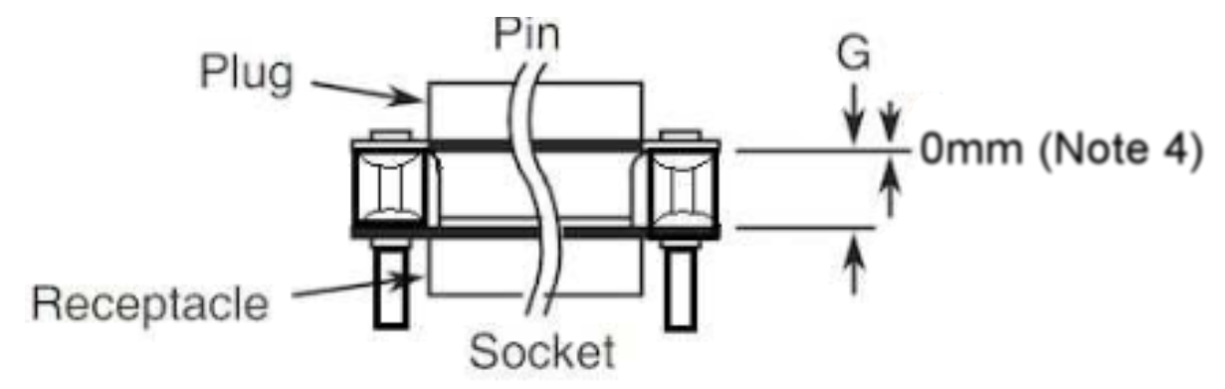
Dimension | Min | Max | Notes
G | 6.35 | 7.11 | 1, 3
 | 6.12 | 6.88 | 2, 3
NOTES:
            - For shell sizes E and A.
            - For shell sizes B, C, D and F.
            - The spacing between the reference planes of two mated connectors shall be adjusted by the use of three washers maximum (see Variant 03 dimensions) so the spacing is equal to dimension G.
            - The locking operation shall not be performed before there is no gap between the Female Fast-Locking Screw Lock Assembly and shell front surface.
MALE FAST-LOCKING SCREW LOCK ASSEMBLIES (VARIANTS 01 and 02)
(All dimensions in millimetres)
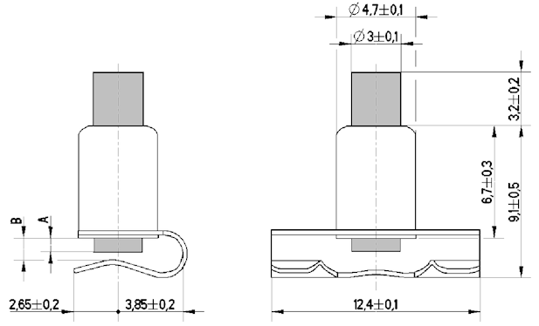
Variant | Dimension A |  | Dimension B
Variant | Min | Max | Min | Max
01 | 0.6 | 1 | 1.1 | 1.5
02 | 1 | 1.4 | 1.5 | 1.9

Figure 2 – physical dimensions (CONTINUED)
FEMALE FAST-LOCKING SCREW LOCK ASSEMBLY (VARIANT 03)
(All dimensions in millimetres)
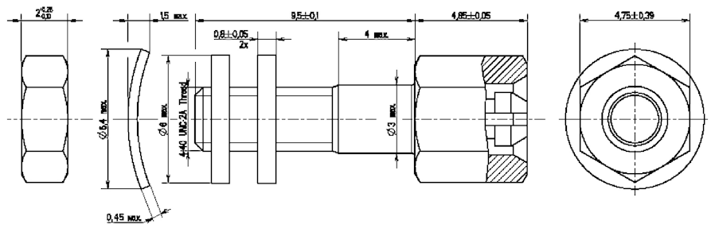
No. | Characteristics | Symbol | Min Limit | Max Limit | Unit
1 | Torque Value for Nuts | Tqe | 4.4 | 4.9 | cm.daN
FAST-LOCKING SCREW LOCK ASSEMBLY FOR SAVER CONNECTORS (VARIANT 04)
(All dimensions in millimetres)
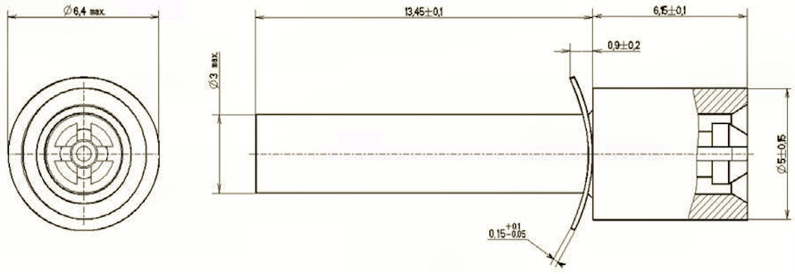
FAST-LOCKING SCREW LOCK ASSEMBLY FOR HYBRID SAVER CONNECTORS
(VARIANT 05)
(All dimensions in millimetres)
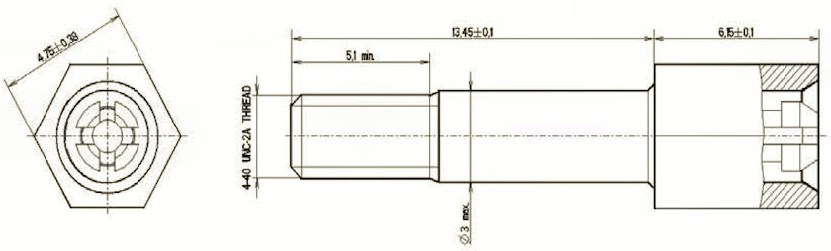
No. | Characteristics | Symbol | Min Limit | Max Limit | Unit
1 | Torque Value for Bushing | Tqe | 4.4 | 4.9 | cm.daN
SECURITY PIN FOR MALE FAST-LOCKING SCREW LOCK ASSEMBLIES
(VARIANT 06)
(All dimensions in millimetres)
Dimension | Min | Max |  | Dimension | Min | Max
A | 5.95 | 6.05 |  | K | 3.9 | 4.1
B | 3.35 | 3.45 |  | L | 4.4 | 4.7
C | 4.35 | 4.65 |  | M | 1.1 | 1.3
ØD | 2.08 | 2.12 |  | N | 1.4 | 1.6
ØE | 1.73 | 1.77 |  | ØP | - | 0.3
ØF | 0.99 | 1.04 |  | ØQ | 0.59 | 0.66
G | 0.45 | 0.55 |  | ØR | 1.3 | 1.5
ØH | 0.45 | 0.55 |  | ØS | 1.8 | 1.9
ØJ | 1.15 | 1.2
Notes:
            - Underlined dimensions in table are critical to ensure intermateability and interchangeability.
            - Measurement point for plating thickness: 2.5 ±1mm.
            - ØJ, ØQ and ØS shall be concentric within 0.04mm.
            - Inspection hole shall only penetrate one wall of the crimp barrel.

REQUIREMENTS

GENERAL
The complete requirements for procurement of the accessories specified herein shall be as stated in this specification and ESCC Generic Specification No. 3401. Deviations from the Generic Specification, applicable to this specification only, are listed in Para 4.2.
Deviations from the Generic Specification and this Detail Specification, formally agreed with specific Manufacturers on the basis that the alternative requirements are equivalent to the ESCC requirements and do not affect the components’ reliability, are listed in the appendices attached to this specification.

DEVIATIONS FROM GENERIC SPECIFICATION

Deviations from Special In-Process Controls
None.

Deviations from Final Production Tests (Chart II)
Only the following tests shall be performed:
          - Para. 9.2, Mating Verification.
          - Para. 9.5, Magnetism Level.
          - Para. 9.6, Dimension Check.
          - Para. 9.7, External Visual Inspection. The magnification shall be ×3.
          - Para. 4.3.4 of this Specification, Locking/Unlocking Forces.

Deviations from Burn-in and Electrical Measurements (Chart III)
Not applicable.

Deviations from Qualification Tests (Chart IV)
Qualification testing shall be performed in accordance with the following Chart. No failures are allowed. Unless otherwise specified, paragraph numbers refer to the ESCC Generic Specification No. 3401.

NOTES:

            - Only the measurements and inspections specified in Table 6 of the Detail Specification shall be performed.

Deviations from Lot Acceptance Tests (Chart V)
Lot Acceptance testing shall be performed in accordance with the following Chart. Unless otherwise specified, paragraph numbers refer to the ESCC Generic Specification No. 3401.

NOTES:
            - Only the measurements and inspections specified in Table 6 of the Detail Specification shall be performed.

MECHANICAL REQUIREMENTS

Dimension Check
The dimensions of the accessories specified herein shall be verified in accordance with the requirements set out in Para. 9.6 of ESCC Generic Specification No. 3401 and shall conform to those shown in Figure 2 of this specification.

Weight
The maximum weight of the accessories specified herein shall be as shown in Table 1(a) of this specification.

Maximum Torque Application
This test shall be performed on Variants 03 and 05.
The torque value specified in Table 6 shall be used to tighten the nuts and/or bushing of the screw locks under test. The nuts and/or bushing shall then be removed.
- Data Points:
The components shall be visually examined both before and after removal, and shall show no evidence of physical damage.

Coupling Nut Unlocking Torque
This test shall be performed on Variants 03 and 05.
The maximum torque value specified in Table 1(b) shall be used to tighten the screw lock under test into the bushing. The screw lock shall then be removed.
- Data Points:
The torque required to remove the screwlock from the bushing shall be measured and recorded and the drift calculated, if specified.

Locking/Unlocking Forces
This test shall be performed on Variants 01, 02 and 04.
The screw locks under test shall be put on appropriate equipment that reproduces the opposite side and ensures a mated spacing between shell front surfaces as defined in Figure 2. The locking operation is performed with the applicable test tool defined as follows:
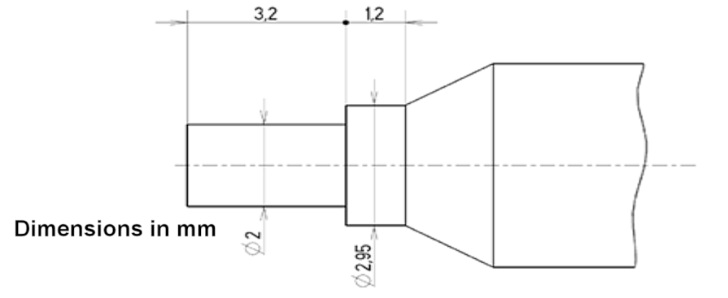
The locking speed shall be 5mm/s maximum.
The locking force is defined as the maximum force registered during the travel.

The unlocking operation is performed with the applicable test tool defined as follows:

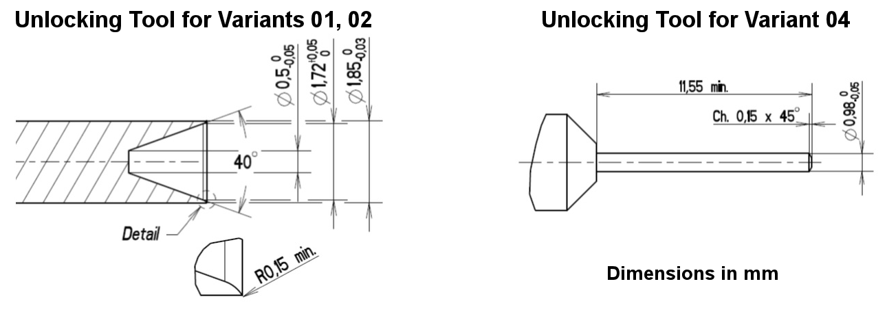
The unlocking speed shall be 5mm/s maximum.
NOTE:
Where the screw locks under test have a Security Pin (Variant 06) engaged, the Security Pin shall be removed prior to performing the Locking/Unlocking Forces test using the installing and removal tool M81969/39-01 in accordance with MIL-DTL-81969/39, or equivalent.
The unlocking force is defined as the maximum force registered during the test.
- Data Points:
For Final Production Test, the locking and unlocking forces shall be measured and recorded, and shall meet the requirements of Table 1(a).
For Qualification and Lot Acceptance Tests, the locking and unlocking forces shall be measured and recorded, and shall meet the requirements of Table 6.

Life Test Locking – Unlocking
This test shall be performed on Variants 01, 02, 03, 04 and 05.
Procedure:
The screw locks under test shall be put on appropriate equipment that reproduces the opposite side and ensures a mated spacing between shell front surfaces as defined in Figure 2. The screw locks shall be subjected to 50 cycles (for both Qualification (Chart IV) and Lot Acceptance (Chart V) testing) with the tools defined in Para. 4.3.4.
A cycle is defined as one locking and one unlocking.
The male and female screw locks shall be completely separated during each cycle.
The locking speed shall be 5mm/s maximum.
The cycling rate shall be 8 cycles/minute maximum.

- Data Points:
Prior to testing, the locking and unlocking forces shall be measured and recorded, and shall meet the requirements of Table 6.
On completing of testing, the components shall be visually examined and shall show no evidence of physical damage. Locking and unlocking forces shall be measured and recorded, and shall meet the requirements of Table 6.

Fast-Locking Screw Lock Retention on Shells
This test shall be performed on Variants 01 and 02.
The male screw lock mounted on a connector as defined in ESCC 3401/001 Figure 2 shall be subjected to an axial force, F, of 20N for a duration of 5s, as follows:
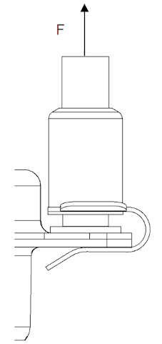
- Data Points:
On completion of testing, the components shall be visually examined and shall show no evidence of physical damage and the screw lock shall not be dislodged from the shell.

Clip Retention Inside Bushing
This test shall be performed on Variants 03, 04 and 05.
The clip inside the female screw lock shall be subjected to an axial force, F, of 150N for a duration of 5s, as follows:
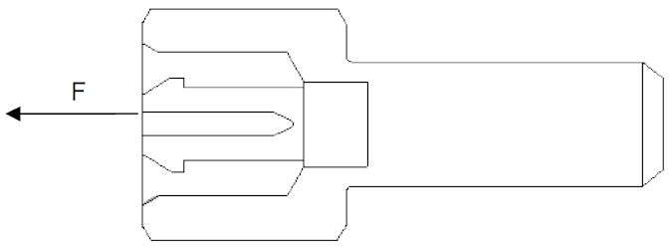
- Data Points:
On completion of testing, the components shall be visually examined. The clip shall not be dislodged from the bushing.

Pull Test on Mated Screw Lock Assemblies
This test shall be performed on Variants 01 (or 02), 03 and 06 (male and female screw locks locked together with the Security Pin engaged).
The Screw Lock assembly shall be mounted on a suitable test fixture as indicated below, that simulates assembly on mated connectors.
The screw lock assembly shall be subjected to a pull test with the following conditions (non-cumulative tests):
Pull Test 1:
- Force applied: 150N
- Duration: 5s
- Direction: 90° to mounting plane (see figure below)
Pull Test 2:
- Force applied: 50N
- Duration: 5s
- Direction: 45° to mounting plane (configuration i – see figure below)
Pull Test 3:
- Force applied: 50N
- Duration: 5s
- Direction: 45° to mounting plane (configuration ii – see figure below)
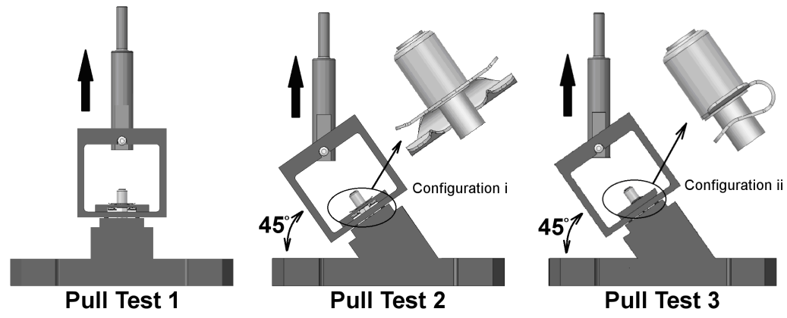
- Data Points:
Prior to testing, the locking and unlocking forces shall be measured and recorded, and shall meet the requirements of Table 6.
On completing of testing, the components shall be visually examined and shall show no evidence of physical damage. Locking and unlocking forces shall be measured and recorded, and shall meet the requirements of Table 6.

Security Pin Retention in Male Fast-Locking Screw Lock Assemblies
This test shall be performed on Variants 01 (or 02), 03 and 06 (male and female screw locks locked together with the Security Pin engaged).
The Security Pin (Variant 06) shall be subjected to an axial force, F, of 40N for a duration of 5s, as follows:
- Data Points:
Prior to testing, the locking and unlocking forces shall be measured and recorded, and shall meet the requirements of Table 6.
On completion of testing, the components shall be visually examined and shall show no evidence of physical damage and the Security Pin shall not be dislodged from the male insert of the screw lock. Locking and unlocking forces shall be measured and recorded, and shall meet the requirements of Table 6.

Mechanical Sequence
This test shall be performed on Variants 01, 03 and 06 (male and female screw locks locked together with the Security Pin engaged).
Procedure:
The Screw Lock assembly shall be mounted on a suitable test fixture as indicated below and subjected to Sinusoidal and Random Vibration followed by Shock or Bump in accordance with Para. 9.11 and 9.12 respectively, of ESCC Generic Specification No. 3401.
- Data Points:
Prior to testing, the locking and unlocking forces shall be measured and recorded, and shall meet the requirements of Table 6.
On completion of Vibration, without being unmounted, the components shall be visually examined and shall show no evidence of physical damage
On completion of Shock or Bump, the components shall be visually examined and shall show no evidence of physical damage. Locking and unlocking forces shall be measured and recorded, and shall meet the requirements of Table 6.

Environmental Sequence
This test shall be performed on Variants 01, 03 and 06 (male and female screw locks locked together with the Security Pin engaged).
Procedure:
The Screw Lock assembly shall be mounted on a suitable test fixture as indicated in Para. 4.3.10 and subjected to Rapid Change of Temperature followed by High Temperature Storage in accordance with Para. 9.16 and 9.21 respectively, of ESCC Generic Specification No. 3401.
- Data Points:
Prior to testing, the locking and unlocking forces shall be measured and recorded, and shall meet the requirements of Table 6.
On completion of Rapid Change of Temperature, without being unmounted, the components shall be visually examined and shall show no evidence of physical damage
On completion of High Temperature Storage, the components shall be visually examined and shall show no evidence of physical damage. Locking and unlocking forces shall be measured and recorded, and shall meet the requirements of Table 6.

MATERIALS AND FINISHES
The materials and finishes shall be as specified herein. Where a definite material is not specified, a material which will enable the components specified herein to meet the performance requirements of this specification shall be used. Acceptance or approval of any constituent material does not guarantee acceptance of the finished product.

Fast-Locking Screw Lock Assemblies
The body shall be made of brass with gold (0.7µm minimum) over copper (1µm minimum) plating.
The button shall be made of passivated stainless steel.
The spring washer (as required) shall be made of beryllium copper with gold (0.7µm minimum) over copper (1µm minimum) plating.
The spring and retaining clip (as required) shall be made of beryllium copper.
The Security Pin (Variant 06) shall be made of copper alloy with gold (0.7μm minimum) over copper (1μm minimum) plating.

Magnetism Level
The allowable value of magnetism shall not exceed that specified for the relevant level (see Para. 4.5.2.1(a)).

MARKING

General
The marking of all components delivered to this specification shall be in accordance with the requirements of ESCC Basic Specification No. 21700 and the following paragraphs.
When the component is too small to accommodate all of the marking specified, as much as space permits shall be marked and the marking information, in full, shall accompany each component in its primary package.
The information to be marked, and the order of precedence, shall be as follows:
          - The ESCC qualified components symbol (for ESCC qualified components only).
          - The ESCC Component Number
          - (including Characteristics)
          - Traceability Information.

The ESCC Component Number
The ESCC Component Number shall be constituted and marked as follows:
Example: 340108501BNMB
- Detail Specification Number: 3401085
- Type Variant (see Table 1(a)): 01 (as required)
- Testing Level: B (Note: this is mandatory, as Testing Level ‘C’ is not applicable).
- Characteristic code: Magnetism Level (≤ 200 gamma): NMB (as required)

Characteristics
The characteristic to be codified as part of the ESCC Component Number shall be as follows:
          - Magnetism Level

          - expressed by means of the following codes:
Code | Definition
NMA | Magnetism Level: ≤ 2000 gamma
NMB | Magnetism Level: ≤ 200 gamma

Traceability Information
Traceability information shall be marked in accordance with ESCC Basic Specification No. 21700.

ELECTRICAL MEASUREMENTS
Not applicable.

BURN-IN AND ELECTRICAL MEASUREMENTS
Not applicable.

ENVIRONMENTAL AND ENDURANCE TESTS

Measurements and Inspections on Completion of Environmental Tests
The parameters to be measured and inspections to be performed on completion of environmental testing are scheduled in Table 6. Unless otherwise specified, these measurements shall be performed at T_{amb} = +22 ±3°C.

Measurements and Inspections at Intermediate Points During Endurance Tests
Not applicable.

Measurements and Inspections on Completion of Endurance Tests
The parameters to be measured and inspections to be performed on completion of endurance tests shall be those specified in Table 6. Unless otherwise specified, these measurements shall be performed at T_{amb} = +22 ±3°C.

Conditions for Operating Life Test (Part of Endurance Testing)
Not applicable.

Electrical Circuits for Operating Life Test
Not applicable.

Conditions for High Temperature Storage Test (Part of Endurance Testing)
The requirements for the high temperature storage test are specified in Section 9 of ESCC Generic Specification No. 3401. The conditions for high temperature storage testing shall be the maximum storage temperature specified in Table 1(b) of this specification.
TABLES 2, 3, 4 AND 5
Not applicable.
TABLE 6 – MEASUREMENTS AND INSPECTIONS ON COMPLETION OF ENVIRONMENTAL TESTS AND ENDURANCE TESTING
No. | ESCC Generic Spec. No. 3401 |  |  |  | Measurements and Inspections |  |  |  | Symbol |  | Limits |  |  |  | Unit
 | Environmental and Endurance Tests  (Note 1) |  | Test Method  and Conditions |  | Identification |  | Conditions |  |  |  | Min |  | Max
01 | Vibration |  | Para. 9.11 |  | Initial Measurements  Locking / Unlocking Forces |  | Para. 4.3.4 of this Spec. |  | F_{LO}, F_{UN} |  | Table 1(b  ) Items 3 & 4 |  |  |  | N
 |  |  |  |  | Coupling Nut Unlocking Torque |  | Para. 4.3.3.1 of this Spec. |  | Tqe |  | 1 |  | - |  | cm.daN
 |  |  |  |  | Measurement during test
 |  |  |  |  | Contact disturbance |  |  |  | - |  | - |  | 1 |  | µs
 |  |  |  |  | Final Measurements  Locking / Unlocking Forces |  | Para. 4.3.4 of this Spec. |  | F_{LO}, F_{UN} |  | Table 1(b) Items 3 & 4 |  |  |  | N
 |  |  |  |  | Coupling Nut Unlocking Torque |  | Para. 4.3.3.1 of this Spec. |  | Tqe |  | 1 |  | - |  | cm.daN
 |  |  |  |  | Coupling Nuts Locking Torque Drift |  | Para. 4.3.3.1 of this Spec. |  | ΔTqe |  | ±0.5 |  |  |  | cm.daN
 |  |  |  |  | Visual Examination |  | No damage |  | - |  | - |  |  |  | -
02 | Shock or Bump  (Note 2) |  | Para. 9.12 |  | Initial Measurements  Locking / Unlocking Forces |  | Para. 4.3.4 of this Spec. |  | F_{LO}, F_{UN} |  | Table 1(b  ) Items 3 & 4 |  |  |  | N
 |  |  |  |  | Measurement during test
 |  |  |  |  | Contact disturbance |  |  |  | - |  | - |  | 1 |  | µs
 |  |  |  |  | Final Measurements  Locking / Unlocking Forces |  | Para. 4.3.4 of this Spec. |  | F_{LO}, F_{UN} |  | Table 1(b  ) Items 3 & 4 |  |  |  | N
 |  |  |  |  | Visual Examination |  | No damage |  | - |  | - |  |  |  | -
03 | Climatic Sequence (Note 2) |  | Para. 9.13 |  | Initial Measurements
 |  |  |  |  | Locking / Unlocking Forces |  | Para. 4.3.4 of this Spec. |  | F_{LO}, F_{UN} |  | Table 1(b  ) Items 3 & 4 |  |  |  | N
 |  |  |  |  | Final Measurements |  | After 1-24 hrs Recovery
 |  |  |  |  | External Visual Inspection |  | ESCC 3401 Para. 9.7 |  | - |  | - |  |  |  | -
 |  |  |  |  | Locking / Unlocking Forces |  | Para. 4.3.4 of this Spec. |  | F_{LO}, F_{UN} |  | Table 1(b) Items 3 & 4 |  |  |  | N
04 | Plating Thickness |  | Para. 9.14 |  | Plating thickness |  |  |  | - |  | Para. 4.4.1 of this Spec. |  |  |  | µm
05 | Life Test Locking - Unlocking  (Note 2) |  | Para. 4.3.5 of this Spec. |  | Initial Measurements  Locking / Unlocking Forces |  | Para. 4.3.4 of this Spec. |  | F_{LO}, F_{UN} |  | Table 1(b  ) Items 3 & 4 |  |  |  | N
 |  |  |  |  | Final Measurements
 |  |  |  |  | Visual Examination |  | No damage |  | - |  | - |  |  |  | -
 |  |  |  |  | Locking / Unlocking Forces |  | Para. 4.3.4 of this Spec. |  | F_{LO}, F_{UN} |  | Table 1(b  ) Items 3 & 4 |  |  |  | N
06 | Rapid Change of Temperature |  | Para. 9.16 |  | Initial Measurements  Locking / Unlocking Forces |  | Para. 4.3.4 of this Spec. |  | F_{LO}, F_{UN} |  | Table 1(b  ) Items 3 & 4 |  |  |  | N
 |  |  |  |  | Final Measurements
 |  |  |  |  | Visual Examination |  | No damage |  | - |  | - |  |  |  | -
 |  |  |  |  | Locking / Unlocking Forces |  | Para. 4.3.4 of this Spec. |  | F_{LO}, F_{UN} |  | Table 1(b  ) Items 3 & 4 |  |  |  | N
07 | High Temperature Storage |  | Para. 9.21 |  | Initial Measurements  Locking / Unlocking Forces |  | Para. 4.3.4 of this Spec. |  | F_{LO}, F_{UN} |  | Table 1(b  ) Items 3 & 4 |  |  |  | N
 |  |  |  |  | Final Measurements
 |  |  |  |  | Visual Examination |  | No damage |  | - |  | - |  |  |  | -
 |  |  |  |  | Locking / Unlocking Forces |  | Para. 4.3.4 of this Spec. |  | F_{LO}, F_{UN} |  | Table 1(b  ) Items 3 & 4 |  |  |  | N
08 | Fast-Locking Screw Lock Retention on Shells |  | Para. 4.3.6 of this Spec. |  | Visual Examination |  | Para. 4.3.6 of this Spec. |  | - |  | - |  |  |  | -
09 | Corrosion |  | Para. 9.22 |  | Visual Examination |  | Para. 9.22 |  | - |  | - |  |  |  | -
10 | Maximum Torque Application |  | Para. 4.3.3 of this Spec. |  | Torque Value |  | Para. 4.3.3 of this Spec. |  | Tqe |  | Table 1(b) Item 5 |  |  |  | cm.daN
 |  |  |  |  | Visual Examination |  | No damage |  | - |  | - |  |  |  | -
11 | Clip Retention Inside Bushing |  | Para. 4.3.7 of this Spec. |  | Visual Examination |  | Para. 4.3.7 of this Spec. |  | - |  | - |  |  |  | -
12 | Pull Test on Mated Screw Lock Assemblies  (Note 2) |  | Para. 4.3.8 of this Spec. |  | Initial Measurements  Locking / Unlocking Forces |  | Para. 4.3.4 of this Spec. |  | F_{LO}, F_{UN} |  | Table 1(b) Items 3 & 4 |  |  |  | N
12 |  |  |  |  | Final Measurements  Visual Examination  Locking / Unlocking Forces |  | No damage  Para. 4.3.4 of this Spec. |  | -  F_{LO}, F_{UN} |  | -  Table 1(b) Items 3 & 4 |  |  |  | -  N
13 | Security Pin Retention in Male Fast-Locking Screw Lock Assemblies |  | Para. 4.3.9 of this Spec. |  | Initial Measurements  Locking / Unlocking Forces |  | Para. 4.3.4 of this Spec. |  | F_{LO}, F_{UN} |  | Table 1(b) Items 3 & 4 |  |  |  | N
13 |  |  |  |  | Final Measurements  Visual Examination  Locking / Unlocking Forces |  | Para. 4.3.9 of this Spec.  Para. 4.3.4 of this Spec. |  | -  F_{LO}, F_{UN} |  | -  Table 1(b) Items 3 & 4 |  |  |  | -  N
14 | Mechanical Sequence  (Note 2) |  | Para. 4.3.10 of this Spec. |  | Initial Measurements  Locking / Unlocking Forces |  | Para. 4.3.4 of this Spec. |  | F_{LO}, F_{UN} |  | Table 1(b) Items 3 & 4 |  |  |  | N
14 |  |  |  |  | Intermediate Inspection  Visual Examination |  | No damage |  | - |  | - |  |  |  | -
14 |  |  |  |  | Final Measurements  Visual Examination  Locking / Unlocking Forces |  | No damage  Para. 4.3.4 of this Spec. |  | -  F_{LO}, F_{UN} |  | -  Table 1(b) Items 3 & 4 |  |  |  | -  N
14 | Environmental Sequence  (Note 2) |  | Para. 4.3.11 of this Spec. |  | Initial Measurements  Locking / Unlocking Forces |  | Para. 4.3.4 of this Spec. |  | F_{LO}, F_{UN} |  | Table 1(b) Items 3 & 4 |  |  |  | N
14 |  |  |  |  | Intermediate Inspection  Visual Examination |  | No damage |  | - |  | - |  |  |  | -
14 |  |  |  |  | Final Measurements  Visual Examination  Locking / Unlocking Forces |  | No damage  Para. 4.3.4 of this Spec. |  | -  F_{LO}, F_{UN} |  | -  Table 1(b) Items 3 & 4 |  |  |  | -  N
Notes:
            - The tests in this Table refer to either Chart IV or V and shall be used as applicable (see Paras. 4.2.4 & 4.2.5 herein)

            - Locking/Unlocking Forces measurements need not be repeated in initial measurements when performed during the final measurements of the previous test.

