

Page 1 of 107

DESTRUCTIVE PHYSICAL ANALYSIS OF EEE COMPONENTS
ESCC Basic Specification No. 21001

Issue 2 Draft A | December 2016



Document Custodian: European Space Agency – see https://escies.org

LEGAL DISCLAIMER AND COPYRIGHT
European Space Agency, Copyright © 2016. All rights reserved.
The European Space Agency disclaims any liability or responsibility, to any person or entity, with respect to any loss or damage caused, or alleged to be caused, directly or indirectly by the use and application of this ESCC publication.
This publication, without the prior permission of the European Space Agency and provided that it is not used for a commercial purpose, may be:
- copied in whole, in any medium, without alteration or modification.
- copied in part, in any medium, provided that the ESCC document identification, comprising the ESCC symbol, document number and document issue, is removed.

DOCUMENTATION CHANGE NOTICE
(Refer to https://escies.org for ESCC DCR content)
DCR No. | CHANGE DESCRIPTION
TBA | Specification upissued to incorporate change per DCR.

TABLE OF CONTENTS
1 PURPOSE 6
2 SCOPE 6
3 RELATED DOCUMENTS 6
3.1 APPLICABLE DOCUMENTS 6
3.2 REFERENCE DOCUMENTS 7
4 TERMS, DEFINITIONS, ABBREVIATIONS, SYMBOLS AND UNITS 7
5 INTRODUCTION 7
6 GENERAL 7
6.1 DPA TEST FACILITIES 7
6.2 DPA SAMPLE SELECTION 8
6.3 REPORTING 8
CHART 1 – DPA FLOW REQUIREMENTS VERSUS EEE COMPONENT FAMILIES 9
APPENDIX A - MINIMUM DPA FLOW REQUIREMENTS 12
APPENDIX A1.1 - MINIMUM DPA FLOW REQUIREMENTS FOR CAPACITORS, CERAMIC, CHIP 13
APPENDIX A1.2 - MINIMUM DPA FLOW REQUIREMENTS FOR CAPACITORS, CERAMIC, LEADED 14
APPENDIX A1.3 - MINIMUM DPA FLOW REQUIREMENTS FOR CAPACITORS, TANTALUM, SOLID, HERMETIC 16
APPENDIX A1.4 - MINIMUM DPA FLOW REQUIREMENTS FOR CAPACITORS, TANTALUM, SOLID, SURFACE MOUNT 18
APPENDIX A1.5 - MINIMUM DPA FLOW REQUIREMENTS FOR CAPACITORS, TANTALUM, WET, HERMETIC 20
APPENDIX A1.6 - MINIMUM DPA FLOW REQUIREMENTS FOR CAPACITORS, VARIABLE 22
APPENDIX A1.7 - MINIMUM DPA FLOW REQUIREMENTS FOR CAPACITORS, FILTER 24
APPENDIX A1.8 - MINIMUM DPA FLOW REQUIREMENTS FOR CAPACITOR, PLASTIC FILM 26
APPENDIX A2.1 - MINIMUM DPA FLOW REQUIREMENTS FOR CONNECTOR CONTACTS AND FILTERED CONTACTS 28
APPENDIX A2.2 - MINIMUM DPA FLOW REQUIREMENTS FOR CONNECTORS, MULTI-PIN 30
APPENDIX A2.3 - MINIMUM DPA FLOW REQUIREMENTS FOR CONNECTORS, RF 32
APPENDIX A3 - MINIMUM DPA FLOW REQUIREMENTS FOR CRYSTALS 34
APPENDIX A4.1 - MINIMUM DPA FLOW REQUIREMENTS FOR DIODES, AXIAL LEAD, GLASS 36
APPENDIX A4.2 - MINIMUM DPA FLOW REQUIREMENTS FOR DIODES, AXIAL LEAD, METAL CASE 38
APPENDIX A4.3 - MINIMUM DPA FLOW REQUIREMENTS FOR DIODES, CHIP AND WIRE, HERMETIC 40
APPENDIX A4.4 - MINIMUM DPA FLOW REQUIREMENTS FOR DIODES, AXIAL LEADED AND SURFACE MOUNT, PLASTIC WITH SOLDER ASSEMBLY 42
APPENDIX A4.5 - MINIMUM DPA FLOW REQUIREMENTS FOR DIODES, CHIP AND WIRE, PLASTIC 48
APPENDIX A5.1 - MINIMUM DPA FLOW REQUIREMENTS FOR FUSES, WIRE, AXIAL LEADED AND SURFACE MOUNT 50
APPENDIX A5.2 - MINIMUM DPA FLOW REQUIREMENTS FOR FUSES, FILM, SURFACE MOUNT AND RADIAL 52
APPENDIX A6 - MINIMUM DPA FLOW REQUIREMENTS FOR HEATERS 54
APPENDIX A7.1 - MINIMUM DPA FLOW REQUIREMENTS FOR HYBRIDS, HERMETIC, CHIP AND WIRE, AND MCMS 55
APPENDIX A7.2 - MINIMUM DPA FLOW REQUIREMENTS FOR HYBRIDS, HERMETIC, SOLDERED CONSTRUCTION 58
APPENDIX A8.1 - MINIMUM DPA FLOW REQUIREMENTS FOR INDUCTORS, AXIAL LEAD 60
APPENDIX A8.2 - MINIMUM DPA FLOW REQUIREMENTS FOR INDUCTORS, SURFACE MOUNT 62
APPENDIX A8.3 - MINIMUM DPA FLOW REQUIREMENTS FOR TRANSFORMERS 64
APPENDIX A9.1 - MINIMUM DPA FLOW REQUIREMENTS FOR MICROCIRCUITS, MONOLITHIC, HERMETIC (AND MMICS, MEMSS, CCDS, SAWS) 66
APPENDIX A9.2 - MINIMUM DPA FLOW REQUIREMENTS FOR MICROCIRCUIT, MONOLITHIC, MOULDED PLASTIC (AND MMICS, MEMSS, CCDS, SAWS) 68
APPENDIX A10.1 - MINIMUM DPA FLOW REQUIREMENTS FOR OPTO-COUPLERS 71
APPENDIX A10.2 - MINIMUM DPA FLOW REQUIREMENTS FOR LIGHT EMITTING DIODES 73
APPENDIX A10.3 - MINIMUM DPA FLOW REQUIREMENTS FOR OPTICAL SENSORS 75
APPENDIX A11 - MINIMUM DPA FLOW REQUIREMENTS FOR RELAYS 77
APPENDIX A12 - MINIMUM DPA FLOW REQUIREMENTS FOR PASSIVE MICROWAVE COMPONENTS 80
APPENDIX A13.1 - MINIMUM DPA FLOW REQUIREMENTS FOR RESISTOR, AXIAL LEADED, WIRE WOUND 82
APPENDIX A13.2 - MINIMUM DPA FLOW REQUIREMENTS FOR RESISTOR, AXIAL LEADED, FILM 84
APPENDIX A13.3 - MINIMUM DPA FLOW REQUIREMENTS FOR RESISTOR, RADIAL LEADED, PRECISION 86
APPENDIX A13.4 - MINIMUM DPA FLOW REQUIREMENTS FOR RESISTOR, SURFACE MOUNT, FILM 88
APPENDIX A14.1 - MINIMUM DPA FLOW REQUIREMENTS FOR SWITCHES, MECHANICAL (TOGGLE, PUSH BUTTON, MICROSWTICHES) 89
APPENDIX A14.2 - MINIMUM DPA FLOW REQUIREMENTS FOR SWITCHES, THERMAL 91
APPENDIX A15.1 - MINIMUM DPA FLOW REQUIREMENTS FOR THERMISTOR, SOLID STATE 93
APPENDIX A15.2 - MINIMUM DPA FLOW REQUIREMENTS FOR THERMISTOR, PLATINUM RESISTANCE 95
APPENDIX A16.1 - MINIMUM DPA FLOW REQUIREMENTS FOR TRANSISTORS, HERMETIC, CHIP AND WIRE CONSTRUCTION 97
APPENDIX A16.2 - MINIMUM DPA FLOW REQUIREMENTS FOR TRANSISTOR, PLASTIC, CHIP AND WIRE CONSTRUCTION 100
APPENDIX A16.3 - MINIMUM DPA FLOW REQUIREMENTS FOR TRANSISTOR, PLASTIC, SOLDERED CONSTRUCTION 105
APPENDIX A17 - MINIMUM DPA FLOW REQUIREMENTS FOR WIRES AND CABLES 106

PURPOSE
This specification defines the minimum requirements for performing Destructive Physical Analysis on electrical, electronic and electro-mechanical components to be used in space application.

SCOPE
Destructive Physical Analysis (DPA) is a set of tests performed on samples randomly selected from each production lot to inspect and verify the internal design, materials, construction and workmanship of the component. It can also be used to monitor processes, to pre-assess lots, to compare suppliers or to suggest corrective actions. The information derived from the DPA may be used:
- To preclude installation of components having patent or latent defects
- To assist in lot disposition
- To aid in defining improvements or changes in design, materials, or processes
- To evaluate supplier production trends
When called up, the requirements of this specification shall apply for the particular component families specified in Chart 1.
DPA shall be performed subsequent to the completion of the EEE component manufacturing.
Application shall be on a manufacturing lot basis.
Sampling shall be as specified herein.

RELATED DOCUMENTS

APPLICABLE DOCUMENTS
The following documents form part of this specification. The relevant issue shall be that in effect on the date of placing the Purchase Order.
- ESCC Basic Specification No. 20400, Internal Visual Inspection.
- ESCC Basic Specification No. 20500, External Visual Inspection.
- ESCC Basic Specification No. 20900, Radiographic Inspection of Electronic Components.
- ESCC Basic Specification No. 21300, Terms, Definitions, Abbreviations, Symbols and Units.
- ESCC Basic Specification No. 21400, Scanning Electron Microscope Inspection of Semiconductor Dice.
- ESCC Basic Specification No. 21500, Calibration System Requirements.
- ESCC Basic Specification No. 23400, Microsection Examination Preparation and Evaluation of Capacitors Fixed Ceramic Leaded and Chips.
- ESCC Basic Specification No. 24800, Resistance to Solvents of Marking, Materials and Finishes.
- ESCC Basic Specification No. 25200, Application of Scanning Acoustic Microscopy to Plastic Encapsulated Devices.
- ESCC Basic Specification No. 25300, Decapsulation of Plastic Encapsulated Semiconductor Devices.
- ESCC Basic Specification No. 25500, Methodology for the Detection of Pure Tin in the External Surface Finish of Case and Leads of EEE Components.
- ECSS-Q-ST-70-26, Standard for Crimping of High-reliability Electrical Connections.
- ECSS-Q-ST-70-38, Standard for High-Reliability Soldering for Surface-Mount and Mixed Technology.
- IEC Publication 60068-2-20, Basic Environmental Testing Procedure: Test T, Soldering.
- MIL-STD-202, Test Method Standard Electronic and Electrical Component Parts.
- MIL-STD-750, Test Methods for Semiconductor Devices.
- MIL-STD-883, Test Methods and Procedures for Micro-electronics.
- MIL-STD-1580, Destructive Physical Analysis for Electronic, Electromagnetic, and Electromechanical Parts.
- MIL-PRF-39016, General Specification for Relays, Electromagnetic, Established Reliability.
- JESD9, Inspection Criteria for Microelectronic Packages and Covers.

REFERENCE DOCUMENTS
- JPL-D-20348, JPL Institutional Parts Program Requirements.
- ECSS-Q-ST-60, Space product assurance. Electrical, Electronic and electromechanical (EEE) components.

TERMS, DEFINITIONS, ABBREVIATIONS, SYMBOLS AND UNITS
The terms, definitions, abbreviations, symbols and units as specified in ESCC Basic Specification No. 21300 shall apply. Other symbols and abbreviations are defined, as applicable, within the documents referenced in Related Documents herein and in the text of this document.

INTRODUCTION
Destructive Physical Analysis (DPA) comprises a series of inspections, tests and analyses performed on a sample of EEE components to verify that the material, design, workmanship and construction used for the EEE component meet the requirements of the relevant specifications and are suitable for the intended application, and that no impact on the potential reliability of the component has been induced by any previous testing.

GENERAL
The minimum DPA flow including test, inspection and analysis requirements together with the minimum photographic image requirements, as applicable to the subject component family, are defined in Chart 1 and Appendix A.

DPA TEST FACILITIES
The following minimum requirements shall apply to the DPA test facility:
- Inspection and test equipment used during DPA shall be appropriate and suitable to the DPA flow for the subject component family.
- The DPA process for the subject component family shall be fully documented by appropriate procedures.
- The DPA test facility shall have a quality assurance system which is certified in accordance with a recognised system and ensures:
- the DPA flow is controlled, including allocation of report numbers, report logging, status updates and reporting.
- test equipment used during DPA is calibrated in accordance with ESCC Basic Specification No. 21500 or an equivalent system, and the calibration period for each equipment is defined.
- traceability of individual components submitted for DPA is maintained.
- completed DPA samples are stored for a specified period of time and the storage conditions are defined.
- The facility shall maintain environmental conditions, protection against electrostatic discharge, cleanliness and handling controls appropriate to the components, the inspection and test equipment, and to the inspections and tests performed.

DPA SAMPLE SELECTION
Unless otherwise specified, the DPA sample size shall be three parts from each manufacturing lot.

REPORTING
A DPA report that collates all the results of the various DPA tests, inspections and analyses required in Chart 1 and Appendix A shall be produced using a suitable format.
The DPA report shall include as a minimum:
- A unique DPA report reference number.
- The component type number.
- The Manufacturer’s name.
- The component Detail and Generic Specification numbers and issues (as applicable).
- Traceability information including lot identification and DPA sample serial numbers.
- The particulars of each inspection, test and analysis including:
- the test setups, materials used and methods for sample preparation
- results attributes and variables data (where applicable) recorded against serial number
- applicable photographic and other images recorded against serial number
- Details of any defects or failures identified during the DPA, including, where applicable, full details of any failure analysis performed.
- A conclusion on the acceptability of the component lot shall be made taking into account the DPA results, including the impact of any defects or failures.

CHART 1 – DPA FLOW REQUIREMENTS VERSUS EEE COMPONENT FAMILIES
Family Type | Sub-Family Type | Minimum DPA Flow Requirement Appendix
Capacitors | Ceramic, Chip | A1.1
Capacitors | Ceramic, Leaded | A1.2
Capacitors | Tantalum, Solid, Hermetic | A1.3
Capacitors | Tantalum, Solid, Surface  Mount | A1.4
Capacitors | Tantalum, Wet, Hermetic | A1.5
Capacitors | Variable | A1.6
Capacitors | Filter | A1.7
Capacitors | Plastic Film | A1.8
Connectors | Contacts & Filtered  Contacts | A2.1
Connectors | Multi-Pin | A2.2
Connectors | RF | A2.3
Crystals | All | A3
Diodes | Axial Lead, Glass | A4.1
Diodes | Axial Lead, Metal Case | A4.2
Diodes | Chip & Wire, Hermetic | A4.3
Diodes | Axial Lead and Surface Mount, Plastic with Solder Assembly | A4.4
Diodes | Chip & Wire, Plastic | A4.5
Fuses | Wire, Axial Leaded And  Surface Mount | A5.1
Fuses | Film, Surface Mount And  Radial | A5.2
Heaters | All | A6
Hybrid Circuits And MCMs (including Hybrid Oscillators) | Hybrids, Hermetic, Chip  And Wire And MCMs | A7.1
Hybrid Circuits And MCMs (including Hybrid Oscillators) | Hybrids, Hermetic, Soldered Construction | A7.2
Inductive Components | Inductors, Axial Lead | A8.1
Inductive Components | Inductors, Surface Mount | A8.2
Inductive Components | Transformers | A8.3
Microcircuits | Monolithic, Hermetic | A9.1
Microcircuits | Monolithic, Moulded Plastic | A9.2
Microcircuits | MMICs | A9.1 or A9.2 (as applicable)
Microcircuits | MEMSs | A9.1 or A9.2 (as applicable)
Optoelectronics | Opto-Couplers | A10.1
Optoelectronics | LEDs | A10.2
Optoelectronics | CCDs | A9.1 or A9.2 (as applicable)
Optoelectronics | Sensors | A10.3
Relays | All | A11
Passive Microwave  Components | Mixers, Couplers, Isolators, Switches, Ferrites | A12
Resistors | Axial Lead, Wire Wound | A13.1
Resistors | Axial Lead, Film | A13.2
Resistors | Radial Lead, Precision | A13.3
Resistors | Surface Mount, Film | A13.4
SAW Components | All | A9.1 or A9.2 (as applicable)
Switches | Toggle | A14.1
Switches | Push Button | A14.1
Switches | Microswitches | A14.1
Switches | Thermal | A14.2
Thermistors | Solid State | A15.1
Thermistors | Platinum Resistance | A15.2
Transistors | Hermetic, Chip & Wire  Construction | A16.1
Transistors | Plastic, Chip & Wire  Construction | A16.2
Transistors | Plastic, Soldered  Construction | A16.3
Wires and Cables | All | A17
NOTES:
            - The appropriate DPA flow in Appendix A shall be selected. Unless otherwise specified, the DPA shall be performed in the specified sequence.
            - Where there is conflict between the specified test method in Appendix A and the test methods in the applicable component specifications, the test method in the component specifications shall be used.
            - In the event of any defect or failure being identified during DPA, full details shall be provided to the appropriate authority who shall decide on how to proceed and whether any further testing or failure analysis is required. Full details of the failure and the conclusions drawn on the impact on acceptability of the lot shall be included in the DPA report.
            - During DPA, the results of all tests with variables data shall be recorded against serial number and shall be included in the DPA report. This data shall include, as applicable:
- Mechanical measurements data
- Terminal strength results
- Wire bond strength test results
- Die shear strength test results
- Hermetic seal measurements
            - Similar photographic images as those given as examples in each DPA flow in Appendix A shall be included as a minimum in the DPA report.
            - The quality of all photographs or other images included in the DPA report to evidence observations or findings shall be of a suitable size and clarity to show the required detail as clearly as possible.
            - All photographs or other images included in the DPA report shall, as a minimum, identify:
- The subject
- The image mode e.g. optical, radiographic, SEM, etc.
- The image magnification or scale, as applicable
- The image conditions e.g. accelerating voltages, angles etc.

APPENDIX A - MINIMUM DPA FLOW REQUIREMENTS

See following pages for details of the minimum DPA flow requirements for each component family:
- Capacitors: A1.1 to A1.8
- Connectors: A2.1 to A2.3
- Crystals: A3
- Diodes: A4.1 to A4.5
- Fuses: A5.1 & A5.2
- Heaters: A6
- Hybrid Circuits and MCMs: A7.1 & A7.2
- Inductive Components: A8.1 to A8.3
- Microcircuits (& MMICs & MEMSs & CCDs & SAWs): A9.1 & A9.2
- Optoelectronics: A10.1 to A10.3
- Relays: A11
- Passive Microwave Components: A12
- Resistors: A13.1 to A13.4
- Switches: A14.1 & A14.2
- Thermistors: A15.1 & A15.2
- Transistors: A16.1 to A16.3
- Wires and Cables: A17

APPENDIX A1.1 - MINIMUM DPA FLOW REQUIREMENTS FOR CAPACITORS, CERAMIC, CHIP
Test  Sequence | Test Description | Test Method | Sample  Allocation
1 | External Visual Inspection | ESCC Basic Specification  No. 20500 | 3 Parts
2 | Photographic Record | Appendix A1.1 | 1 Part
3 | Verification of Lead  Material/Finish | ESCC Basic Specification No. 25500  Note 2 | 1 Part
4 | Marking Permanence | ESCC Basic Specification  No. 24800 | 3 Parts
5 | Solderability | MIL-STD-202 Method 208 | 3 Parts
6 | Microsectional Analysis | ESCC Basic Specification  No. 20400 & 23400  Note 1 | 3 Parts
7 | Photographic Record | Appendix A1.1 | 1 Part
8 | DPA Report | Para. 6.3 | 3 Parts
NOTES:
            - The dielectric thickness shall be verified to be a minimum of 20µm.
            - Operation not required if it has been already performed as part of the Incoming Inspection, or any other previous validation step.
A1.1 - IMAGES REQUIRED FOR DPA REPORT
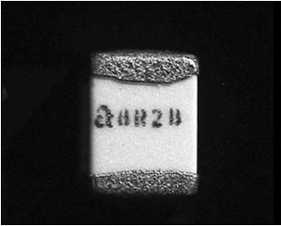  1 | 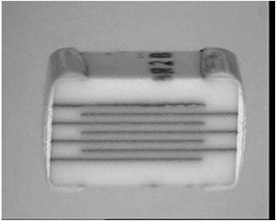  2
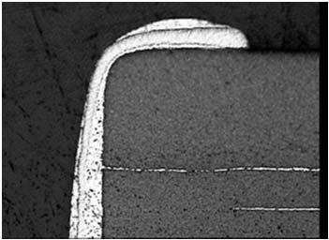  3 | 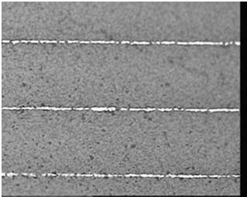  4
IMAGE INDEX:
            - Capacitor marking.
            - Capacitor in microsection.
            - Capacitor termination in microsection.
            - Capacitor plates in microsection.

APPENDIX A1.2 - MINIMUM DPA FLOW REQUIREMENTS FOR CAPACITORS, CERAMIC, LEADED
Test  Sequence | Test Description | Test Method | Sample  Allocation
1 | External Visual Inspection | ESCC Basic Specification  No. 20500 | 3 Parts
2 | Photographic Record | Appendix A1.2 | 1 Part
3 | Radiographic Inspection | ESCC Basic Specification  No. 20900 | 3 Parts
4 | Verification of Lead  Material Finish | ESCC Basic Specification  No. 25500 Note 4 | 1 Part
5 | Marking Permanence | ESCC Basic Specification  No. 24800 | 3 Parts
6 | Solderability | MIL-STD-202 Method 208 | 3 Parts
7 | Terminal Strength Test | MIL-STD-202 Method 211 | 3 Parts
8 | De-encapsulation | Note 1 | 2 Parts
9 | Internal Visual Inspection | ESCC Basic Specification  No. 20400 | 2 Parts
10 | Photographic Record | Appendix A1.2 | 1 Part
11 | Microsectional Analysis | ESCC Basic Specification  No. 20400 & 23400  Note 2, 3 | 3 Parts
12 | Photographic Record | Appendix A1.2 | 1 Part
13 | DPA Report | Para. 6.3 | 3 Parts
NOTES:
            - The encapsulant shall be removed using a suitable solvent.
            - The samples shall be encapsulated in a clear epoxy resin and microsectioned to the middle of the component. Two capacitors shall be microsectioned in the longitudinal axis of the lead-outs and one across the longitudinal axis of the lead-outs.
            - The dielectric thickness shall be verified to be a minimum of 0.2mm (ref. JPL-D-20348).
            - Operation not required if it has been already performed as part of the Incoming Inspection, or any other previous validation step.
A1.2 - IMAGES REQUIRED FOR DPA REPORT
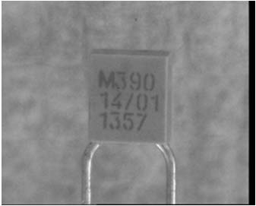  1 | 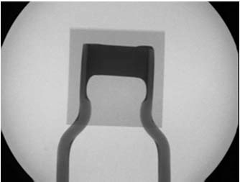  2 | 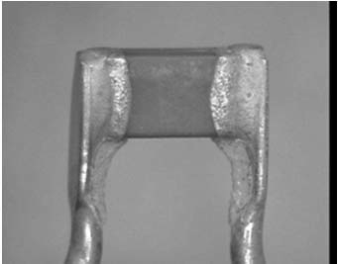  3
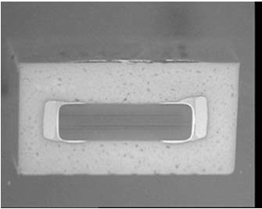  4 | 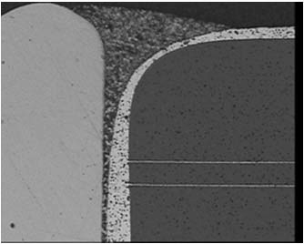  5 | 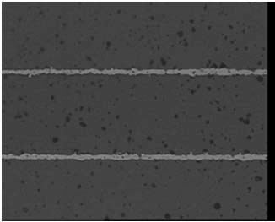  6
IMAGE INDEX:
            - Capacitor marking.
            - Radiographic image.
            - De-encapsulated sample.
            - Encapsulated capacitor in microsection.
            - Lead-out – solder – termination in microsection.
            - Ceramic and plates in microsection.

APPENDIX A1.3 - MINIMUM DPA FLOW REQUIREMENTS FOR CAPACITORS, TANTALUM, SOLID, HERMETIC
Test  Sequence | Test Description | Test Method | Sample  Allocation
1 | External Visual Inspection | ESCC Basic Specification  No. 20500 | 3 Parts
2 | Photographic Record | Appendix A1.3 | 1 Part
3 | Verification of Lead  Material Finish | ESCC Basic Specification  No. 25500 Note 4 | 1 Part
4 | Marking Permanence  Note 1 | ESCC Basic Specification  No. 24800 | 3 Parts
5 | Radiographic Inspection | ESCC Basic Specification  No. 20900 | 3 Parts
6 | Hermetic Seal Tests  Note 1 | MIL-STD-202 Method 112 | 3 Parts
7 | Solderability | MIL-STD-202 Method 208 | 3 Parts
8 | Terminal Strength Test | MIL-STD-202 Method 211 | 3 Parts
9 | Microsectional Analysis  Note 2 | ESCC Basic Specification  No. 20400  Note 3 | 3 Parts.
10 | Photographic Record | Appendix A1.3 | 1 Part
11 | DPA Report | Para. 6.3 | 3 Parts
NOTES:
            - The insulating sleeve shall be removed before performing the hermetic seal and marking permanence test.
            - The samples shall be embedded in a clear epoxy resin and shall be microsectioned parallel to the longitudinal axis of the capacitor. Once a “window” has been cut through the casing the interior cavity shall be back filled with clear epoxy resin.
            - The inspection shall also ensure that:
- There is a metallurgical bond between the tantalum anode wire and the anode lead-out and the weld is free of voids and cracks.
- The solder used to seal the anode eyelet is wetted to the anode lead-out and the eyelet and is free of voids and cracks. There shall be no solder protruding into the cavity.
- The solder used to attach the silver plated tantalum slug to the case (cathode) is wetted to the slug and the case and is free of voids and cracks.
- There are no bubbles, cracks or chip-outs in the anode glass seal.
- There is a metallurgical bond between the case and the cathode lead-out and the weld is free of voids and cracks.
            - Operation not required if it has been already performed as part of the Incoming Inspection, or any other previous validation step.
A1.3 - IMAGES REQUIRED FOR DPA REPORT
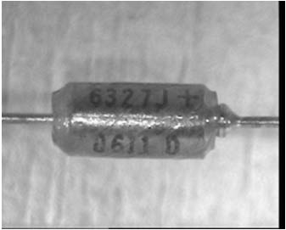  1 | 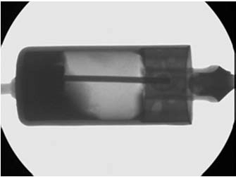  2 | 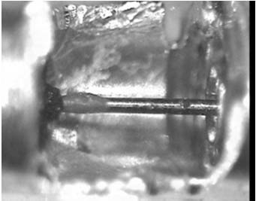  3
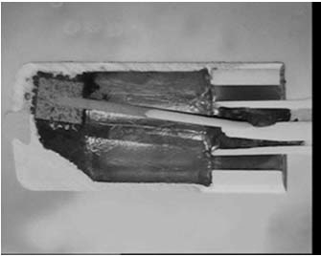  4 | 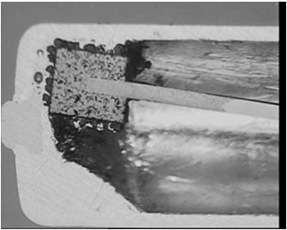  5 | 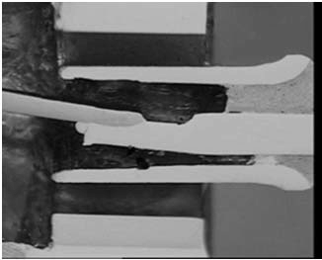  6
IMAGE INDEX:
            - Capacitor with insulating sleeve in-situ.
            - Radiographic image.
            - Window in the case showing the tantalum anode spike.
            - Capacitor in microsection.
            - Detail of the tantalum “slug” and the cathode attachment in microsection.
            - Detail of the anode spike weld to the anode lead-out and the solder fill of the anode eyelet in microsection.

APPENDIX A1.4 - MINIMUM DPA FLOW REQUIREMENTS FOR CAPACITORS, TANTALUM, SOLID, SURFACE MOUNT
Test  Sequence | Test Description | Test Method | Sample  Allocation
1 | External Visual Inspection | ESCC Basic Specification  No. 20500 | 3 Parts
2 | Photographic Record | Appendix A1.4 | 1 Part
3 | Verification of Lead  Material Finish | ESCC Basic Specification  No. 25500 Note 6 | 1 Part
4 | Marking Permanence | ESCC Basic Specification  No. 24800 | 3 Parts
5 | Radiographic Inspection  Note 1 | ESCC Basic Specification  No. 20900 | 3 Parts
6 | Solderability | MIL-STD-202 Method 208 | 3 Parts
7 | Terminal Strength Test | MIL-STD-202 Method 211 | 3 Parts
8 | Microsectional Analysis  Notes 2, 3, 4 | ESCC Basic Specification  No. 20400  Note 5 | 3 Parts.
9 | Photographic Record | Appendix A1.4 | 1 Part
10 | DPA Report | Para. 6.3 | 3 Parts
NOTES:
            - There is considerable variation between part types and manufacturers in the connection of the tantalum anode wire to the anode termination. Radiographic inspection shall be used to establish what type of assembly the samples have.
            - There are also two common types of encapsulation, moulded epoxy (Images 1 & 2 below) and epoxy coated (Image 3 below),
            - The samples shall be embedded in a clear epoxy resin in a plane which provides the most information about the weld between the tantalum anode spike and the anode termination.
            - The DPA facility shall take precautions to maintain the integrity of the layers of material of varying hardness around the tantalum slug.
            - The inspection shall also ensure that:
- There is a metallurgical bond between the tantalum anode wire and the anode termination and the weld is free of voids and cracks.
- The silver conductive epoxy used to attach the tantalum slug to the cathode termination is free of cracks and separation of the silver particles.
- The silver conductive epoxy is present over at least 50% of the available attachment area.
- There is a clear separation between the silver conductive epoxy of the cathode attachment and the anode.
- There are no gaps, pin holes, cracks or chip-outs in the encapsulation which reduce the effective thickness of the encapsulant by > 50%.
            - Operation not required if it has been already performed as part of the Incoming Inspection, or any other previous validation step.
A1.4 - IMAGES REQUIRED FOR DPA REPORT
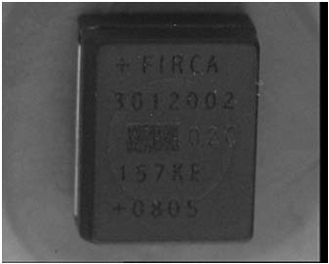  1 | 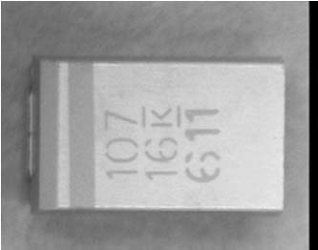  2 | 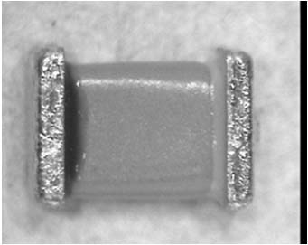  3
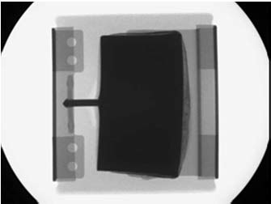  4 | 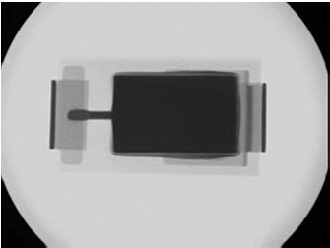  5 | 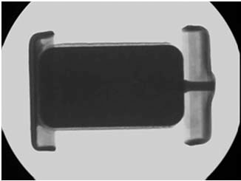  6
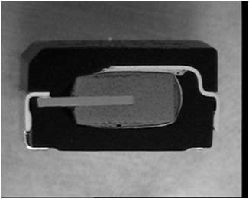  7 | 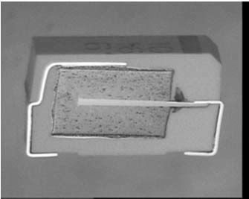  8 | 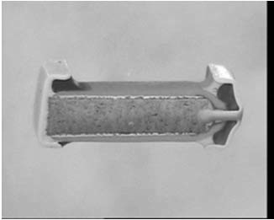  9
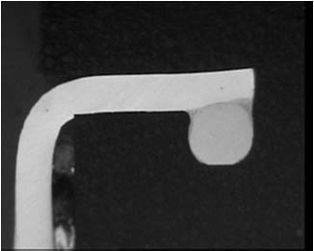  10 | 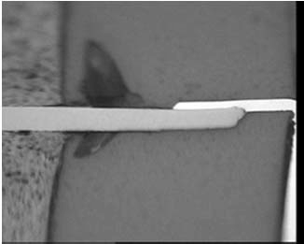  11 | 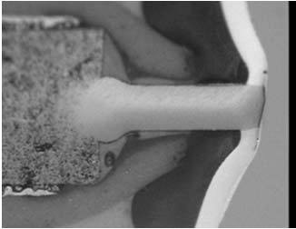  12
NOTES:
          - The images should be read vertically for the report for a specific capacitor style.
          - Images 1 to 3 show different styles of surface mount solid tantalum capacitors.
          - Images 4 to 6 are radiographic images showing different anode connections.
          - Images 7 to 9 are microsection images showing different types of assemblies.
          - Images 10 to 12 are microsection images showing different anode connections.

APPENDIX A1.5 - MINIMUM DPA FLOW REQUIREMENTS FOR CAPACITORS, TANTALUM, WET, HERMETIC
Test  Sequence | Test Description | Test Method | Sample  Allocation
1 | External Visual Inspection | ESCC Basic Specification  No. 20500 | 3 Parts
2 | Photographic Record | Appendix A1.5 | 1 Part
3 | Verification of Lead  Material Finish | ESCC Basic Specification  No. 25500 Note 5 | 1 Part
4 | Marking Permanence  Note 1 | ESCC Basic Specification  No. 24800 | 3 Parts
5 | Radiographic Inspection | ESCC Basic Specification  No. 20900 | 3 Parts
6 | Hermetic Seal Tests  Note 1 | MIL-STD-202 Method 112 | 3 Parts
7 | Solderability | MIL-STD-202 Method 208 | 3 Parts
8 | Terminal Strength Test | MIL-STD-202 Method 211 | 3 Parts
9 | Disassembly  Notes 2, 3 | - | 2 Parts
10 | Internal Visual Inspection | ESCC Basic Specification  No. 20400  Note 5 | 2 Parts
11 | Photographic Record | Appendix A1.5 | 2 Parts
12 | Microsectional Analysis  Notes 2, 4 | ESCC Basic Specification  No. 20400  Note 6 | 1 Part
13 | Photographic Record | Appendix A1.5 | 1 Part
14 | DPA Report | Para. 6.3 | 3 Parts
NOTES:
            - The insulating sleeve shall be removed before performing the hermetic seal and marking permanence test.
            - The electrolyte used in wet tantalum capacitors is acidic. When performing DPA the acid must be handled using all appropriate state or European directives for the handling and disposal of hazardous materials. Neutralisation of the acid is strongly recommended.
            - Disassembly may be achieved by cutting through the case around the anode end of the capacitor to a depth equivalent to the thickness of the case. The tantalum slug and anode may then be withdrawn.
            - The sample shall be embedded in a clear epoxy resin and microsectioned parallel to the longitudinal axis of the capacitor. Initially a “window” shall be ground through the case and the acid removed. The cavity exposed shall be back filled with more epoxy and the section continued to the centre of the part.
            - Operation not required if it has been already performed as part of the Incoming Inspection, or any other previous validation step.
            - The inspection shall also ensure that:
- Electrolyte is present in the cavity and each DPA sample contains a similar amount of electrolyte.
- There is no foreign material or particles in the electrolyte.
- The Teflon (or similar) spacers are correctly positioned above and around the tantalum slug.
- The anode glass seal is not cracked or broken.
- There are no broken lead-outs, cracked or damaged welds.
A1.5 - IMAGES REQUIRED FOR DPA REPORT
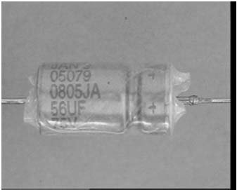  1 | 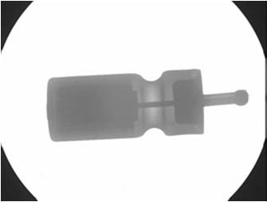  2 | 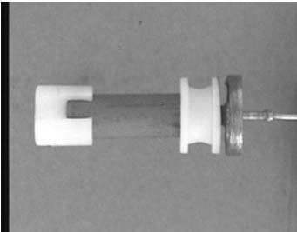  3
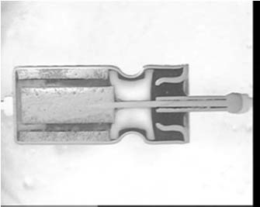  4 | 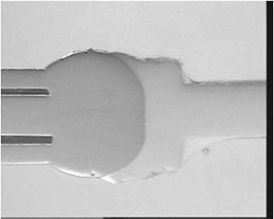  5 | 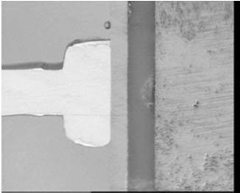  6
IMAGE INDEX:
            - Capacitor with insulating sleeve in place.
            - Radiographic image of a wet tantalum capacitor.
            - Disassembled wet tantalum capacitor.
            - Microsectioned wet tantalum capacitor.
            - Microsectional image of the weld between the tantalum anode and the lead-out.
            - Microsectional image of the weld between the tantalum case and the cathode lead-out.

APPENDIX A1.6 - MINIMUM DPA FLOW REQUIREMENTS FOR CAPACITORS, VARIABLE
Test  Sequence | Test Description | Test Method | Sample  Allocation
1 | External Visual Inspection | ESCC Basic Specification  No. 20500 | 3 Parts
2 | Photographic Record | Appendix A1.6 | 1 Part
3 | Verification of Lead  Material Finish | ESCC Basic Specification  No. 25500 Note 5 | 1 Part
4 | Marking Permanence | ESCC Basic Specification  No. 24800 | 3 Parts
5 | Hermetic Seal Tests  (Where Applicable) | Detail Specification | 3 Parts
6 | Solderability | MIL-STD-202 Method 208 | 3 Parts
7 | Terminal Strength Test | MIL-STD-202 Method 211 | 3 Parts
8 | Disassembly  Notes 1, 2 | - | 2 Parts
9 | Internal Visual Inspection | ESCC Basic Specification  No. 20400  Note 4 | 2 Parts
10 | Microsectional Analysis  Note 3 | ESCC Basic Specification  No. 20400  Note 4 | 1 Part
11 | Photographic Record | Appendix A1.6 | 1 Part
12 | DPA Report | Para. 6.3 | 3 Parts
NOTES:
            - Disassembly is achieved by rotating the rotor screw anti-clockwise until the rotor assembly is completely disengaged.
            - The capacitors shall be disassembled over a clean sheet of white paper and any particles shall be collected and examined.
            - The capacitor shall be embedded in a clear epoxy resin and shall be microsectioned in a plane parallel to the longitudinal axis of the capacitor.
            - The inspection shall also ensure that:
- There are no loose particles in the rotor or stator.
- The rotor and stator are concentric and there is no corrosion, bending, distortion, misalignments or irregularities such as burrs, bumps and nicks.
- There are no burrs, scratches or particles in the screw threaded areas.
- There is no blistering, flaking, bubbles, pits, cracks, or peeling of plated surfaces.
- The ceramic tube is correctly seated in the solder and the solder is free of voids, cracks and dewetting.
- There are no cracks in the ceramic tube.
            - Operation not required if it has been already performed as part of the Incoming Inspection, or any other previous validation step.
A1.6 - IMAGES REQUIRED FOR DPA REPORT
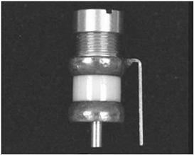  1 | 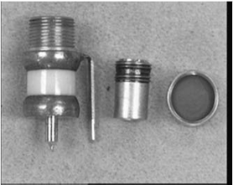  2 | 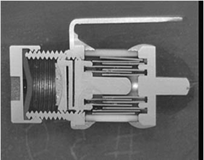  3
IMAGE INDEX:
            - Typical variable capacitor.
            - Capacitor with cap and rotor removed.
            - Capacitor in microsection with the rotor in-situ.

APPENDIX A1.7 - MINIMUM DPA FLOW REQUIREMENTS FOR CAPACITORS, FILTER
Test  Sequence | Test Description | Test Method | Sample  Allocation
1 | External Visual Inspection | ESCC Basic Specification  No. 20500 | 3 Parts
2 | Photographic Record | Appendix A1.7 | 1 Part
3 | Verification of Lead Finish | ESCC Basic Specification  No. 25500 Note 5 | 1 Part
4 | Radiographic Inspection | ESCC Basic Specification  No. 20900 | 3 Parts
5 | Marking Permanence | ESCC Basic Specification  No. 24800 | 3 Parts
6 | Solderability | MIL-STD-202 Method 208 | 3 Parts
7 | Terminal Strength Test | MIL-STD-202 Method 211 | 3 Parts
8 | Hermeticity (Where  Applicable) | MIL-STD-202 Method 112 | 3 Parts
9 | Microsectional Analysis  Notes 1, 2, 3 | ESCC Basic Specification  No. 20400  Note 4 | 3 Parts
10 | Photographic Record | Appendix A1.7 | 1 Part
11 | DPA Report | Para. 6.3 | 3 Parts
NOTES:
            - The samples shall be embedded in a thermo-setting epoxy resin and shall be ground and polished to reveal the internal structure including ceramic to metal bonds, solder joints, glass seals and epoxy fillings. If the filter is found to have a cavity this shall be back filled before continuing the microsection.
            - Two samples shall be microsectioned parallel to the plane of the longitudinal axis of the part to the centre of the part.
            - One sample shall be microsectioned in a plane transverse to the longitudinal axis to the centre of the discoidal capacitor.
            - The inspection shall also ensure that:
- There is no evidence of cracks or chips in any glass seals.
- There are no voids in any potting material which might allow movement of the internal components.
- The ceramic discoidal capacitor(s) meet the requirements of ESCC Basic Specification No. 24800.
- At least 240° of the circumference of the discoidal capacitor shall be soldered or bonded with a conductive epoxy (as appropriate) to the shell of the filter connector.
- At least 20% of the discoidal capacitor shall be soldered or bonded with a conductive epoxy (as appropriate) to the central conductor of the filter connector.
- There is no evidence of cracked, cold or de-wetted solder joints.
- There is no misalignment > 10° of capacitive and inductive elements (when included)
- with respect to the shell of the connector.
- Any inductor ferrite cores are free of chips and cracks.
- Any inductor wires are insulated from the connector shell and the ferrite core and have adequate stress relief.
- The interior of the filter is free from solder balls and other foreign material.
- When appropriate the solder in the eyelet or tubelet shall fill 50% of the eyelet or tubelet and shall be free of cracks and dewetting.
            - Operation not required if it has been already performed as part of the Incoming Inspection, or any other previous validation step.
A1.7 - IMAGES REQUIRED FOR DPA REPORT
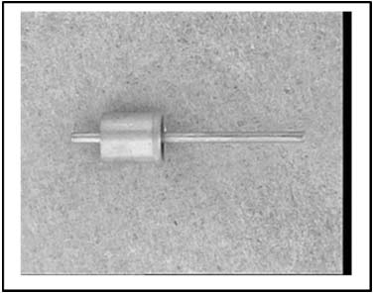  1 | 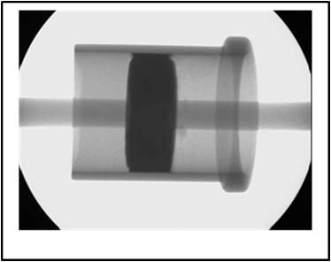  2 | 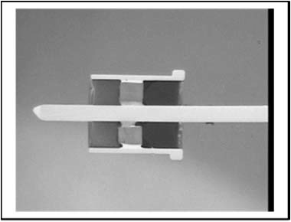  3
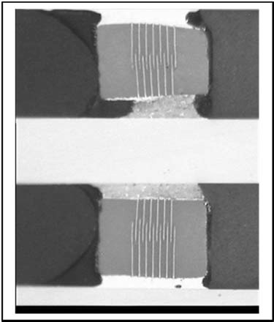  4 | 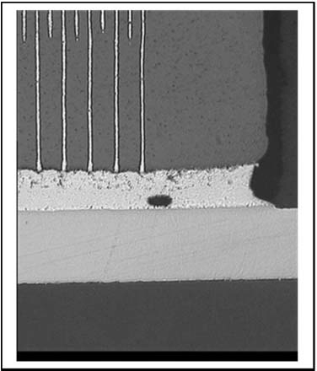  5
IMAGE INDEX:
            - Example of a filter connector.
            - Radiographic image of a filter connector.
            - Filter connector in microsection showing the disc capacitor.
            - Filter connector in microsection showing the disc capacitor attachment.
            - Filter connector in microsection showing the disc capacitor metallisation.

APPENDIX A1.8 - MINIMUM DPA FLOW REQUIREMENTS FOR CAPACITOR, PLASTIC FILM
Test  Sequence | Test Description | Test Method | Sample  Allocation
1 | External Visual Inspection | ESCC Basic Specification  No. 20500 | 3 Parts
2 | Photographic Record | Appendix A1.8 | 1 Part
3 | Verification of Lead  Material Finish | ESCC Basic Specification  No. 25500 Note 3 | 1 Part
4 | Radiographic Inspection | ESCC Basic Specification  No. 20900 | 3 Parts
5 | Marking Permanence | ESCC Basic Specification  No. 24800 | 3 Parts
6 | Solderability | MIL-STD-202 Method 208 | 3 Parts
7 | Terminal Strength Test | MIL-STD-202 Method 211 | 3 Parts
8 | Microsectional Analysis  Note 1 | ESCC Basic Specification  No. 20400  Note 4 | 1 Part
9 | Photographic Record | Appendix A1.8 | 1 Part
10 | DPA Report | Para. 6.3 | 3 Parts
NOTES:
            - The samples shall be embedded in a thermo-setting epoxy resin and shall be ground and polished parallel to the longitudinal axis of the capacitor to reveal the internal structure particularly the attachment of the lead outs to the capacitor film.
            - The inspection shall ensure that:
- There is no run down of solder in the rolled plastic film or end spray metallisation.
- There are no loose or broken lead wires or broken solder joints to the foil end spray metallisation.
- There is no contamination or foreign material embedded in between the windings of the capacitor element.
- There are no burnt or charred regions in the capacitor element which damage the dielectric.
- There are no scratches or cracks in the plastic film.
- There are no folds, blisters or wrinkles in the plastic film.
- The end spray metallisation provides at least 75% area contact to all turns of the plastic film winding and there is no evidence of poor adhesion of the spray to the plastic film or to the lead out attachment.
- There are no voids or holes in the end seal.
            - Operation not required if it has been already performed as part of the Incoming Inspection, or any other previous validation step.
A1.8 - IMAGES REQUIRED FOR DPA REPORT
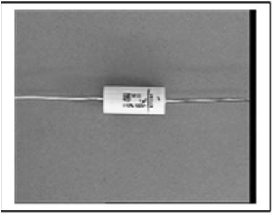  1 | 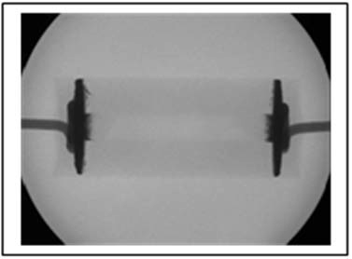  2 | 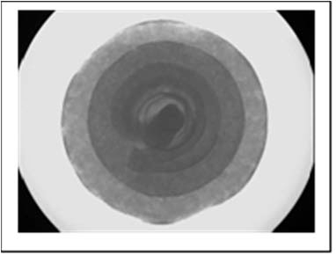  3
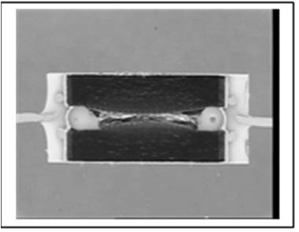  4 | 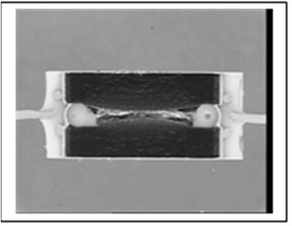  5
IMAGE INDEX:
            - Example of a plastic film capacitor.
            - Radiographic image showing the lead out attachment and “spray” penetration.
            - Radiographic image showing the winding of the plastic film.
            - Capacitor in microsection.
            - Detail of the lead out attachment and “spray” penetration.

APPENDIX A2.1 - MINIMUM DPA FLOW REQUIREMENTS FOR CONNECTOR CONTACTS AND FILTERED CONTACTS
Test  Sequence | Test Description | Test Method | Sample  Allocation
1 | External Visual Inspection | ESCC Basic Specification  No. 20500 | 3 Parts
2 | Photographic Record | Appendix A2.1 | 1 Part
3 | Verification of Surface  Material Finish | MIL-STD-1580 Requirement 9 | 1 Part
4 | Marking Permanence | ESCC Basic Specification  No. 24800 | 3 Parts
5 | Solderability (Where Applicable)  Crimp Test (Where Applicable) | MIL-STD-202 Method 208  ECSS-Q-ST-70-26 | 3 Parts
6 | Visual Inspection | ESCC Basic Specification  No. 20500 | 3 Parts
7 | Microsectional Analysis  Note 1 | ESCC Basic Specification  No. 20400  Notes 2, 3 | 1 Part
8 | Photographic Record | Appendix A2.1 | 1 Part
9 | DPA Report | Para. 6.3 | 3 Parts
NOTES:
            - The samples shall be embedded in a thermo-setting epoxy resin and shall be ground and polished parallel to the longitudinal axis of the contact to reveal the internal structure including any plating finishes. It may be necessary to backfill the space between the connector pin and the ferrite tube of filtered connector contacts.
            - The inspection shall ensure that:
- Any plating(s) are continuous and bonded to the underlying material.
- Where applicable the plating thicknesses are as specified.
            - In addition, for filter connector contacts, the inspection shall also ensure that:
- The cylindrical capacitor and the ferrite tube are free of cracks.
- The solder joint between the capacitor and the contact is continuous and free of voids.
- The ground electrode is continuous, and free of contamination and corrosion.
A2.1 - IMAGES REQUIRED FOR DPA REPORT
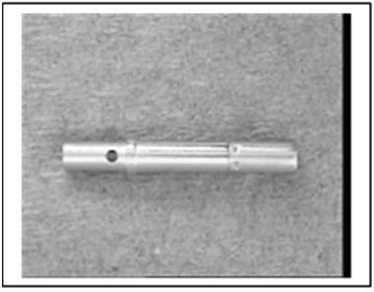  1 | 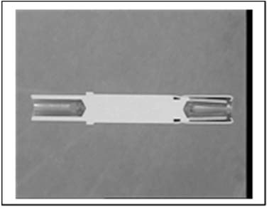  2 | 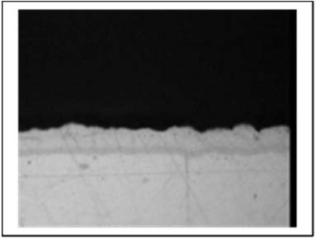  3
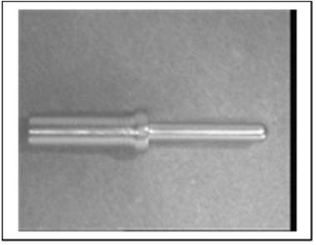  4 | 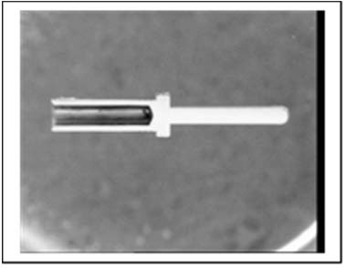  5 | 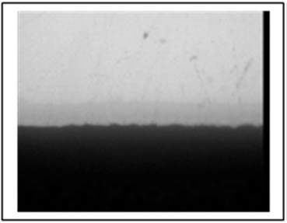  6
IMAGE INDEX:
            - Female connector pin.
            - Female connector pin in microsection.
            - Female connector pin in microsection, plating finish.
            - Male connector pin.
            - Male connector pin in microsection.
            - Male connector pin microsection plating finish.

APPENDIX A2.2 - MINIMUM DPA FLOW REQUIREMENTS FOR CONNECTORS, MULTI-PIN
Test  Sequence | Test Description | Test Method | Sample  Allocation
1 | External Visual Inspection | ESCC Basic Specification  No. 20500 | 3 Parts
2 | Photographic Record | Appendix A2.2 | 1 Part
3 | Verification of Material  Finish | ESCC Basic Specification  No. 25500 Note 4 | 1 Part
4 | Marking Permanence | ESCC Basic Specification  No. 24800 | 3 Parts
5 | Microsectional Analysis  Note 1 | ESCC Basic Specification  No. 20400  Notes 2, 3 | 1 Part
6 | Photographic Record | Appendix A2.2 | 1 Part
7 | DPA Report | Para. 6.3 | 3 Parts
NOTES:
            - The connector shall be embedded in epoxy resin and shall be microsectioned in a plane parallel to the plane of the pins or the pin retention clips if pins are not fitted.
            - The DPA requirements for connector pins are detailed in Appendix A2.1.
            - The inspection shall:
- Confirm that the contact retention clips are correctly installed.
- Confirm that there are no broken or damaged contact retention clip tangs.
- Any plating(s) are continuous and bonded to the underlying material.
- Confirm that the connector shell is bonded to the connector insert.
            - Operation not required if it has been already performed as part of the Incoming Inspection, or any other previous validation step.
A2.2 - IMAGES REQUIRED FOR DPA REPORT
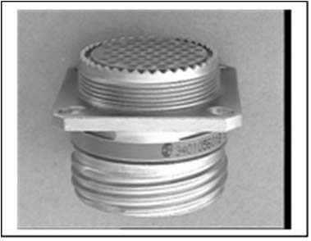  1 | 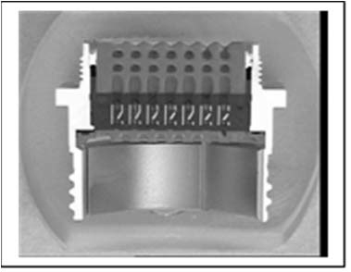  2 | 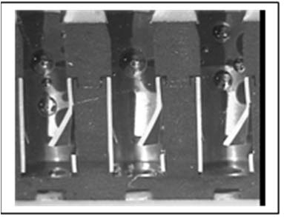  3
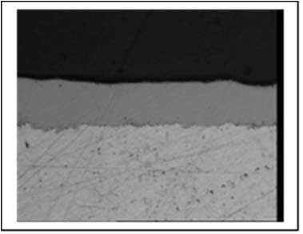  4 | 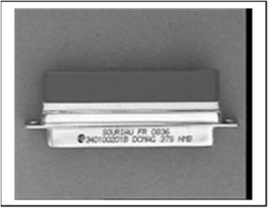  5 | 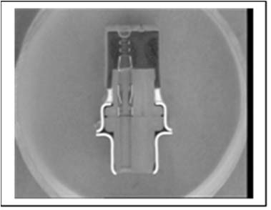  6
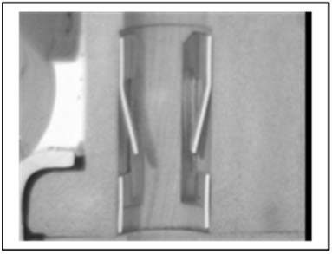  7 | 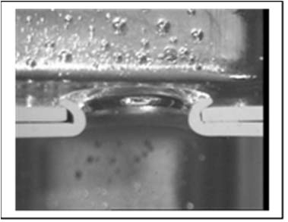  8 | 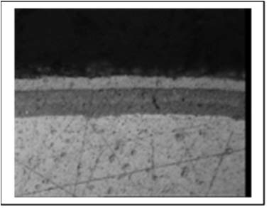  9
IMAGE INDEX:
            - Example of a circular multi-pin connector.
            - Co-axial connector in microsection showing the shell and insert.
            - Co-axial connector in microsection showing pin retention clips.
            - Co-axial connector in microsection showing plating finish.
            - Example of a rectangular multi-pin connector.
            - Edge connector in microsection showing the shell and insert.
            - Edge connector in microsection showing pin retention clips.
            - Edge connector in microsection showing shell riveting.
            - Edge connector in microsection showing plating finish.

APPENDIX A2.3 - MINIMUM DPA FLOW REQUIREMENTS FOR CONNECTORS, RF
Test  Sequence | Test Description | Test Method | Sample  Allocation
1 | External Visual Inspection | ESCC Basic Specification  No. 20500 | 3 Parts
2 | Photographic Record  Note 3 | Appendix A2.3 | 1 Part
3 | Verification of Material  Finish | ESCC Basic Specification  No. 25500 Note 5 | 1 Part
4 | Radiographic Inspection | ESCC Basic Specification  No. 20900 Note 3 | 3 Parts
5 | Marking Permanence | ESCC Basic Specification  No. 24800 | 3 Parts
6 | Microsectional Analysis  Notes 1, 2, 3 | ESCC Basic Specification  No. 20400  Note 4 | 1 Part
7 | Photographic Record | Appendix A2.3 | 1 Part
8 | DPA Report | Para. 6.3 | 3 Parts
NOTES:
            - Connectors shall be embedded in a clear epoxy resin and shall be microsectioned parallel to the longitudinal axis of the connector.
            - Where possible connectors shall be sectioned as mating pairs.
            - Radiographic Inspection shall only be performed for RF connectors with passive elements. Radiographic inspection shall be used to establish the best orientation for sectioning connectors containing passive elements, see example below.
            - The inspection shall ensure that:
- The requirements for DPA of connector pins and connectors described in Appendices A2.1 and A2.2 are met.
- Any epoxy or similar staking of the centre conductor to the connector shell is correctly engaged and is free of cracks and damage.
- Any brazed, solder or epoxy joints are well attached and are free of cracks and voids.
- The mating surfaces of the ring, shell and coupling nut are not rounded, chamfered or sloped.
            - Operation not required if it has been already performed as part of the Incoming Inspection, or any other previous validation step.
A2.3 - IMAGES REQUIRED FOR DPA REPORT
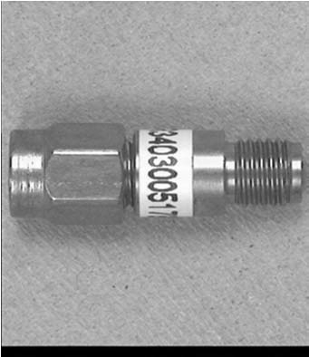  1 | 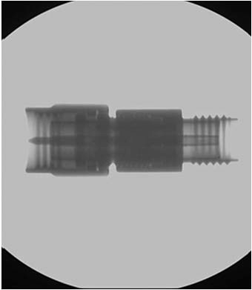  2 | 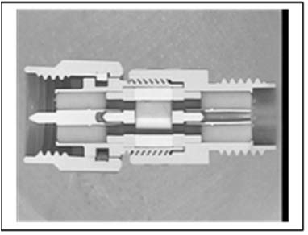  3
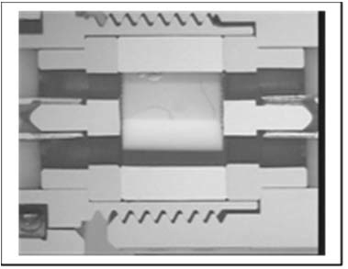  4 | 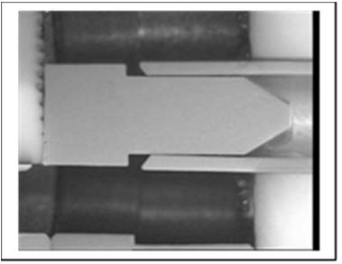  5 | 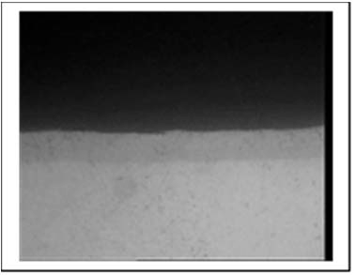  6
IMAGE INDEX:
            - Example of a RF co-axial connector.
            - Radiographic image of an RF connector.
            - RF connector in microsection showing the shell, pins and internal load.
            - RF connector in microsection showing pin inserts and load.
            - RF connector in microsection showing pin insert.
            - RF connector in microsection showing plating finish of pin.

APPENDIX A3 - MINIMUM DPA FLOW REQUIREMENTS FOR CRYSTALS
Test  Sequence | Test Description | Test Method | Sample  Allocation
1 | External Visual Inspection | ESCC Basic Specification  No. 20500 | 3 Parts
2 | Photographic Record | Appendix A3 | 1 Part
3 | Verification of Lead  Material Finish | ESCC Basic Specification  No. 25500 Note 3 | 1 Part
4 | Hermetic Seal Tests | MIL-STD-202 Method 112 | 3 Parts
5 | Radiographic Inspection | ESCC Basic Specification  No. 20900 | 3 Parts
6 | Marking Permanence Test | ESCC Basic Specification  No. 24800 | 3 Parts
7 | Solderability Test | MIL-STD-202 Method 208 | 3 Parts
8 | Terminal Strength Test | Detail Specification | 3 Parts
9 | De-encapsulation  Note 1 | - | 3 Parts
10 | Internal Visual Inspection | ESCC Basic Specification  No. 20400  Note 2 | 3 Parts
11 | Photographic Record | Appendix A3 | 1 Part
12 | DPA Report | Para. 6.3 | 3 Parts
NOTES:
            - De-encapsulation is achieved by separating the can from the header at the weld between the can and the header. During de-encapsulation great care must be taken to insure that neither the can nor the header is distorted which may stress the lead-out/crystal arm/crystal attachment/crystal.
            - The inspection shall also ensure that:
- The crystal disc is parallel to or perpendicular to the header as required by the design.
- The crystal disc is centred within the crystal supports, ±0.8mm with respect to the header.
- There are no cracks in or separation of the electrically conductive cement bonding the crystal disc to the crystal support.
- The quantities of electrically conductive cement are uniform and none is present except in the appropriate bonding areas.
- There are no cracks or voids in the weld attaching the crystal support to the lead-out.
- There is no adhering weld splatter with a dimension exceeding 0.8mm. Weld splatter is considered to be attached if it cannot be removed by a dry nitrogen gas blow of 150 kilopascal.
- There are no cracks or fractures in the crystal disc including cracked or flaked edges.
- There is no cracking, peeling or voiding of the electrodes on the crystal disc.
- There is no loose material from the weld or the conductive cement or any other foreign material on the header, the crystal disc, the lead-out, the support arm or in the can.
- There is no corrosion or contamination on any surface in the crystal can.
- There is no mechanical damage, cuts, cracks or distortion to the lead-outs or crystal supports.
- There are no cracks or bubbles in the glass seals of the header.
            - Operation not required if it has been already performed as part of the Incoming Inspection, or any other previous validation step.
A3 - IMAGES REQUIRED FOR DPA REPORT
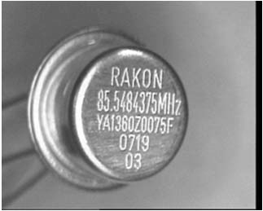  1 | 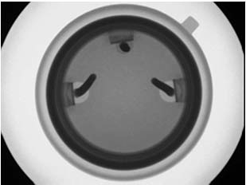  2 | 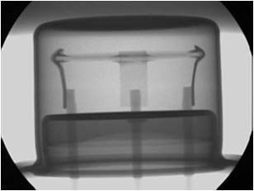  3
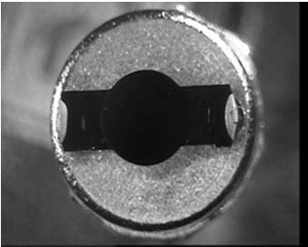  4 | 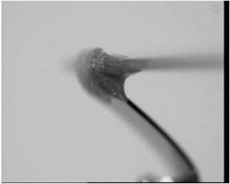  5 | 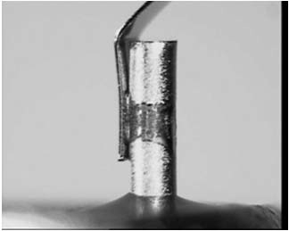  6
IMAGE INDEX:
            - A typical quartz crystal, note the marking on the can is engraved and marking permanence test is not applicable.
            - Radiographic image.
            - Radiographic image showing the assembly
            - De-encapsulated component showing the quartz crystal disc.
            - Optical image showing an example of the electrically conductive cement attachment of the quartz disc to a crystal support.
            - Optical image showing an example of the attachment of a crystal support to a lead-out.

APPENDIX A4.1 - MINIMUM DPA FLOW REQUIREMENTS FOR DIODES, AXIAL LEAD, GLASS
Test  Sequence | Test Description | Test Method | Sample  Allocation
1 | External Visual Inspection | ESCC Basic Specification  No. 20500 | 3 Parts
2 | Photographic Record | Appendix A4.1 | 1 Part
3 | Verification of Lead  Material Finish | ESCC Basic Specification  No. 25500 Note 4 | 1 Part
4 | Marking Permanence | ESCC Basic Specification  No. 24800 | 3 Parts
5 | Paint Finish On Glass Envelope Removal Note 1 | - | 3 Parts
6 | Internal Visual Inspection | ESCC Basic Specification  No. 20400 | 3 Parts
7 | Photographic Record | Appendix A4.1 | 3 Parts
8 | Hermetic Seal Test | MIL-STD-750 Method 1071  Condition D (Dye Penetrant) | 3 Parts
9 | Solderability | MIL-STD-750 Method 2026 | 3 Parts
10 | Terminal Strength Test | Detail Specification | 3 Parts
11 | Scribe And Break | MIL-STD-750 Method 2101 | 2 Parts
12 | Photographic Record | Appendix A4.1 | 2 Parts
13 | Microsectional Analysis  Note 2 | ESCC Basic Specification  No. 20400  Note 3 | 1 Part
14 | Photographic Record | Appendix A4.1 | 1 Part
15 | DPA Report | Para. 6.3 | 3 Parts
NOTES:
            - The paint finish may be removed mechanically e.g. with a scalpel or chemically using a proprietary paint and varnish stripper.
            - The sample shall be embedded in a thermo-setting epoxy resin and shall be ground and polished to reveal the internal structure including metal to metal bonds, welds, brazes, and silicon to metal bonds
            - The inspection shall also ensure that:
- The die attach used conforms to the requirements of the Detail Specification.
            - Operation not required if it has been already performed as part of the Incoming Inspection, or any other previous validation step.
A4.1 - IMAGES REQUIRED FOR DPA REPORT
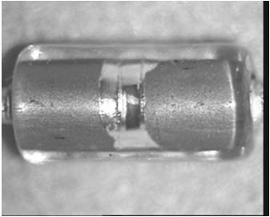  1 | 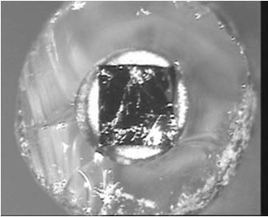  2 | 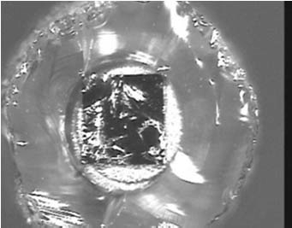  3
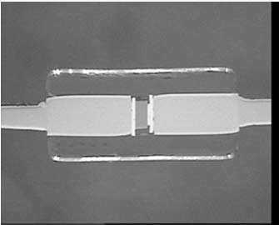  4 | 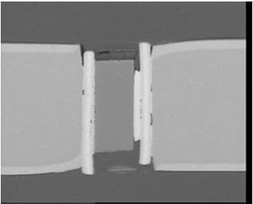  5 | 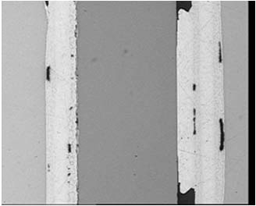  6
IMAGE INDEX:
            - Diode with paint finish removed.
            - Post crack test, anode heat sink.
            - Post crack test, cathode heat sink.
            - Diode assembly in microsection.
            - Die assembly in microsection.
            - Die attachment in microsection.

APPENDIX A4.2 - MINIMUM DPA FLOW REQUIREMENTS FOR DIODES, AXIAL LEAD, METAL CASE
Test  Sequence | Test Description | Test Method | Sample  Allocation
1 | External Visual Inspection | ESCC Basic Specification  No. 20500 | 3 Parts
2 | Photographic Record | Appendix A4.2 | 1 Part
3 | Verification of Lead Material  Finish | ESCC Basic Specification  No. 25500 Note 4 | 1 Part
4 | Hermetic Seal Tests | MIL-STD-750 Method 1071 | 3 Parts
5 | Radiographic Inspection | ESCC Basic Specification  No. 20900 | 3 Parts
6 | Marking Permanence | ESCC Basic Specification  No. 24800 | 3 Parts
7 | Solderability | MIL-STD-750 Method 2026 | 3 Parts
8 | Terminal Strength Test | Detail Specification | 3 Parts
9 | De-encapsulation  Note 1 | - | 2 Parts
10 | Internal Inspection | ESCC Basic Specification  No. 20400  Note 3 | 2 Parts
11 | Photographic Record | Appendix A4.2 | 2 Parts
12 | Microsectional Analysis  Note 2 | ESCC Basic Specification  No. 20400  Note 3 | 1 Part
13 | Photographic Record | Appendix A4.2 | 1 Part
14 | DPA Report | Para. 6.3 | 3 Parts
NOTES:
            - The part is de-encapsulated by cutting through the tube above the welds to the anode and cathode assemblies.
            - The sample shall be embedded in a thermo-setting epoxy resin and shall be ground and polished to reveal the internal structure including metal to metal bonds, welds, brazes, and silicon to metal bonds.
            - The inspection shall also ensure that:
- The anode and cathode die attach solder are free of voids, cracks and de-wetting.
- Similarly any solder joints or welds in the anode or cathode lead-outs hall be free of voids, cracks and de-wetting.
            - Operation not required if it has been already performed as part of the Incoming Inspection, or any other previous validation step.
A4.2 - IMAGES REQUIRED FOR DPA REPORT
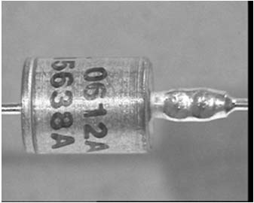  1 | 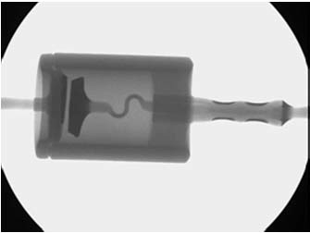  2 | 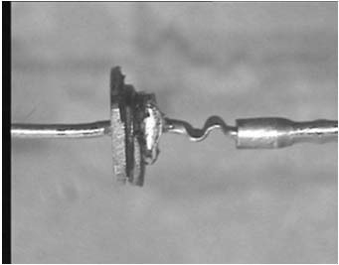  3
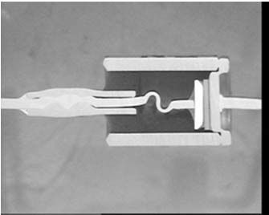  4 | 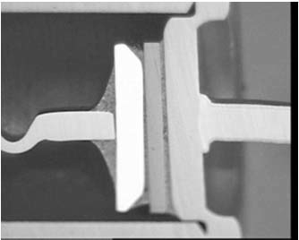  5 | 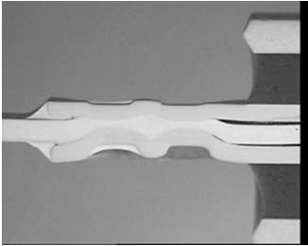  6
IMAGE INDEX:
            - Example of an axial lead metal can diode.
            - Radiographic image.
            - Diode with the case removed.
            - Diode in microsection.
            - Cathode assembly in microsection.
            - Anode assembly in microsection.

APPENDIX A4.3 - MINIMUM DPA FLOW REQUIREMENTS FOR DIODES, CHIP AND WIRE, HERMETIC
Test  Sequence | Test Description | Test Method | Sample  Allocation
1 | External Visual Inspection | ESCC Basic Specification  No. 20500 | 3 Parts
2 | Photographic Record | Appendix A4.3 | 1 Part
3 | Verification of Lead Material  Finish | ESCC Basic Specification  No. 25500 Note 2 | 1 Part
4 | Hermetic Seal Tests | MIL-STD-750 Method 1071 | 3 Parts
5 | Radiographic Inspection | ESCC Basic Specification  No. 20900 | 3 Parts
6 | Marking Permanence | ESCC Basic Specification  No. 24800 | 3 Parts
7 | Solderability | MIL-STD-750 Method 2026 | 3 Parts
8 | Terminal Strength Test | Detail Specification | 3 Parts
9 | De-encapsulation  Note 1 | - | 3 Parts
10 | Internal Inspection | ESCC Basic Specification  No. 20400 | 3 Parts
11 | Photographic Record | Appendix A4.3 | 3 Parts
12 | Wire Bond Strength Test | MIL-STD-750 Method 2037 | 3 Parts
13 | Die Shear Strength Test | MIL-STD-750 Method 2017 | 3 Parts
14 | DPA Report | Para. 6.3 | 3 Parts
NOTES:
            - The method of de-encapsulation is dependent on the type of package used:
- For standard metal can glass seal encapsulation (e.g. JEDEC TO cans) see hermetic transistors.
- For microwave diode packages the anode bond wire is often embedded in the solder used to seal the package. The de-cap options are to reflow this solder or to embed the part in epoxy resin and cut a window in the ceramic package as shown on the following pages.
            - Operation not required if it has been already performed as part of the Incoming Inspection, or any other previous validation step.
A4.3 - IMAGES REQUIRED FOR DPA REPORT
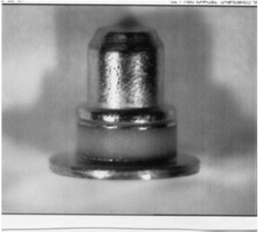  1 | 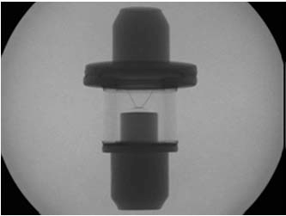  2 | 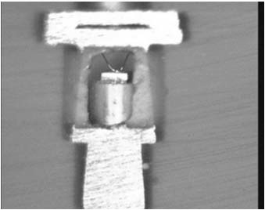  3
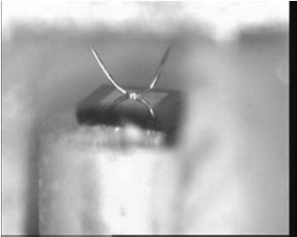  4 | 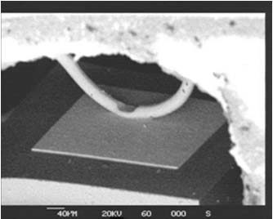  5 | 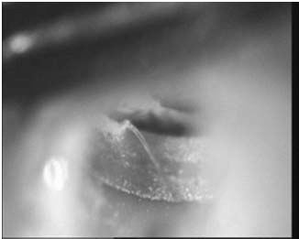  6
IMAGE INDEX:
            - Example of an hermetic chip and wire microwave diode.
            - Radiographic image of an hermetic chip and wire diode.
            - Window in the ceramic of the package revealing the inner structure.
            - Die and the anode bond and bond wire loop (Optical Image).
            - Die metallisation and anode bond (SEM Image).
            - Anode bond wire and bond to the package (Optical Image).

APPENDIX A4.4 - MINIMUM DPA FLOW REQUIREMENTS FOR DIODES, AXIAL LEADED AND SURFACE MOUNT, PLASTIC WITH SOLDER ASSEMBLY
Test  Sequence | Test Description | Test Method | Sample  Allocation
1 | External Visual Inspection | ESCC Basic Specification No. 20500 | 3 Parts
2 | Photographic Record | Appendix A4.4 | 1 Part
3 | Verification of Lead  Material Finish | ESCC Basic Specification  No. 25500 Note 5 | 1 Part
4 | Radiographic Inspection  Note 1 | ESCC Basic Specification No. 20900 | 3 Parts
5 | Scanning Acoustic  Microscopy  Note 2 | ESCC Basic Specification No. 25200 | 3 Parts
6 | Marking Permanence | ESCC Basic Specification  No. 24800 | 3 Parts
7 | Solderability | MIL-STD-750 Method 2026 | 3 Parts
8 | Terminal Strength Test | Detail Specification | 3 Parts
9 | De-Encapsulation  Note 3 | - | 2 Parts
10 | Internal Inspection | ESCC Basic Specification No. 20400  Note 6 | 2 Parts
11 | Photographic Record | Appendix A4.4 | 2 Parts
12 | Microsectional Analysis  Note 4 | ESCC Basic Specification  No. 20400  Note 6 | 1 Part
13 | Photographic Record | Appendix A4.4 | 1 Part
14 | DPA Report | Para. 6.3 | 3 Parts
NOTES:
            - There are several assembly techniques for surface mount solder assembly plastic encapsulated diodes, see following pages. Radiographic inspection shall be performed before attempting Scanning Acoustic Microscopy to identify the assembly technique used and to help establish if the SAM inspection is valid, see below.
            - SAM is limited by a number of factors:
- Curved surface on the plastic moulding; SAM is not suitable for axial lead diodes.
- Non planarity of the anode and cathode connections within the encapsulation.
- Orientation of the die i.e. anode facing up or down.
            - De-encapsulation is not the preferred option for the DPA of surface mount solder assembly plastic encapsulated diodes because the die and die attach are often masked by the anode and cathode lead frame. De-encapsulation involves a mixture of fuming nitric and sulphuric acid and must be handled with appropriate care and safety equipment. Every care must be taken to prevent damage to the internal elements of the component during de encapsulation.
            - Samples shall be embedded in a thermo-setting epoxy resin and shall be ground and polished through to the centre of the die.
            - Operation not required if it has been already performed as part of the Incoming Inspection, or any other previous validation step.
            - The inspection shall ensure that:
- The anode and cathode die attach solder are free of voids, cracks and de-wetting.
- Similarly any solder joints or welds in the anode or cathode lead frame shall be free of voids, cracks and de-wetting.
A4.4 - IMAGES REQUIRED FOR DPA REPORT
DIODE EXAMPLE 1
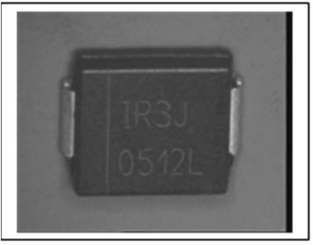  1 | 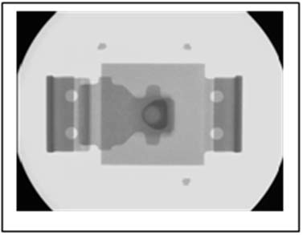  2 | 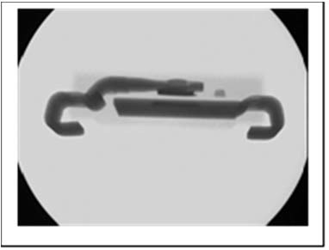  3
The concave form of the  anode immediately above the die would scatter the ultrasound signal and inhibit resolution of the anode and cathode solder joints. CSAM is therefore not applicable.  4 | 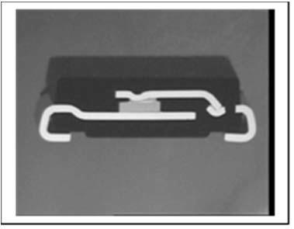  5 | 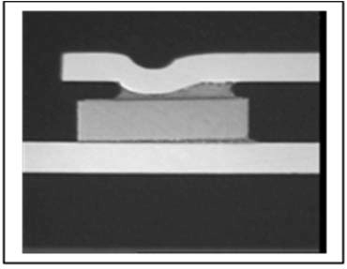  6
IMAGE INDEX:
            - Example of a surface mount solder assembly plastic encapsulated diode.
            - Radiographic image showing shapes of the anode and cathode connections.
            - Radiographic image showing the concave form of the anode connection.
            - SAM applicability.
            - Diode in microsection.
            - Diode in microsection.
DIODE EXAMPLE 2
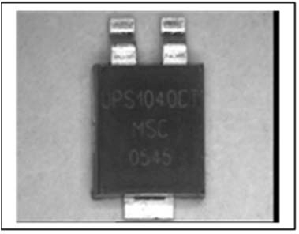  1 | 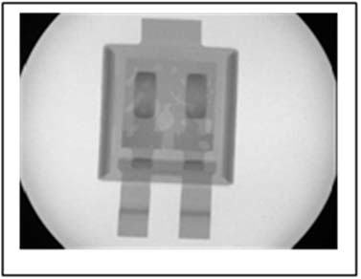  2 | 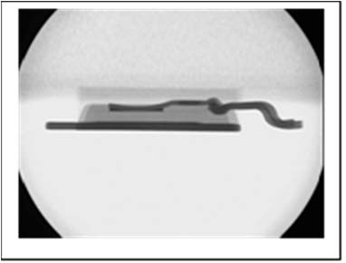  3
The presence of a silicone coating would refract the ultrasound signal giving the impression that the encapsulant was delaminated from the die.  4 | 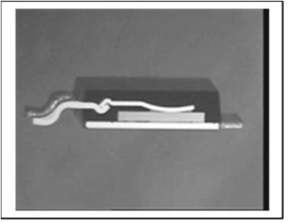  5 | 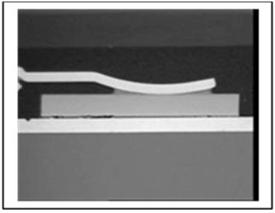  6
IMAGE INDEX:
            - Example of a surface mount solder assembly plastic encapsulated diode.
            - Radiographic image showing shapes of the anode and cathode connections.
            - Radiographic image showing the presence of a silicone coating on the die and anode connection.
            - SAM applicability.
            - Diode in microsection.
            - Diode in microsection.
DIODE EXAMPLE 3
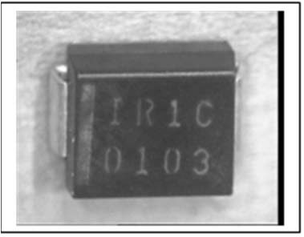  1 | 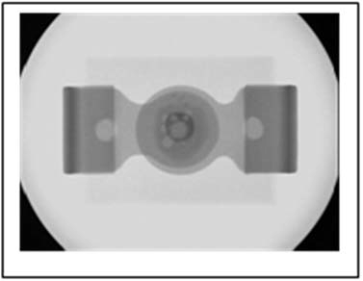  2 | 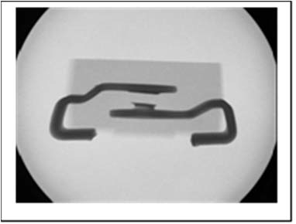  3
The concave form of the  anode and the lack of planarity would scatter the ultrasound signal and inhibit resolution of the anode and cathode solder joints. CSAM is therefore not applicable.  4 | 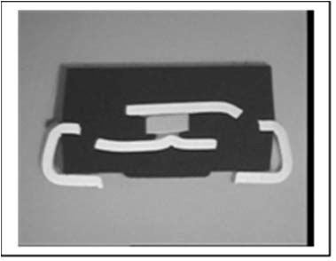  5 | 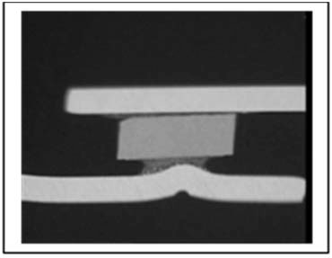  6
IMAGE INDEX:
            - Example of a surface mount solder assembly plastic encapsulated diode.
            - Radiographic image showing shapes of the anode and cathode connections.
            - Radiographic image showing the die is orientated “back side” up and the connections are not coplanar.
            - SAM applicability.
            - Diode in microsection.
            - Diode in microsection.
DIODE EXAMPLE 4
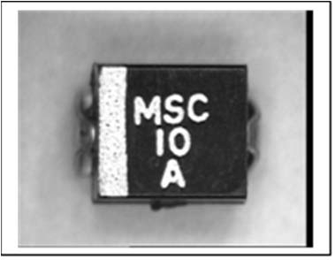  1 | 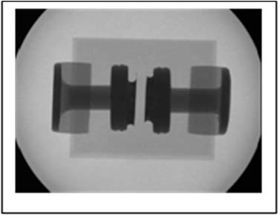  2 | 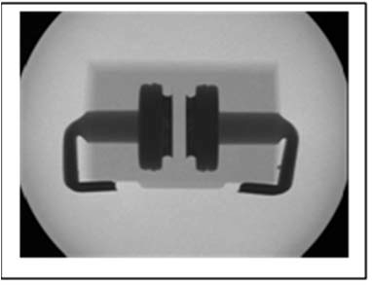  3
Although this diode has a square package all of the internal elements are circular in section and the sample is unsuitable for SAM inspection4 | 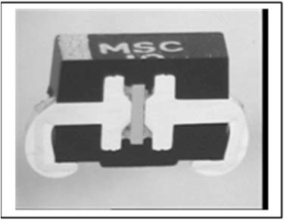  5 | 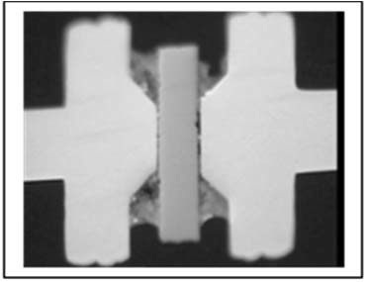  6
IMAGE INDEX:
            - Example of a surface mount solder assembly plastic encapsulated diode.
            - Radiographic image showing diode assembly is a modified axial lead structure.
            - Radiographic image confirming Note 2 above.
            - SAM applicability.
            - Diode in microsection.
            - Diode in microsection.
DIODE EXAMPLE 5
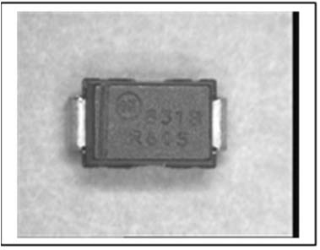  1 | 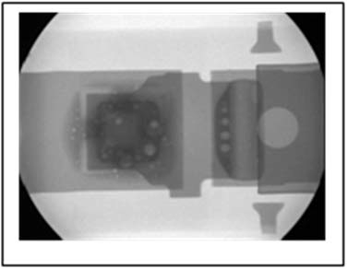  2 | 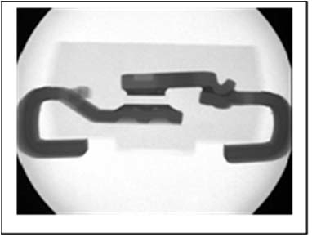  3
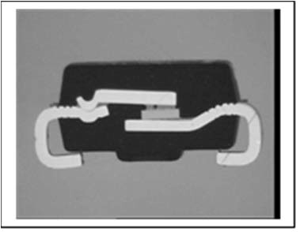  4 | 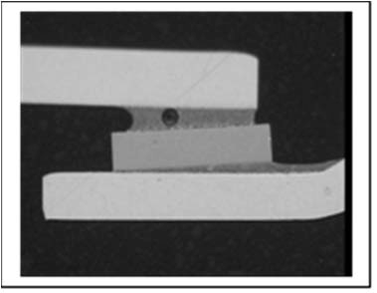  5 | 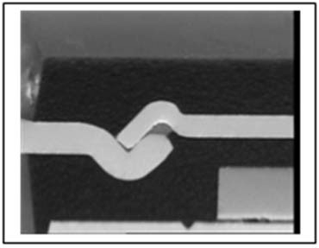  6
IMAGE INDEX:
            - Example of a surface mount solder assembly plastic encapsulated diode.
            - Radiographic image showing solder joint in the anode connection assembly.
            - Radiographic image confirming the presence of a soldered two piece anode connection.
            - Diode in microsection.
            - Die and die attach in microsection.
            - Solder joint on the two piece anode connection.

APPENDIX A4.5 - MINIMUM DPA FLOW REQUIREMENTS FOR DIODES, CHIP AND WIRE, PLASTIC
Test  Sequence | Test Description | Test Method | Sample  Allocation
1 | External Visual Inspection | ESCC Basic Specification  No. 20500 | 3 Parts
2 | Photographic Record | Appendix A4.5 | 1 Part
3 | Verification of Lead  Material Finish | ESCC Basic Specification  No. 25500 Note 5 | 1 Part
4 | Scanning Acoustic  Microscopy  Note 1 | ESCC Basic Specification  No. 25200 | 3 Parts
5 | Radiographic Inspection | ESCC Basic Specification  No. 20900 | 3 Parts
6 | Marking Permanence | ESCC Basic Specification  No. 24800 | 3 Parts
7 | Solderability | MIL-STD-750 Method 2026 | 3 Parts
8 | Terminal Strength Test | Detail Specification | 3 Parts
9 | De-Encapsulation  Notes 2, 3, 4 | ESCC Basic Specification  No. 25300  Note 3 | 3 Parts
10 | Internal Inspection | ESCC Basic Specification  No. 20400 | 3 Parts
11 | Photographic Record | Appendix A4.5 | 1 Part
12 | Wire Bond Strength Test | MIL-STD-750 Method 2037 | 3 Parts
13 | Die Shear Strength Test | MIL-STD-750 Method 2017 | 3 Parts
14 | DPA Report | Para. 6.3 | 3 Parts
NOTES:
            - Scanning acoustic microscopy may not be effective or only partially effective if:
- The moulding of the encapsulation has significant rounding of edges and corners.
- The anode and cathode lead frame elements within the encapsulation are not parallel to the top or bottom surface of the encapsulation.
            - De-encapsulation involves a mixture of fuming nitric and sulphuric acid and must be handled with appropriate care and safety equipment.
Every care must be taken to prevent damage to the internal elements of the component during de-encapsulation.
It should be noted that most plastic encapsulated diodes have silver plating on the bonding area of the lead frame. This silver plating will be rapidly degraded by the acid.
It should also be noted that some plastic encapsulated diodes have copper bond wires which will be rapidly degraded by the acid.
            - Any die identification shall be recorded and shall be verified as being appropriate to the components submitted for DPA.
Scanning Electron Microscopy (SEM) may be used to support the Internal Visual Inspection of wire bonding, see images below.
It should be noted that most plastic encapsulated chip and wire diodes have gold ball and wedge wire bonding to aluminium metallisation. This assembly technique may result in the formation of undesirable intermetallics. SEM is the preferred technique for examining the gold ball bond to aluminium die metallisation interface, see images below.
            - It should be noted that many plastic encapsulated diodes have an epoxy or polymer die attach which may be degraded by the acid used in de-encapsulation process
            - Operation not required if it has been already performed as part of the Incoming Inspection, or any other previous validation step.
A4.5 - IMAGES REQUIRED FOR DPA REPORT
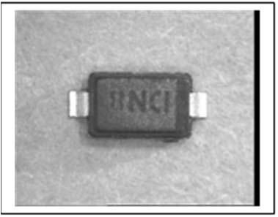  1 | 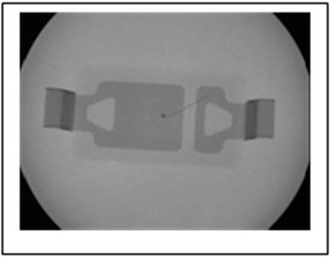  2 | 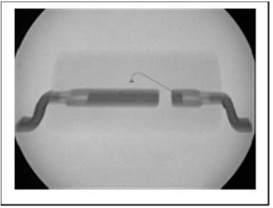  3
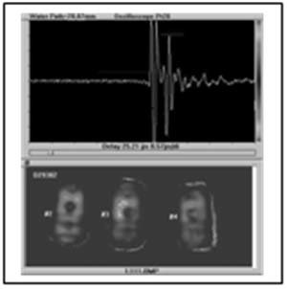  4 | 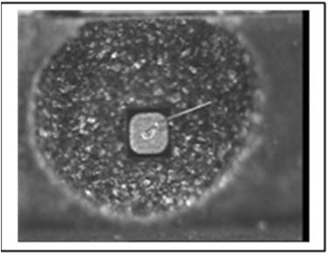  5 | 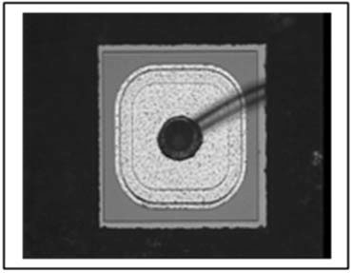  6
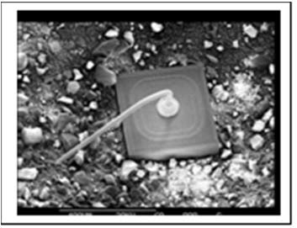  7 | 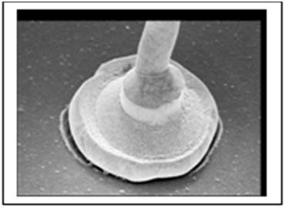  8 | 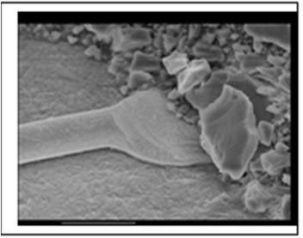  9
IMAGE INDEX:
            - Example of a plastic chip and wire diode.
            - Radiographic image of a chip and wire diode.
            - Radiographic image of a chip and wire diode.
            - SAM image of a group of three DPA samples.
            - De-encapsulated plastic chip and wire diode.
            - Surface of the diode die.
            - Bond wire dressing (SEM Image).
            - Ball bond at the die (SEM Image).
            - Wedge bond to a lead out (SEM Image).

APPENDIX A5.1 - MINIMUM DPA FLOW REQUIREMENTS FOR FUSES, WIRE, AXIAL LEADED AND SURFACE MOUNT
Test  Sequence | Test Description | Test Method | Sample  Allocation
1 | External Visual Inspection | ESCC Basic Specification No. 20500 | 3 Parts
2 | Photographic Record | Appendix A5.1 | 1 Part
3 | Verification of Material  Finish | ESCC Basic Specification  No. 25500 Note 3 | 1 Part
4 | Radiographic Inspection | ESCC Basic Specification No. 20900 | 3 Parts
5 | Marking Permanence | ESCC Basic Specification  No. 24800 | 3 Parts
6 | Solderability | MIL-STD-202 Method 208 | 3 Parts
7 | Microsectional Analysis  Note 1 | ESCC Basic Specification  No. 20400  See Note 2 | 3 Parts
8 | Photographic Record | Appendix A5.1 | 1 Part
9 | DPA Report | Para. 6.3 | 3 Parts
NOTES:
            - The samples shall be embedded in a thermo-setting epoxy resin and shall be ground and polished in a plane parallel to the longitudinal axis of the samples. When a window has been cut into the cavity an inspection of the interior shall be made to the criteria defined below. The cavity shall be back filled with epoxy and the microsection progressed to the midpoint of the end-caps.
            - The inspection shall ensure that:
- There is no evidence of corrosion of the fuse element or the end-caps.
- The fuse core is free of cracks.
- The fuse element is adequately soldered to the end-caps.
- The end-caps are adequately attached to the body of the part.
            - Operation not required if it has been already performed as part of the Incoming Inspection, or any other previous validation step.
A5.1 - IMAGES REQUIRED FOR DPA REPORT
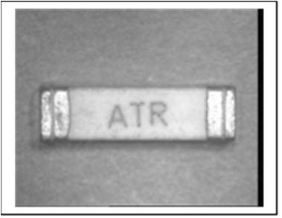  1 | 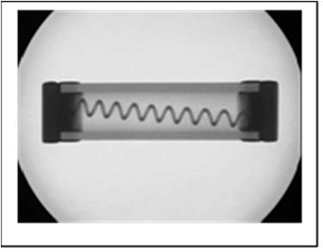  2 | 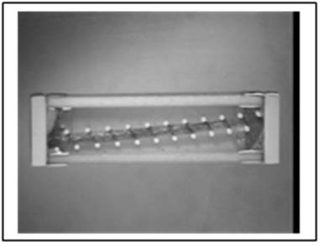  3
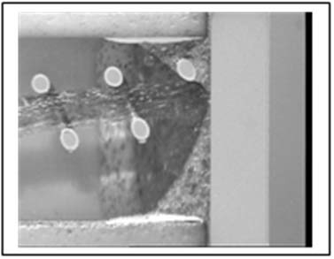
4
IMAGE INDEX:
            - Example of an axial lead fuse.
            - Radiographic image of an axial lead fuse.
            - Window in the ceramic of the fuse revealing the inner structure.
            - Detail of the solder attachment of the fuse element to the end-cap.

APPENDIX A5.2 - MINIMUM DPA FLOW REQUIREMENTS FOR FUSES, FILM, SURFACE MOUNT AND RADIAL
Test  Sequence | Test Description | Test Method | Sample  Allocation
1 | External Visual Inspection | ESCC Basic Specification No. 20500 | 3 Parts
2 | Photographic Record | Appendix A5.2 | 1 Part
3 | Verification of Material  Finish | ESCC Basic Specification  No. 25500 Note 4 | 1 Part
4 | Radiographic Inspection | ESCC Basic Specification No. 20900 | 3 Parts
5 | Terminal Strength | Detail Specification | 3 Parts
6 | Solderability | MIL-STD-202 Method 208 | 3 Parts
7 | Marking Permanence | ESCC Basic Specification No. 24800 | 3 Parts
8 | Microsectional Analysis  Note 1, 2 | ESCC Basic Specification  No. 20400  Note 3 | 3 Parts
9 | Photographic Record | Appendix A5.2 | 1 Part
10 | DPA Report | Para. 6.3 | 3 Parts
NOTES:
            - Surface mount fuses are ceramic with plated end terminations and the fuse element co-fired in the ceramic. The samples shall be embedded and microsections shall be made in a plane perpendicular to the fuse element.
            - Axial lead fuses have a ceramic substrate with the fuse element deposited on the substrate, lead out soldered to the substrate and the assembly encapsulated in an epoxy. The samples shall be embedded in a thermo-setting epoxy resin. Microsections shall be made:
- Longitudinally through one lead out.
- Transversely through the centre of the sample.
- Through the back face of the sample and the thus through the ceramic until it is sufficiently thinned to allow inspection of the fuse element.
            - The inspection shall ensure that:
- The fuse element and any coating is free from pin holes, voids and discontinuities.
- The ceramic is free of cracks and voids.
- Any solder joints are free of de-wetting, cracks and voids > 25% of the cross-sectional area of the solder joint.
            - Operation not required if it has been already performed as part of the Incoming Inspection, or any other previous validation step.
A5.2 - IMAGES REQUIRED FOR DPA REPORT
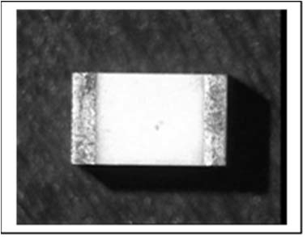  1 | 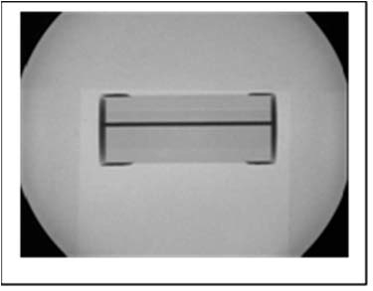  2 | 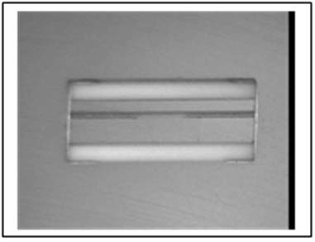  3
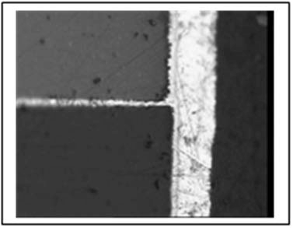
4
IMAGE INDEX:
            - Example of a surface mount fuse.
            - Radiographic image of a surface mount fuse.
            - Microsection of the fuse.
            - Detail of the fuse element to the termination.

APPENDIX A6 - MINIMUM DPA FLOW REQUIREMENTS FOR HEATERS
Test  Sequence | Test Description | Test Method | Sample  Allocation
1 | External Visual Inspection | ESCC Basic Specification No. 20500 | 3 Parts
2 | Photographic Record | Exterior of Heater | 1 Part
3 | Verification of Material  Finish | ESCC Basic Specification  No. 25500 Note 3 | 1 Part
4 | Solderability | MIL-STD-202 Method 208 | 3 Parts
5 | Marking Permanence | ESCC Basic Specification  No. 24800 | 3 Parts
6 | Terminal Strength | Detail Specification | 3 Parts
7 | Microsection  Note 1 | Note 2 | 3 Parts
8 | Photographic Record | As Applicable | 1 Part
9 | DPA Report | Para. 6.3 | 3 Parts
NOTES:
            - The samples shall be encapsulated in a thermo-setting epoxy resin and shall be ground and polished and microsection through the lead out attachment welds.
            - The inspection shall ensure that:
- There is no evidence of loosening, tearing or corrosion of the weld.
            - Operation not required if it has been already performed as part of the Incoming Inspection, or any other previous validation step.

APPENDIX A7.1 - MINIMUM DPA FLOW REQUIREMENTS FOR HYBRIDS, HERMETIC, CHIP AND WIRE, AND MCMS
Test  Sequence | Test Description | Test Method | Sample  Allocation
1 | External Visual Inspection | MIL-STD-883 Method 2009 or JESD9 (To Include Ceramic And Metal Packages) | 3 Parts
2 | Photographic Record | Appendix A7.1 | 1 Part
3 | Verification of Lead  Material Finish | ESCC Basic Specification  No. 25500 Note 4 | 1 Part
4 | Radiographic Inspection | ESCC Basic Specification  No. 20900 | 3 Parts
5 | CSAM Note 1 | MIL-STD-883 Method 2018 | 3 Parts
6 | Hermetic Seal Test | MIL-STD-883 Method 1014 (Condition A2, C) | 3 Parts
7 | Particle Impact Noise  Detection Test | MIL-STD-883 Method 2020  Condition A Note 6 | 3 Parts
8 | Marking Permanence Test | ESCC Basic Specification  No. 24800 | 3 Parts
9 | Solderability Test | MIL-STD-883 Method 2003 | 3 Parts
10 | Terminal Strength Test | Detail Specification (MIL-STD-883 Method 2004, Condition As Applicable) | 3 Parts
11 | Residual Gas Analysis  Note 5 | MIL-STD-883 Method 1018 | 3 Parts
12 | De-encapsulation  Note 2 | - | 3 Parts
13 | Internal Visual Inspection | MIL-STD-883 Method 2017  Class K Notes 2, 3 | 3 Parts
14 | SEM Inspection | ESCC Basic Specification  No. 21400. Note 3 | 1 Part
15 | Photographic Record | Appendix A7.1, Glop-Top Removal As Applicable. SEM (MIL-STD-883 Method 2018) | 1 Part
16 | Bond Strength Test | MIL-STD-883 Method 2011 | 3 Parts
17 | Photographic Record | Appendix A7.1 | 1 Part
18 | Die & Surface Mount Shear  Strength Test | MIL-STD-883 Method 2019 or  2027 As Applicable | 3 Parts
19 | DPA Report | Para. 6.3 | 3 Parts
NOTES:
            - CSAM is used to inspect die attach, die interconnect, seal integrity etc.
            - De-encapsulation shall be achieved mechanically or thermally (de-soldering) depending on the type of hermetic seal used.
The DPA operative shall be aware if beryllium oxide ceramic is used in the component and must take all appropriate health and safety precautions.
Every care shall be taken to prevent damage to the internal elements of the component during de-encapsulation.
De-encapsulation may introduce debris into the cavity all such debris shall be noted to be from the de-encapsulation process.
If the Particle Impact Noise Detection test has identified the presence of particles in the cavity every effort shall be made to recover and identify such particles.
            - Any die identification shall be recorded and shall be verified as being appropriate to the components submitted for DPA. Scanning Electron Microscopy shall be used to support the Internal Visual Inspection of wire bonding, see images below.
            - Operation not required if it has been already performed as part of the Incoming Inspection, or any other previous validation step.
            - RGA test is optional. In case the test is performed, three (3) separate units will be used, being the acceptance criteria 0 failures. In case of one failure, two additional devices can be tested. If sample size (accept number) of 5(1) is used to pass the lot, the manufacturer shall provide a reason for the failure.
            - PIND shall only be performed if it is tested or guaranteed by the Manufacturer.
A7.1 - IMAGES REQUIRED FOR DPA REPORT
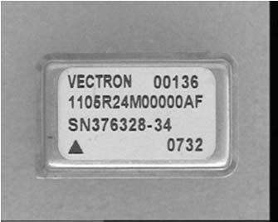  1 | 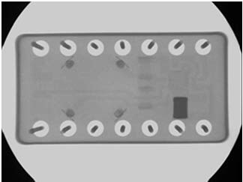  2 | 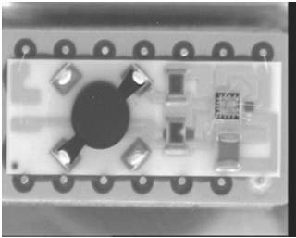  3
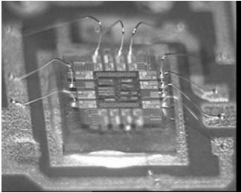  4 | 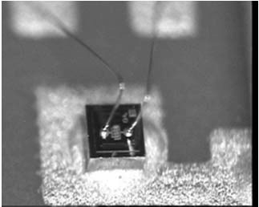  5 | 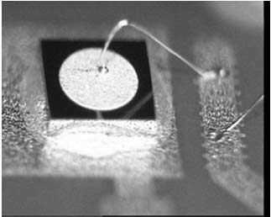  6
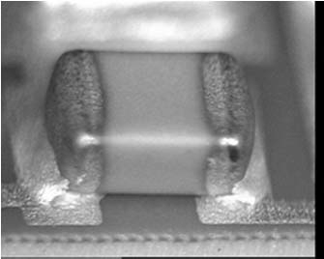  7 | 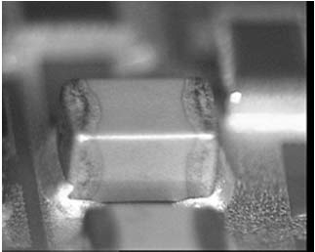  8 | 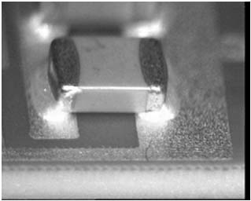  9
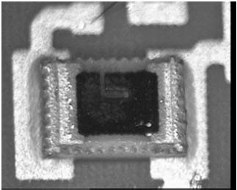  10 | 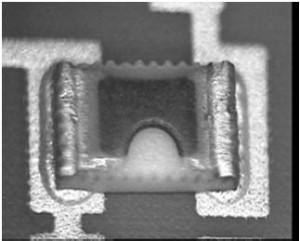  11 | 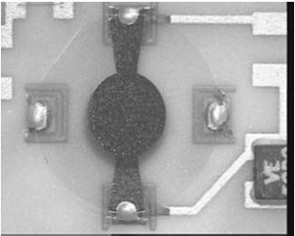  12
IMAGE INDEX:
            - Example of a hybrid (crystal oscillator).
            - Radiographic image of a hybrid.
            - De-encapsulated hybrid.
            - Example of a microcircuit die in-situ.
            - Example of a transistor die in-situ.
            - Example of a diode die in-situ.
            - Example of a surface mount chip capacitor in-situ.
            - Example of a surface mount chip capacitor in-situ.
            - Example of a surface mount chip capacitor in-situ.
            - Example of a surface mount chip resistor in-situ.
            - Example of a surface mount chip resistor in-situ.
            - Example of a quartz crystal in-situ.
NOTES:
- Detailed images of the die surface, die identification and wire bonding shall be made as for each type of die in the hybrid.
- Each type of surface mounted component shall be photographed as indicated in Appendix A as applicable to the component type.
- For crystal, details of the crystal and the crystal mounting shall be photographed as indicated in Appendix A3.

APPENDIX A7.2 - MINIMUM DPA FLOW REQUIREMENTS FOR HYBRIDS, HERMETIC, SOLDERED CONSTRUCTION
Test  Sequence | Test Description | Test Method | Sample  Allocation
1 | External Visual Inspection | MIL-STD-883 Method 2009 or JESD9 (To Include Ceramic And Metal Packages) | 3 Parts
2 | Photographic Record | Appendix A7.2 | 1 Part
3 | Verification of Lead  Material Finish | ESCC Basic Specification  No. 25500 Note 4 | 1 Part
4 | Radiographic Inspection | ESCC Basic Specification  No. 20900 | 3 Parts
5 | CSAM Note 1 | MIL-STD-883 Method 2018 | 3 Parts
6 | Hermetic Seal Test | MIL-STD-883 Method 1014 (Condition A2, C) | 3 Parts
7 | Marking Permanence Test | ESCC Basic Specification  No. 24800 | 3 Parts
8 | Solderability Test | MIL-STD-883 Method 2003 | 3 Parts
9 | Terminal Strength Test | Detail Specification (MIL-STD-883 Method 2004 Condition As  Applicable) | 3 Parts
10 | Residual Gas Analysis  Note 5 | MIL-STD-883 Method 1018 | 3 Parts
11 | De-encapsulation  Notes 2, 3 | - | 3 Parts
12 | Internal Visual Inspection | MIL-STD-883 Method 2017  And ECSS-Q-ST-70-38 (As Applicable)  Note 3 | 3 Parts
13 | Photographic Record | Appendix A7.2 and Appendix  A7.1 where applicable, Glop-Top Removal As Applicable.  SEM (MIL-STD-883 Method 2018) | 1 Part
14 | DPA Report | Para. 6.3 | 3 Parts
NOTES:
            - CSAM is used to inspect die attach, die interconnect, seal integrity etc.
            - All components incorporated in the hybrid shall be subjected to the appropriate DPA flow as described in this specification.
            - De-encapsulation may be achieved mechanically or thermally (de-soldering) depending on the type of hermetic seal used.
The DPA operative must be aware if beryllium oxide ceramic is used in the component and must take all appropriate health and safety precautions.
Every care must be taken to prevent damage to the internal elements of the component during de-encapsulation.
De-encapsulation may introduce debris into the cavity and it is essential that such debris is confirmed to be from the de-encapsulation process.
            - Operation not required if it has been already performed as part of the Incoming Inspection, or any other previous validation step.
            - RGA test is optional. In case the test is performed, three (3) separate units will be used, being the acceptance criteria 0 failures. In case of one failure, two additional devices can be tested. If sample size (accept number) of 5(1) is used to pass the lot, the manufacturer shall provide a reason for the failure.
A7.2 - IMAGES REQUIRED FOR DPA REPORT
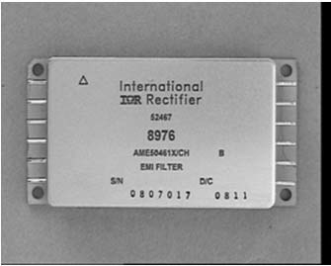  1 | 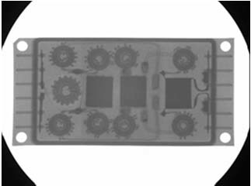  2 | 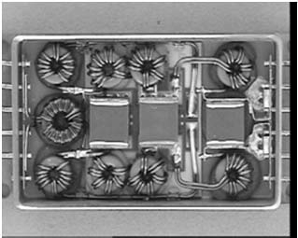  3
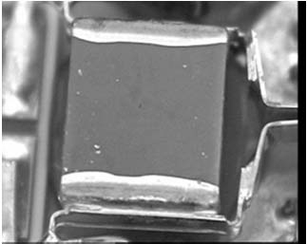  4 | 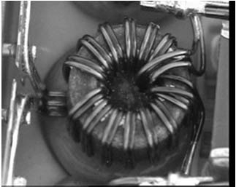  5 | 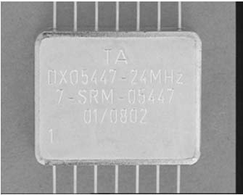  6
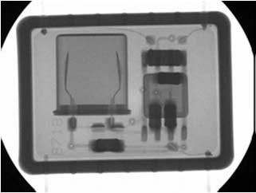  7 | 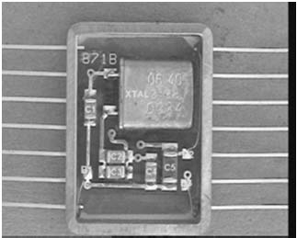  8 | 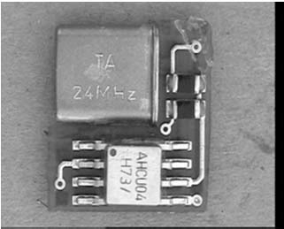  9
IMAGE INDEX:
            - Example of a solder assembly hybrid containing surface mount components.
            - Radiographic image of a solder assembly hybrid containing surface mount components.
            - De-encapsulated solder assembly hybrid containing surface mount components.
            - Example of a ceramic capacitor stack.
            - Example of a wire wound component.
            - Example of a solder assembly hybrid containing discreet components.
            - Radiographic image of a solder assembly hybrid containing discreet components.
            - De-encapsulated solder assembly hybrid containing discreet mount components.
            - PCB removed from the hybrid (opposite side from image 8).
NOTES:
          - All discrete components incorporated in the hybrid shall be photographed as indicated in
Appendix A as applicable to the component type.

APPENDIX A8.1 - MINIMUM DPA FLOW REQUIREMENTS FOR INDUCTORS, AXIAL LEAD
Test  Sequence | Test Description | Test Method | Sample  Allocation
1 | External Visual Inspection | ESCC Basic Specification  No. 20500 | 3 Parts
2 | Photographic Record | Appendix A8.1 | 1 Part
3 | Verification of Material  Finish | ESCC Basic Specification  No. 25500 Note 3 | 1 Part
4 | Radiographic Inspection | ESCC Basic Specification  No. 20900 | 3 Parts
5 | Terminal Strength Test | Detail Specification | 3 Parts
6 | Solderability | MIL-STD-202 Method 208 | 3 Parts
7 | Marking Permanence | ESCC Basic Specification  No. 24800 | 3 Parts
8 | Microsectional Analysis  Note 1 | ESCC Basic Specification  No. 20400  Note 2 | 1 Part
9 | Photographic Record | Appendix A8.1 | 1 Part
10 | DPA Report | Para. 6.3 | 3 Parts
NOTES:
            - The samples shall be embedded and cross-sectioned in a plane perpendicular to the lead-outs.
            - The inspection shall ensure that:
- Wires are not attached to terminals only by solder and there are at least three wire wraps.
- There are no cold solder joints, dewetting or solder joints without a fillet of solder around the wire and the termination.
- Solder joints are free of cracks and voids.
- Welds are free of cracks and voids.
- There is stress relief in all wire connections to terminals.
- No wire shows evidence of nicks, kinks or wire diameter reduction particular attention shall be made to where the winding exits the solder joint and the inductor core.
            - Operation not required if it has been already performed as part of the Incoming Inspection, or any other previous validation step.
A8.1 - IMAGES REQUIRED FOR DPA REPORT
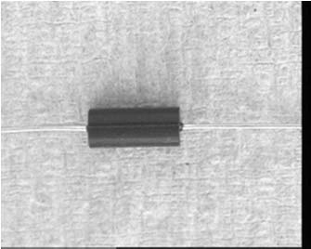  1 | 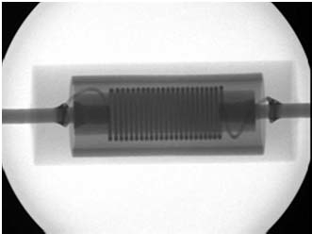  2 | 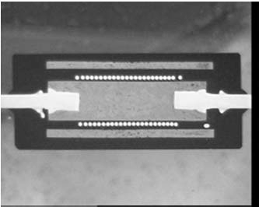  3
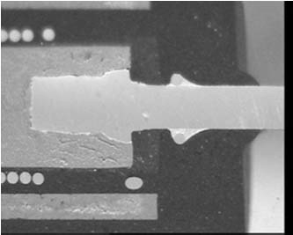
4
IMAGE INDEX:
            - Example of a wire wound inductor.
            - Radiographic image of a wire wound inductor.
            - Microsection of the wire wound.
            - Detail of the wire termination to the lead-out.

APPENDIX A8.2 - MINIMUM DPA FLOW REQUIREMENTS FOR INDUCTORS, SURFACE MOUNT
Test  Sequence | Test Description | Test Method | Sample  Allocation
1 | External Visual Inspection | ESCC Basic Specification  No. 20500 | 3 Parts
2 | Photographic Record | Appendix A8.2 | 1 Part
3 | Verification of Material  Finish | ESCC Basic Specification  No. 25500 Note 3 | 1 Part
4 | Radiographic Inspection | ESCC Basic Specification  No. 20900 | 3 Parts
5 | Solderability | MIL-STD-202 Method 208 | 3 Parts
6 | Marking Permanence | ESCC Basic Specification  No. 24800 | 3 Parts
7 | Microsectional Analysis  Note 1 | ESCC Basic Specification  No. 20400  Note 2 | 3 Parts
8 | Photographic Record | Appendix A8.2 | 1 Part
9 | DPA Report | Para. 6.3 | 3 Parts
NOTES:
            - The samples shall be embedded and cross-sectioned in the plane which will provide the most significant information, particularly the interfaces between the vias and the metallisation layers and the metallisation layers and the terminations.
            - The inspection criteria defined in ESCC Basic Specification No. 23400 shall be applied to the appropriate parts of the inductor.
            - Operation not required if it has been already performed as part of the Incoming Inspection, or any other previous validation step.
A8.2 - IMAGES REQUIRED FOR DPA REPORT
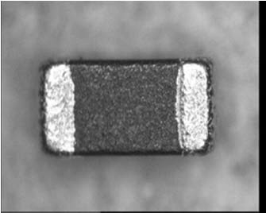  1 | 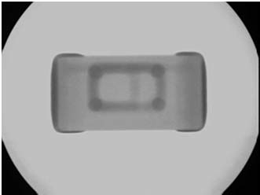  2 | 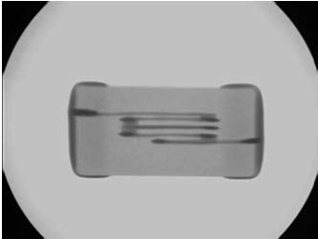  3
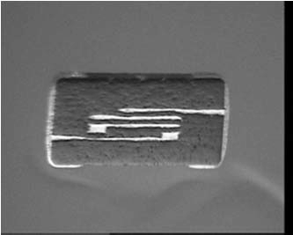  4 | 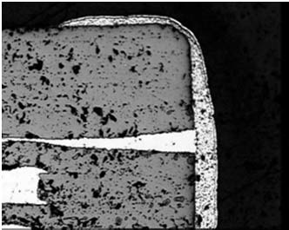  5
IMAGE INDEX:
            - Example of a surface mount inductor.
            - Radiographic image of a surface mount inductor.
            - Radiographic image of a surface mount inductor.
            - Microsection of a surface mount inductor.
            - Detail of the metallisation to termination connection.

APPENDIX A8.3 - MINIMUM DPA FLOW REQUIREMENTS FOR TRANSFORMERS
Test  Sequence | Test Description | Test Method | Sample  Allocation
1 | External Visual Inspection | ESCC Basic Specification  No. 20500 | 3 Parts
2 | Photographic Record | Appendix A8.3 | 1 Part
3 | Verification of Material  Finish | ESCC Basic Specification  No. 25500 Note 4 | 1 Part
4 | Radiographic Inspection | ESCC Basic Specification  No. 20900 | 3 Parts
5 | Solderability | MIL-STD-202 Method 208 | 3 Parts
6 | Marking Permanence | ESCC Basic Specification  No. 24800 | 3 Parts
7 | Terminal Strength Test | Detail Specification | 3 Parts
8 | Microsectional Analysis  Notes 1, 2 | ESCC Basic Specification  No. 20400  Note 3 | 1 Part
9 | Photographic Record | Appendix A8.3 | 1 Part
10 | DPA Report | Para. 6.3 | 3 Parts
NOTES:
            - Generally transformers are completely encapsulated in an epoxy resin. Where this is not the case and disassembly is possible, one sample shall be disassembled and inspected with respect to the appropriate criteria.
            - The microsection sample shall be embedded and cross-sectioned in the planes which will reveal the most significant information, particularly core winding to terminal solder joint.
            - The inspection shall ensure that:
- Wires are not attached to terminals only by solder and there are at least three wire wraps.
- There are no cold solder joints or solder joints without a fillet of solder around the wire and the termination.
- Solder joints are free of cracks and voids.
- Welds are free of cracks and voids.
- There is stress relief in all wire connections to terminals.
- No wire shows evidence of nicks, kinks or wire diameter reduction.
            - Operation not required if it has been already performed as part of the Incoming Inspection, or any other previous validation step.
A8.3 - IMAGES REQUIRED FOR DPA REPORT
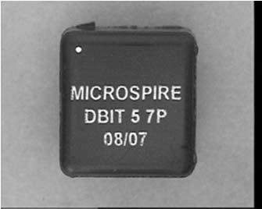  1 | 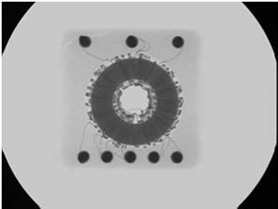  2 | 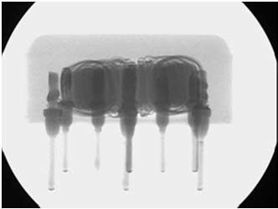  3
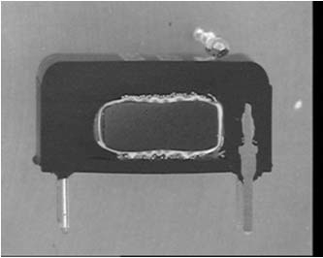  4 | 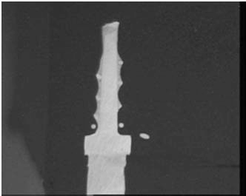  5
IMAGE INDEX:
            - Example of a transformer.
            - Radiographic image of a transformer.
            - Radiographic image of a transformer.
            - Microsection of the transformer.
            - Detail of the wire termination to the lead.

APPENDIX A9.1 - MINIMUM DPA FLOW REQUIREMENTS FOR MICROCIRCUITS, MONOLITHIC, HERMETIC (AND MMICS, MEMSS, CCDS, SAWS)
Test  Sequence | Test Description | Test Method | Sample  Allocation
1 | External Visual Inspection | ESCC Basic Specification  No. 20500 | 3 Parts
2 | Photographic Record | Appendix A9.1 | 1 Part
3 | Verification of Lead  Material Finish | ESCC Basic Specification  No. 25500 Note 4 | 1 Part
4 | Radiographic Inspection | ESCC Basic Specification  No. 20900 | 3 Parts
5 | Hermetic Seal Tests | MIL-STD-883 Method 1014 | 3 Parts
6 | Particle Impact Noise  Detection Test | MIL-STD-883 Method 2020 | 3 Parts
7 | Marking Permanence Test | ESCC Basic Specification  No. 24800 | 3 Parts
8 | Solderability Test | MIL-STD-883 Method 2003 | 3 Parts
9 | Terminal Strength Test | Detail Specification | 3 Parts
10 | Residual Gas Analysis  Note 5 | MIL-STD-883 Method 1018 | 3 Parts
11 | De-encapsulation  Note 1 | - | 3 Parts
12 | Internal Visual Inspection | ESCC Basic Specification  No. 20400  Notes 1, 2 | 3 Parts
13 | SEM Inspection | ESCC Basic Specification  No. 21400  Note 2 | 1 Part
14 | Photographic Record | Appendix A9.1 | 1 Part
15 | Wire Bond Strength Test | MIL-STD-883 Method 2011 | 3 Parts
16 | Metallisation Quality  Assessment  Note 3 | ESCC Basic Specification  No. 21400 | 1 Part
17 | Photographic Record | Appendix A9.1 | 1 Part
18 | Die Shear Strength Test or Substrate Attach Strength | MIL-STD-883 Method 2019  MIL-STD-883 Method 2027 | 3 Parts
19 | DPA Report | Para. 6.3 | 3 Parts
NOTES:
            - De-encapsulation shall be achieved mechanically or thermally (de-soldering) depending on the type of hermetic seal used.
Every care shall be taken to prevent damage to the internal elements of the component during de-encapsulation.
De-encapsulation may introduce debris into the cavity and such debris shall be confirmed to be from the de-encapsulation process.
If the Particle Impact Noise Detection test has identified the presence of particles in the cavity every effort shall be made to recover and identify such particles.
            - Any die identification shall be recorded and shall be verified as being appropriate to the components submitted for DPA.
Scanning Electron Microscopy shall be used to support the Internal Visual Inspection of wire bonding, see images below.
            - A number of techniques are available for the Assessment of Metallisation quality. The operation will be made using SEM and the correct sample preparation based on the complexity of the metallisation, i.e. the number levels of metallisation and the width of the metallisation features:
- Wet chemical or plasma de-glassivation, suitable for single and two layer metallisation systems.
- Mechanical cross-sectioning, shall be considered suitable for multi-level metallisation systems but has limitations by the size of metallisation features. Less suitable for planarised die with multiple vias,. Cleaving or cracking the die shall not be performed.
- Where b) is not practical Focused Ion Beam (FIB) may be performed. For special technologies FIB may be requested.
            - Operation not required if it has been already performed as part of the Incoming Inspection, or any other previous validation step.
            - RGA test is optional. In case the test is performed, three (3) separate units will be used, being the acceptance criteria 0 failures. In case of one failure, two additional devices can be tested. If sample size (accept number) of 5(1) is used to pass the lot, the manufacturer shall provide a reason for the failure.
A9.1 - IMAGES REQUIRED FOR DPA REPORT
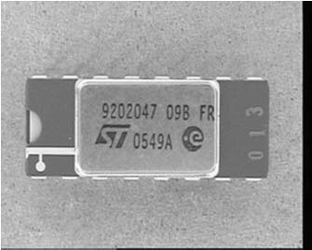  1 | 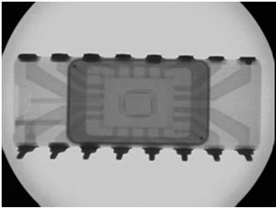  2 | 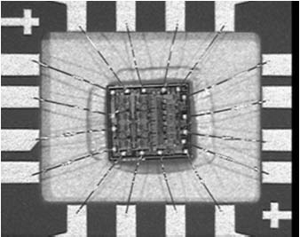  3
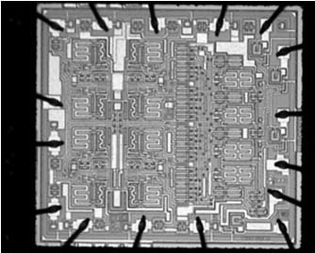  4 | 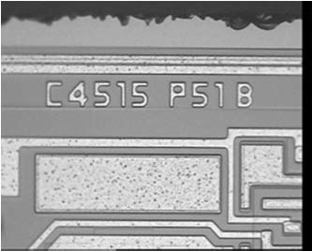  5 | 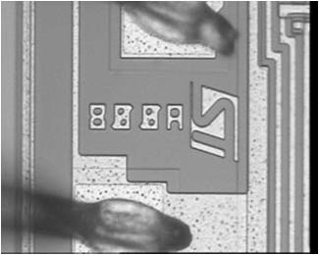  6
IMAGE INDEX:
            - Example of an hermetic microcircuit.
            - Radiographic image of an hermetic microcircuit.
            - Optical image of an hermetic microcircuit after de-encapsulation.
            - Optical image of the die surface of an hermetic microcircuit.
            - Optical image of the die identification of an hermetic microcircuit.
            - Optical image of the die identification of an hermetic microcircuit.

APPENDIX A9.2 - MINIMUM DPA FLOW REQUIREMENTS FOR MICROCIRCUIT, MONOLITHIC, MOULDED PLASTIC (AND MMICS, MEMSS, CCDS, SAWS)
Test  Sequence | Test Description | Test Method | Sample  Allocation
1 | External Visual Inspection | ESCC Basic Specification  No. 20500 | 3 Parts
2 | Photographic Record | Appendix A9.2 | 1 Part
3 | Verification of Lead  Material Finish | ESCC Basic Specification  No. 25500 Note 11 | 1 Part
4 | Scanning Acoustic  Microscopy | ESCC Basic Specification  No. 25200 | 3 Parts
5 | Marking Permanence Test | ESCC Basic Specification  No. 24800 | 3 Parts
6 | Solderability Test | MIL-STD-883 Method 2003 | 3 Parts
7 | Terminal Strength Test | Detail Specification | 3 Parts
8 | De-Encapsulation  Notes 1, 2, 3, 4, 8, 10 | ESCC Basic Specification  No. 25300  Note 1 | 3 Parts
9 | Internal Visual Inspection  Note 6, 7 | ESCC Basic Specification  No. 20400  Note 5 | 3 Parts
10 | SEM Inspection  Notes 6, 7 | ESCC Basic Specification  No. 21400 | 1 Part
11 | Photographic Record | Appendix A9.2 | 1 Part
12 | Wire Bond Strength Test  Note 4 | MIL-STD-883 Method 2011 | 3 Parts
13 | Metallisation Quality  Assessment  Note 9 | ESCC Basic Specification  No. 21400 | 1 Part
14 | Photographic Record | Appendix A9.2 | 1 Part
15 | Die Shear Strength Test or Substrate Attach Strength  Note 8 | MIL-STD-883 Method 2019  MIL-STD-883 Method 2027 | 3 Parts
16 | DPA Report | Para. 6.3 | 3 Parts
NOTES:
            - De-encapsulation involves a mixture of fuming nitric and sulphuric acid and shall be handled with appropriate care and safety equipment.
            - Every care shall be taken to prevent damage to the internal elements of the component during de-encapsulation.
            - It shall be noted that most plastic encapsulated microcircuits have silver plating on the bonding area of the lead frame. This silver plating will be rapidly degraded by the acid.
            - It shall also be noted that some plastic encapsulated microcircuits have copper bond wires which will be rapidly degraded by the acid.
            - Any die identification shall be recorded and shall be verified as being appropriate to the components submitted for DPA.
            - Scanning Electron Microscopy (SEM) shall be used to support the Internal Visual Inspection of wire bonding, see images below.
            - It shall be noted that most plastic encapsulated microcircuits have gold ball and wedge wire bonding to aluminium metallisation. This assembly technique may result in the formation of undesirable intermetallics. SEM shall be the preferred technique for examining the gold ball bond to aluminium die metallisation interface, see images below.
            - It shall be noted that most plastic encapsulated microcircuits have an epoxy or polymer die attach which may be degraded by the acid used in the-encapsulation process.
            - A number of techniques are available for the Assessment of Metallisation quality. The operation will be made using SEM and the correct sample preparation based on the complexity of the metallisation, i.e. the number levels of metallisation and the width of the metallisation features:
- Wet chemical or plasma de-glassivation, suitable for single and two layer metallisation systems.
- Mechanical cross-sectioning, shall be considered suitable for multi-level metallisation systems but has limitations by the size of metallisation features. Cleaving or cracking the die shall not be performed.
- Where b) is not practical Focused Ion Beam (FIB) may be performed. For special technologies FIB may be requested.
            - For MMICs, CCDs and SAW Components, it should be noted that that gallium arsenide die will be degraded by the fuming nitric acid mix used to de-encapsulate plastic components.
            - Operation not required if it has been already performed as part of the Incoming Inspection, or any other previous validation step.
A9.2 - IMAGES REQUIRED FOR DPA REPORT
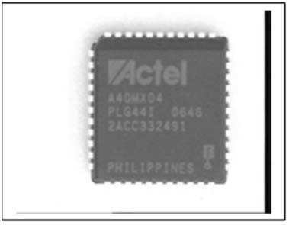  1 | 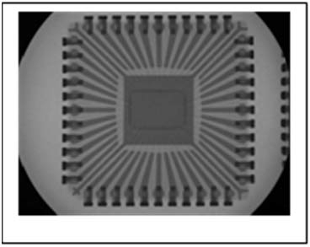  2 | 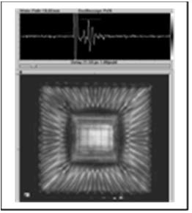  3
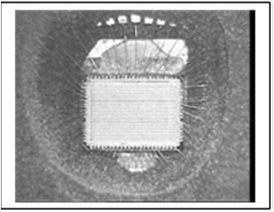  4 | 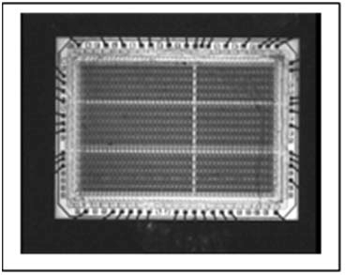  5 | 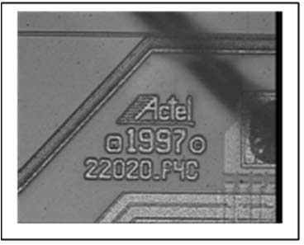  6
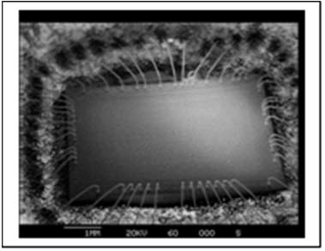  7 | 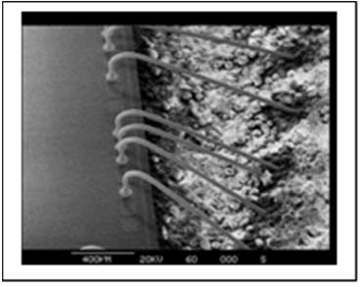  8 | 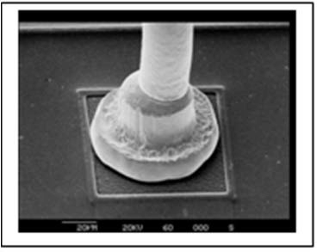  9
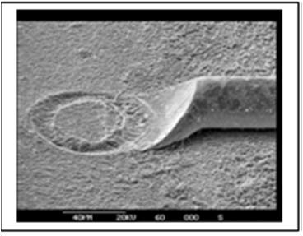  10 | 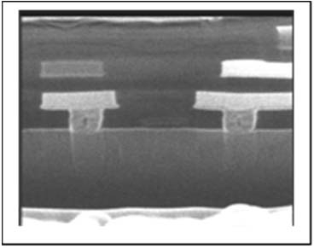  11
IMAGE INDEX:
            - Example of a plastic encapsulated microcircuit.
            - Radiographic image of a plastic encapsulated microcircuit.
            - Acoustic microscope image of a plastic encapsulated microcircuit.
            - De-encapsulated microcircuit.
            - De-encapsulated die.
            - Die identification.
            - SEM Image of the de-encapsulated microcircuit.
            - SEM Image of the bond wire dressing.
            - SEM Image of a ball bond at the die.
            - SEM Image of a wedge bond to a lead out, note exposure of this bond may reduce the wire bond strength.
            - FIB Image of planarised metallisation with vias, see images required for an hermetic microcircuit for alternatives.

APPENDIX A10.1 - MINIMUM DPA FLOW REQUIREMENTS FOR OPTO-COUPLERS
Test  Sequence | Test Description | Test Method | Sample  Allocation
1 | External Visual Inspection | ESCC Basic Specification  No. 20500 | 3 Parts
2 | Photographic Record | Appendix A10.1 | 1 Part
3 | Verification of Lead  Material Finish | ESCC Basic Specification  No. 25500 Note 5 | 1 Part
4 | Radiographic Inspection | ESCC Basic Specification  No. 20900 | 3 Parts
5 | Hermetic Seal Tests | MIL-STD-883 Method 1014 | 3 Parts
6 | Particle Impact Noise  Detection Test | MIL-STD-883 Method 2020 | 3 Parts
7 | Marking Permanence Test | ESCC Basic Specification  No. 24800 | 3 Parts
8 | Solderability Test | MIL-STD-883 Method 2003 | 3 Parts
9 | Terminal Strength Test | Detail Specification | 3 Parts
10 | De-encapsulation  Note 1 | Note 2 | 3 Parts
11 | Internal Visual Inspection | ESCC Basic Specification  No. 20400  Notes 1, 3 | 3 Parts
12 | SEM Inspection | ESCC Basic Specification  No. 21400  Note 3 | 3 Parts
13 | Photographic Record | Appendix A10.1 | 1 Part
14 | Wire Bond Strength Test | MIL-STD-883 Method 2011 | 3 Parts
15 | Metallisation Quality  Assessment  Note 4 | ESCC Basic Specification  No. 21400 | 1 Part
16 | Photographic Record | Appendix A10.1 | 1 Part
17 | Die Shear Strength Test | MIL-STD-883 Method 2019 | 3 Parts
18 | DPA Report | Para. 6.3 | 3 Parts
NOTES:
            - Initial de-encapsulation, removing the primary package shall be achieved mechanically or thermally (de-soldering) depending on the type of hermetic seal used. An inspection and photographic inspection shall be made at this stage.
The coatings shall be removed using a suitable solvent selected to minimise damage to the dice and wire bonding. The DPA operative must be aware of any hazards from the solvent and must take all appropriate health and safety precautions.
Every care must be taken to prevent damage to the internal elements of the component during de-encapsulation.
De-encapsulation may introduce debris into the cavity and such debris shall be confirmed to be from the de-encapsulation process.
If the Particle Impact Noise Detection test has identified the presence of particles in the cavity every effort shall be made to recover and identify such particles.
            - Opto-couplers and isolators shall contain at least two die, a detector and a LED coated with a transparent silicone and often an opaque coating.
            - Any die identification shall be recorded and shall be verified as being appropriate to the components submitted for DPA.
Scanning Electron Microscopy shall be used to support the Internal Visual Inspection of wire bonding, see images below.
            - A number of techniques are available for the Assessment of Metallisation quality. The operation will be made using SEM and the correct sample preparation based on the complexity of the metallisation, i.e. the number levels of metallisation and the width of the metallisation features:
- Wet chemical or plasma de-glassivation, suitable for single and two layer metallisation systems.
- Mechanical cross-sectioning, shall be considered suitable for multi-level metallisation systems but has limitations by the size of metallisation features. Cleaving or cracking the die shall not be performed.
- Where b) is not practical Focused Ion Beam (FIB) may be performed. For special technologies FIB may be requested.
            - Operation not required if it has been already performed as part of the Incoming Inspection, or any other previous validation step.
A10.1 - IMAGES REQUIRED FOR DPA REPORT
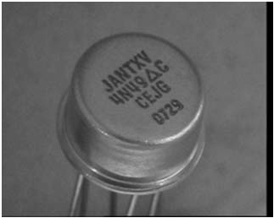  1 | 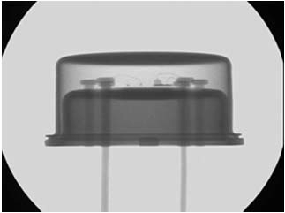  2 | 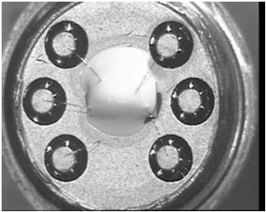  3
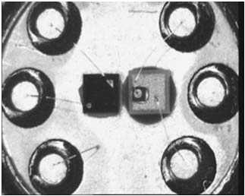  4 | 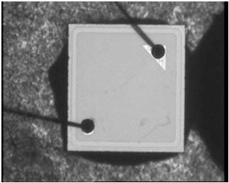  5 | 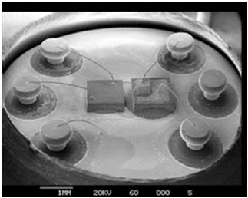  6
IMAGE INDEX:
            - Example of an opto-coupler in a TO can.
            - Radiographic image of an opto-coupler.
            - De-encapsulated opto-coupler. Note the opaque white silicone coating.
            - Dice with the silicone coating removed; note gold bond wires.
            - Photo-transistor die surface.
            - SEM image showing the positioning of the die. Note that the diode is mounted on an insulating substrate.

APPENDIX A10.2 - MINIMUM DPA FLOW REQUIREMENTS FOR LIGHT EMITTING DIODES
Test  Sequence | Test Description | Test Method | Sample  Allocation
1 | External Visual Inspection | ESCC Basic Specification  No. 20500 | 3 Parts
2 | Photographic Record | Appendix A10.2 | 1 Part
3 | Verification of Lead  Material Finish | ESCC Basic Specification  No. 25500 Note 3 | 1 Part
4 | Hermetic Seal Tests  Note 1 | MIL-STD-750 Method 1071 | 3 Parts
5 | Radiographic Inspection | ESCC Basic Specification  No. 20900 | 3 Parts
6 | Marking Permanence | ESCC Basic Specification  No. 24800 | 3 Parts
7 | Solderability | MIL-STD-750 Method 2026 | 3 Parts
8 | Terminal Strength Test | Detail Specification | 3 Parts
9 | De-encapsulation  Note 2 | - | 3 Parts
10 | Internal Inspection | ESCC Basic Specification  No. 20400 | 3 Parts
11 | Photographic Record | Appendix A10.2 | 3 Parts
12 | Wire Bond Strength Test | MIL-STD-750 Method 2037 | 3 Parts
13 | Die Shear Strength Test | MIL-STD-750 Method 2017 | 3 Parts
14 | DPA Report | Para. 6.3 | 3 Parts
NOTES:
            - For panel mounted LEDs, the panel mounting housing shall be removed before the parts are subjected to hermetic seal tests.
            - It shall be established by radiographic inspection if the anode bond wire is located in the solder seal; if this is the case, extra care shall be taken during de-encapsulation (see Appendix A10.3 image 6)
            - Operation not required if it has been already performed as part of the Incoming Inspection, or any other previous validation step.
A10.2 - IMAGES REQUIRED FOR DPA REPORT
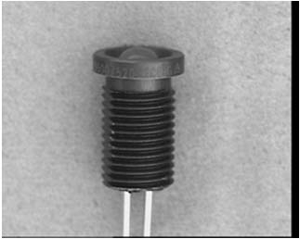  1 | 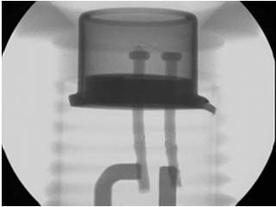  2 | 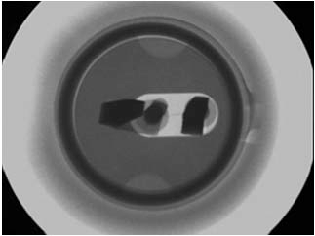  3
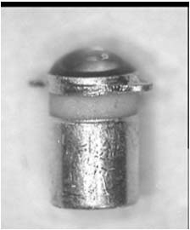  4 | 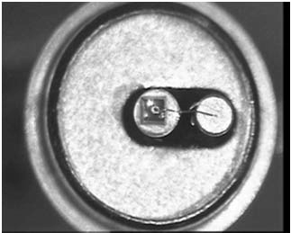  5 | 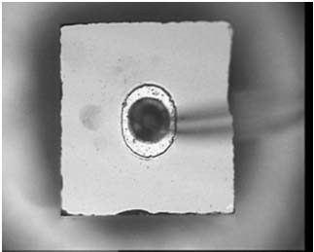  6
IMAGE INDEX:
            - LED in panel mounting housing.
            - Radiographic image.
            - Radiographic image.
            - LED removed from the panel mounting.
            - De-capped LED.
            - LED die.

APPENDIX A10.3 - MINIMUM DPA FLOW REQUIREMENTS FOR OPTICAL SENSORS
Test  Sequence | Test Description | Test Method | Sample  Allocation
1 | External Visual Inspection | ESCC Basic Specification  No. 20500 | 3 Parts
2 | Photographic Record | Appendix A10.3 | 1 Part
3 | Verification of Lead  Material Finish | ESCC Basic Specification  No. 25500 Note 4 | 1 Part
4 | Hermetic Seal Tests  Note 1 | MIL-STD-750 Method 1071 | 3 Parts
5 | Radiographic Inspection | ESCC Basic Specification  No. 20900 | 3 Parts
6 | Marking Permanence | ESCC Basic Specification  No. 24800 | 3 Parts
7 | Solderability | MIL-STD-750 Method 2026 | 3 Parts
8 | Terminal Strength Test | Detail Specification | 3 Parts
9 | Residual Gas Analysis  Note 5 | MIL-STD-750 Method 1018 | 3 Parts
10 | De-encapsulation  Note 2 | - | 3 Parts
11 | Internal Inspection | ESCC Basic Specification  No. 20400  Note 3 | 3 Parts
12 | Photographic Record | Appendix A10.3 | 3 Parts
13 | Wire Bond Strength Test | MIL-STD-750 Method 2037 | 3 Parts
14 | Die Shear Strength Test | MIL-STD-750 Method 2017 | 3 Parts
15 | DPA Report | Para. 6.3 | 3 Parts
NOTES:
            - For panel mounted Optical Sensors, the panel mounting housing shall be removed before the parts are subjected to hermetic seal tests.
            - It shall be established by radiographic inspection if the anode bond wire is located in the solder seal; if this is the case extra care shall be taken during de-encapsulation (see Appendix A10.3 image 6).
            - A gold bond wire embedded in solder shall not be permitted.
            - Operation not required if it has been already performed as part of the Incoming Inspection, or any other previous validation step.
            - RGA test is optional. In case the test is performed, three (3) separate units will be used, being the acceptance criteria 0 failures. In case of one failure, two additional devices can be tested. If sample size (accept number) of 5(1) is used to pass the lot, the manufacturer shall provide a reason for the failure.
A10.3 - IMAGES REQUIRED FOR DPA REPORT
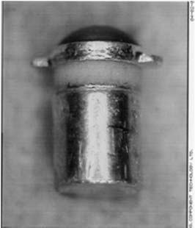  1 | 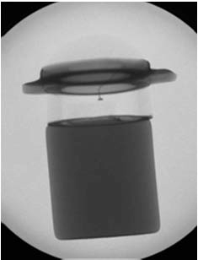  2 | 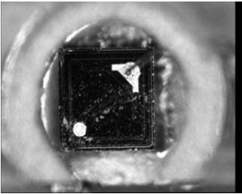  3
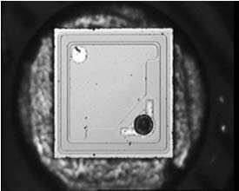  4 | 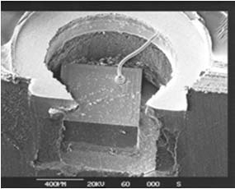  5 | 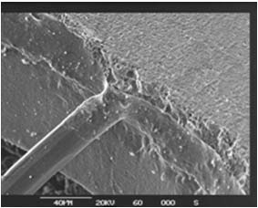  6
IMAGE INDEX:
            - Example of an optical detector.
            - Radiographic image.
            - De-capped detector.
            - Optical detector die.
            - SEM image showing the anode bond wire arrangement.
            - Anode bond wire embedded in the solder seal.

APPENDIX A11 - MINIMUM DPA FLOW REQUIREMENTS FOR RELAYS
Test  Sequence | Test Description | Test Method | Sample  Allocation
1 | External Visual Inspection | ESCC Basic Specification  No. 20500 | 3 Parts
2 | Photographic Record | Appendix A11 | 1 Part
3 | Verification of Lead  Material Finish | ESCC Basic Specification  No. 25500 Note 6 | 1 Part
4 | Radiographic Inspection | ESCC Basic Specification  No. 20900 | 3 Parts
5 | Hermetic Seal Test | MIL-STD-202 Method 112 | 3 Parts
6 | Particle Impact Noise  Detection Test  Note 1 | MIL-PRF-39016 | 3 Parts
7 | Marking Permanence Test | ESCC Basic Specification  No. 24800 | 3 Parts
8 | Solderability Test | MIL-STD-202 Method 208 | 3 Parts
9 | Terminal Strength Test | Detail Specification | 3 Parts
10 | De-encapsulation  Note 2 | - | 3 Parts
11 | Internal Visual Inspection | ESCC Basic Specification  No. 20400  Notes 2, 3 | 3 Parts
12 | Photographic Record | Appendix A11 | 1 Part
13 | Frame Weld Strength Test | Note 4
14 | Microsectional Analysis  Note 5 | ESCC Basic Specification  No. 20400  Note 3 | 3 Parts
15 | Photographic Record | Appendix A11 | 1 Part
16 | DPA Report | Para. 6.3 | 3 Parts
NOTES:
            - Particle Impact Noise Detection shall be undertaken when it is a requirement of the Detail specification. Care must be taken in determining between responses due to particles and responses due to noise caused by contact between the elements of the relay.
            - Mechanical de-encapsulation is the only option. Every care shall be taken to prevent damage to the internal elements of the component during de-encapsulation. Physical pressure which might deform the relay frame or stress the welds between the frame and the header must be avoided.
TO5 type relays can be de-encapsulated by cutting through the flange and thus the header to can weld with very sharp side cutters removing small amounts of material each time. Alternately a “pipe cutter” adapted to open TO5 cans may be used but the pressure applied and the depth of cut must be limited to prevent deformation of the relay assembly. Rectangular or crystal can relays may be de-encapsulated by partially milling through the weld between header and can or partially sawing through the can above the weld. Final opening is achieved using a sharp blade.
De-encapsulation may introduce debris into the cavity and it is essential that such debris is confirmed to be from the de-encapsulation process.
If the Particle Impact Noise Detection test has been performed and has identified the presence of particles in the cavity every effort should be made to recover and identify such particles.
            - The inspection shall also ensure that:
- There are no loose metallic or non-metallic particles or fibres in the relay assembly or the can.
- The contacts are free of burrs, cracks and peeling plating.
- The contacts are in alignment and have equal contact gaps.
- The contact terminal welds are free of flash or ball type weld splatter.
- The armature and pole pieces are free of burrs, cracks and peeling plating.
- There shall be no evidence of rust (iron oxide) on the pole piece or the armature.
- The glass “pusher” beads are free of cracks, surface erosion or strings of bubbles.
- The coil assembly is fixed to the core.
- The connecting lead between the coil and the coil lead-out is insulated, cannot interfere with moving parts, is not in tension (stretched taut) or kinked.
            - Historically there have been failures of the welds between the frame and the header. If there are any doubts in the integrity of the weld a shear force may be applied to the frame weld. The frame welds shall be expected to survive a shear force of 5kg.
            - Microsectional analysis shall be performed on any welds where Visual inspection indicates any deficiency in the weld.
            - Operation not required if it has been already performed as part of the Incoming Inspection, or any other previous validation step.
A11 - IMAGES REQUIRED FOR DPA REPORT
 | 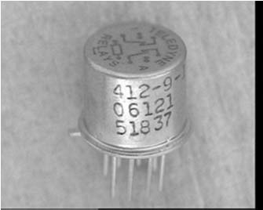  1 |  | 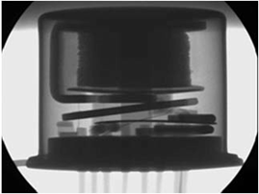  2 |  | 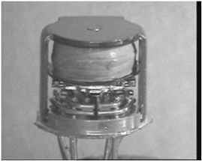  3
 | 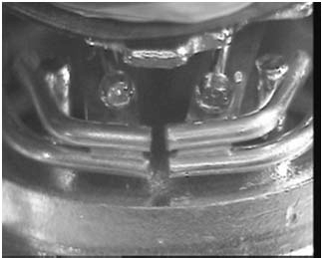  4 |  | 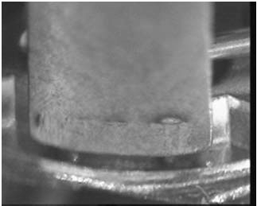  5 |  | 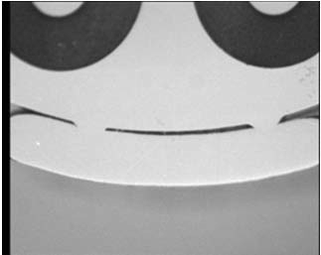  6
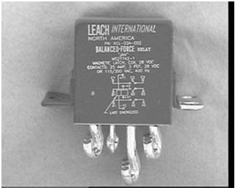  7 |  | 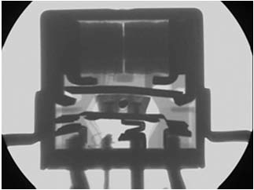  8 |  | 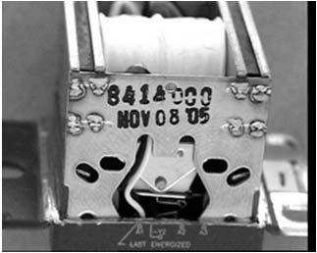  9
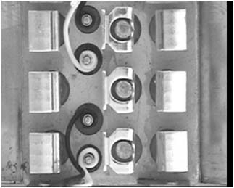  10 |  | 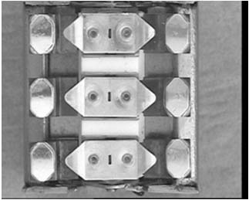  11 |  | 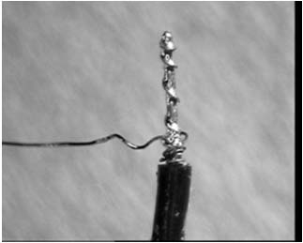  12
IMAGE INDEX:
            - Example of a TO can relay.
            - Radiographic image of a TO can relay.
            - De-encapsulated TO can relay (by cutting through the flange with side cutters).
            - Example of the TO can relay contacts and the actuating mechanism.
            - Example of the TO can frame to header welds.
            - Example of the TO can frame to header welds in microsection.
            - Example of a crystal can relay.
            - Radiographic image of a crystal can relay.
            - De-encapsulated crystal can relay (by sawing above the weld).
            - Disassembled crystal can relay – header and fixed contacts.
            - Disassembled crystal can relay – armature and moving contacts.
            - Disassembled crystal can relay – example of the wire wrap connection between the coil and the lead-out.

APPENDIX A12 - MINIMUM DPA FLOW REQUIREMENTS FOR PASSIVE MICROWAVE COMPONENTS
Test  Sequence | Test Description | Test Method | Sample  Allocation
1 | External Visual Inspection | ESCC Basic Specification  No. 20500 | 3 Parts
2 | Photographic Record | Appendix A12 | 1 Part
3 | Verification of Lead  Material Finish | ESCC Basic Specification  No. 25500 Note 8 | 1 Part
4 | Radiographic Inspection  Note 2 & 3 | ESCC Basic Specification  No. 20900 | 3 Parts
5 | Hermetic Seal Test  Note 2 | MIL-STD-202 Method 112 | 3 Parts
6 | Marking Permanence Test | ESCC Basic Specification  No. 24800 | 3 Parts
7 | Solderability Test  Note 2 | MIL-STD-202 Method 208 | 3 Parts
8 | Terminal Strength Test  Note 2 | Detail Specification | 3 Parts
9 | De-encapsulation or  Disassembly  Notes 2, 4, 5 | - | 3 Parts
10 | Internal Visual Inspection | ESCC Basic Specification  No. 20400  Note 6 | 3 Parts
11 | Photographic Record | Appendix A12 | 1 Part
12 | Microsectional Analysis  Note 7 | ESCC Basic Specification  No. 20400  Note 6 | 3 Parts
13 | Photographic Record | Appendix A12 | 1 Part
14 | DPA Report | Para. 6.3 | 3 Parts
NOTES:
            - Passive microwave components include circulators, isolators, dividers, splitters etc. An isolator is given as an example.
            - As appropriate.
            - For monolithic isolators and circulators acoustic microscopy shall be used in addition to or as an alternative to radiographic inspection, see example below.
            - Hermetically sealed components shall be de-encapsulated by techniques which minimise damage to any internal elements and prevent the introduction of material into any internal cavities.
            - Any piece part components incorporated in the passive microwave components shall be subjected to the appropriate DPA flow as described in this specification.
            - The inspection shall also ensure that:
- Ceramics and ferrites are free of cracks and chip-outs.
- The interior of the components are free of particles and foreign material.
- There is no mechanical damage to any piece parts.
- There is no contamination or corrosion of any piece parts.
            - Microsection shall be performed on elements which cannot be adequately assessed by Visual inspection
            - Operation not required if it has been already performed as part of the Incoming Inspection, or any other previous validation step.
A12 - IMAGES REQUIRED FOR DPA REPORT
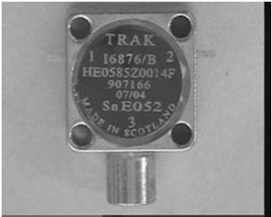  1 | 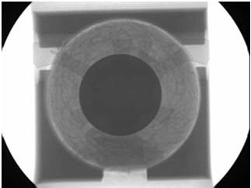  2 | 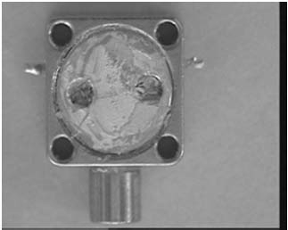  3
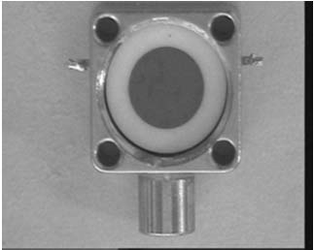  4 | 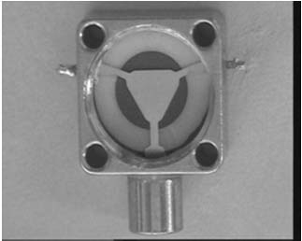  5 | 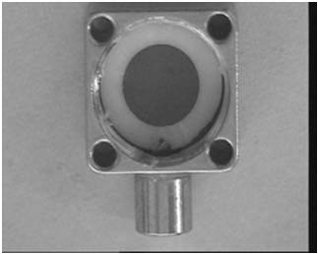  6
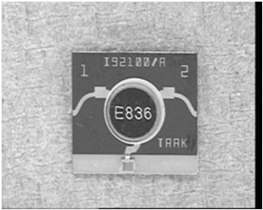  7 | 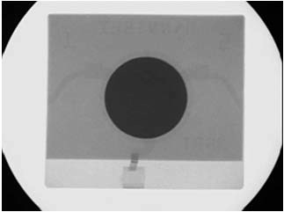  8 | 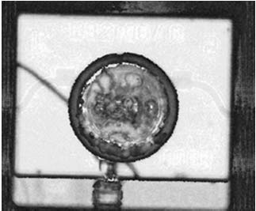  9
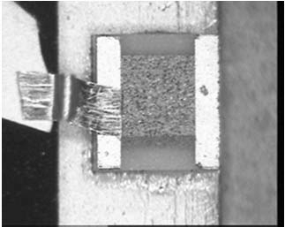
10
IMAGE INDEX:
            - Example of a non-hermetic isolator.
            - Radiographic image of a non-hermetic isolator.
            - Disassembly of a non-hermetic isolator: stage 1) label removed exposing retaining plate.
            - Disassembly of a non-hermetic isolator: stage 2) retaining plate removed exposing upper ceramic and ferrite.
            - Disassembly of a non-hermetic isolator: stage 3) upper ceramic and ferrite removed exposing the circulator element.
            - Disassembly of a non-hermetic isolator: stage 4) circulator element removed exposing the lower ceramic and ferrite.
            - Example of a monolithic isolator.
            - Radiographic image of a monolithic isolator.
            - Acoustic microscope image of a monolithic isolator (with cracked ferrite)
            - Load and ribbon bond of a monolithic isolator (an example where wire bond strength test is appropriate).

APPENDIX A13.1 - MINIMUM DPA FLOW REQUIREMENTS FOR RESISTOR, AXIAL LEADED, WIRE WOUND
Test  Sequence | Test Description | Test Method | Sample  Allocation
1 | External Visual Inspection | ESCC Basic Specification  No. 20500 | 3 Parts
2 | Photographic Record | Appendix A13.1 | 1 Part
3 | Verification of Lead Material  Finish | ESCC Basic Specification  No. 25500 Note 5 | 1 Part
4 | Radiographic Inspection | ESCC Basic Specification  No. 20900 | 3 Parts
5 | Hermetic Seal Test  Note 1 | MIL-STD-202 Method 112 | 3 Parts
6 | Marking Permanence Test | ESCC Basic Specification  No. 24800 | 3 Parts
7 | Solderability Test | MIL-STD-202 Method 208 | 3 Parts
8 | Terminal Strength Test | Detail Specification | 3 Parts
9 | De-Encapsulation  Notes 1, 2 | - | 3 Parts
10 | Internal Visual Inspection | ESCC Basic Specification  No. 20400 | 3 Parts
11 | Photographic Record | Appendix A13.1 | 1 Part
12 | Microsectional Analysis  Note 3 | ESCC Basic Specification  No. 20400 | 3 Parts
13 | Photographic Record | Appendix A13.1 | 1 Part
14 | DPA Report | Para. 6.3 | 3 Parts
NOTES:
            - When appropriate.
            - Chemical de-encapsulation, all health and safety precautions shall be observed.
            - Only if the core does not contain hazardous materials e.g. beryllium oxide (BeO)
            - The inspection shall also ensure that:
- The core is not chipped or cracked.
- Any end-cap misalignment is > 10 degrees.
- The end-cap welds are free of voids and cracks and any weld splatter is confined to flat end of the cap.
- There is no corrosion or lifted/blistered/missing plating from the end-cap. Discolouration due to welding is not cause for rejection.
- There is no foreign material, corrosion or contamination on the resistor element.
- There are no particles between the spirals of the resistor element.
- There is no damage to the resistor element which reduces the wire diameter by > 50% or the separation between adjacent turns to < 50%.
- At least 80% of the resistor element to end-cap weld is positioned on the end-cap.
            - Operation not required if it has been already performed as part of the Incoming Inspection, or any other previous validation step.
A13.1 - IMAGES REQUIRED FOR DPA REPORT
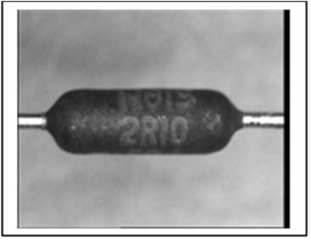  1 | 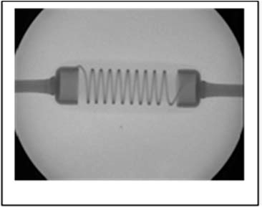  2 | 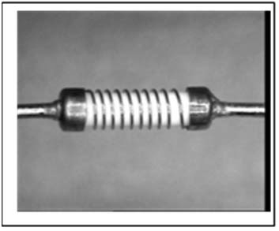  3
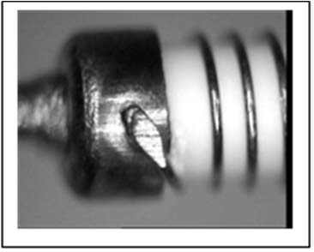  4 | 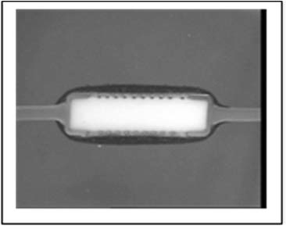  5 | 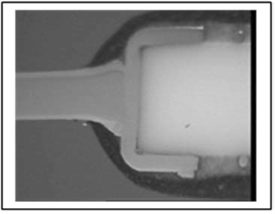  6
IMAGE INDEX:
            - Example of a wire wound resistor.
            - Radiographic image of a wire wound resistor.
            - Wire wound resistor with the encapsulant removed.
            - As above, detail of a weld to an end-cap.
            - Wire wound resistor in microsection.
            - As above, detail of a weld between a lead out and an end-cap.

APPENDIX A13.2 - MINIMUM DPA FLOW REQUIREMENTS FOR RESISTOR, AXIAL LEADED, FILM
Test  Sequence | Test Description | Test Method | Sample  Allocation
1 | External Visual Inspection | ESCC Basic Specification  No. 20500 | 3 Parts
2 | Photographic Record | Appendix A13.2 | 1 Part
3 | Verification of Lead  Material Finish | ESCC Basic Specification  No. 25500 Note 6 | 1 Part
4 | Radiographic Inspection | ESCC Basic Specification  No. 20900 | 3 Parts
5 | Hermetic Seal Test  Note 1 | MIL-STD-202 Method 112 | 3 Parts
6 | Marking Permanence Test | ESCC Basic Specification  No. 24800 | 3 Parts
7 | Solderability Test | MIL-STD-202 Method 208 | 3 Parts
8 | Terminal Strength Test | Detail Specification | 3 Parts
9 | De-Encapsulation  Notes 1, 2, 3 | - | 3 Parts
10 | Internal Visual Inspection | ESCC Basic Specification  No. 20400 | 3 Parts
11 | Photographic Record | Appendix A13.2 | 1 Part
12 | Removal of End-Caps  Note 4 | Notes 4, 5 | 3 Parts
13 | Photographic Record | Appendix A13.2 | 1 Part
14 | DPA Report | Para. 6.3 | 3 Parts
NOTES:
            - Where appropriate, see example on the following page.
            - If chemical de-encapsulant is necessary all health and safety precautions shall be observed.
            - Hermetically sealed resistors shall have the hermetic encapsulant mechanically removed to permit inspection of the resistor film. Care must be taken to prevent damage to the metal film.
            - The end-caps shall be removed to facilitate inspection for any evidence of corrosion, blistering or peeling of the end-cap material or the metal film.
To remove the end-caps roll the both end-caps and the resistor element between two hard flat surfaces e.g. glass sheets.
Experience has shown that the end-caps are often not detached simultaneously. If it is necessary to continue rolling the remaining cap care must be taken to prevent damage being induced to the exposed end of the core.
            - The inspection shall also ensure that:
- The core is not chipped or cracked.
- Any end-cap misalignment is > 10 degrees.
- The end-cap welds are free of voids and cracks and any weld splatter is confined to flat end of the cap.
- There is no corrosion or lifted/blistered/missing plating from the end-cap. Discolouration due to welding is not cause for rejection.
- There is no foreign material or contamination on the metal film.
- There are no particles in the spiral cut in the resistor film.
- There is no damage to the metal film that reduces the width of any metallised turn by > 50% or the separation between adjacent turns to < 50%.
- There is no lifting, peeling or blistering of the metal film.
- Any coating applied to the metal film does not extend under the end-cap to > 50% of the length of the end-cap.
- Any discolouration, foreign material, bubbles, pin holes or peeling of the coating applied to the film.
- Any excessively deep cuts during laser trimming for thick films this should not exceed 0.18mm or for thin films should not exceed 0.0125mm.
- Any uncut material remaining as a result of the laser beam “skipping” during trimming.
            - Operation not required if it has been already performed as part of the Incoming Inspection, or any other previous validation step.
A13.2 - IMAGES REQUIRED FOR DPA REPORT
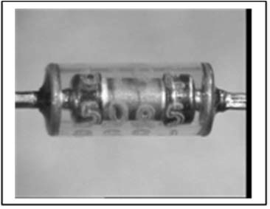  1 | 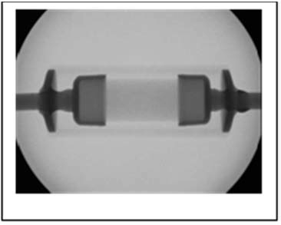  2 | 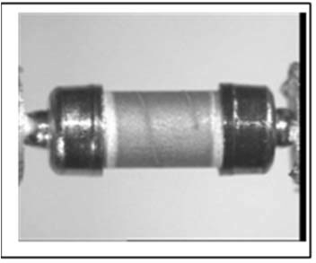  3
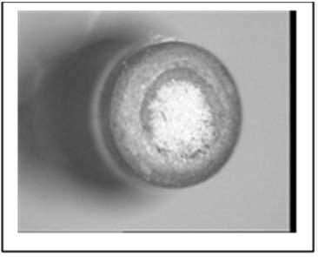  4 | 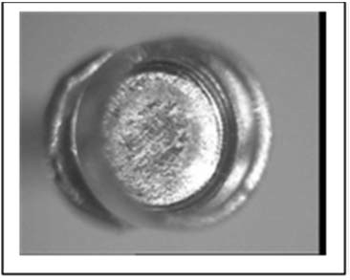  5
IMAGE INDEX:
            - Example of an axial lead film resistor in an hermetic enclosure.
            - Radiographic image of an axial lead film resistor in an hermetic enclosure.
            - Resistor element with the enclosure removed.
            - Example of the core and resistor film under an end-cap.
            - Example of the interior of an end-cap.

APPENDIX A13.3 - MINIMUM DPA FLOW REQUIREMENTS FOR RESISTOR, RADIAL LEADED, PRECISION
Test  Sequence | Test Description | Test Method | Sample  Allocation
1 | External Visual Inspection | ESCC Basic Specification  No. 20500 | 3 Parts
2 | Photographic Record | Appendix A13.3 | 1 Part
3 | Verification of Lead Material  Finish | ESCC Basic Specification  No. 25500 Note 3 | 1 Part
4 | Radiographic Inspection | ESCC Basic Specification  No. 20900 | 3 Parts
5 | Marking Permanence Test | ESCC Basic Specification  No. 24800 | 3 Parts
6 | Solderability Test | MIL-STD-202 Method 208 | 3 Parts
7 | Terminal Strength Test | Detail Specification | 3 Parts
8 | De-Encapsulation  Note 1 | - | 3 Parts
9 | Internal Visual Inspection | ESCC Basic Specification  No. 20400  Note 2 | 3 Parts
10 | Photographic Record | Appendix A13.3 | 1 Part
11 | DPA Report | Para. 6.3 | 3 Parts
NOTES:
            - This type of resistor (RNC90) has a thin metal foil resistor network bonded to a ceramic substrate with the lead outs either directly welded to the metal foil or connected to the metal foil by a metal ribbon welded at both ends. De-encapsulant is best achieved using a proprietary solvent. The resistor network and the welds between the lead outs and the resistor network shall be exposed for inspection.
If chemical de-encapsulant is necessary all health and safety precautions shall be observed.
            - The inspection shall also ensure that:
- There are no cracks or chip outs in the substrate which extend under the resistor network
- At least 80% of the lead out to network weld is positioned on resistor network weld pad area.
- At least 50% of the weld is positioned on the lead out.
- The lead out is not positioned over active areas of the resistor network.
- There is no evidence of weld splatter
- The metal ribbon when used is not torn.
- The epoxy used to attach the lead outs to the back of the ceramic has not ingressed under or into the welds.
- The lead outs are not cracked, nicked or dented.
- The resistor network width is not reduced by > 75% at any point
- The resistor network is not loose or lifted.
- There are no heavy scratches or gouges in the active area of the resistor network.
- There are no particles which could reduce the isolation width at any point in the resistor network by > 50%.
- Any trim cuts made to adjust the resistance are clean and without particles which might cause short circuits.
            - Operation not required if it has been already performed as part of the Incoming Inspection, or any other previous validation step.
A13.3 - IMAGES REQUIRED FOR DPA REPORT
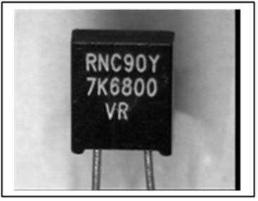  1 | 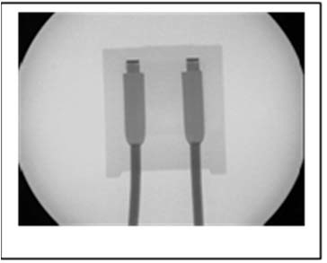  2 | 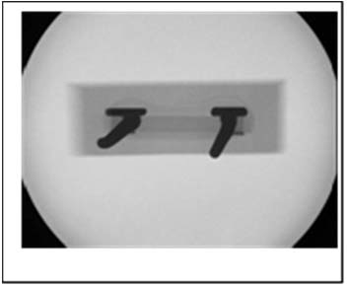  3
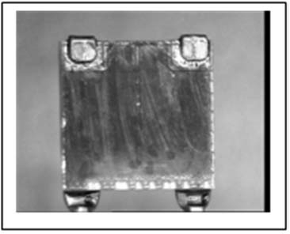  4 | 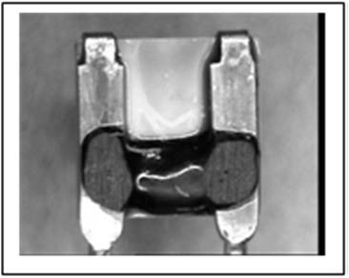  5
IMAGE INDEX:
            - Example of a radial lead precision film resistance.
            - Radiographic image of a radial lead precision resistor.
            - Radiographic image of a radial lead precision resistor.
            - Resistor with the encapsulant removed showing the resistor network and the welds directly from the lead outs to the network. This part does not have a ribbon connection.
            - As above showing the backside of the resistor and the bonding of the lead outs to the core.

APPENDIX A13.4 - MINIMUM DPA FLOW REQUIREMENTS FOR RESISTOR, SURFACE MOUNT, FILM
Test  Sequence | Test Description | Test Method | Sample  Allocation
1 | External Visual Inspection | ESCC Basic Specification  No. 20500 | 3 Parts
2 | Photographic Record | Appendix A13.4 | 1 Part
3 | Verification of Lead Material  Finish | ESCC Basic Specification  No. 25500 Note 3 | 1 Part
4 | Marking Permanence Test | ESCC Basic Specification  No. 24800 | 3 Parts
5 | Solderability Test | MIL-STD-202 Method 208 | 3 Parts
6 | Microsectional Analysis  Note 1 | ESCC Basic Specification  No. 20400  Note 2 | 3 Parts
7 | Photographic Record | Appendix A13.4 | 1 Part
8 | DPA Report | Para. 6.3 | 3 Parts
NOTES:
            - Resistor shall be embedded in a thermo-setting resin selected to provide good edge retention during microsectioning. If necessary, a hard filler may be included in the embedding material.
            - The inspection shall also ensure that:
- There are no cracks or chip outs in the component.
- There is no foreign material or discolouration of the substrate, resistive film or the terminations.
- There is no lifting, peeling or blistering of the resistive film, terminations or protective coating (when applied).
- There is no uncut material left over from the scribing or trimming operation.
            - Operation not required if it has been already performed as part of the Incoming Inspection, or any other previous validation step.
A13.4 - IMAGES REQUIRED FOR DPA REPORT
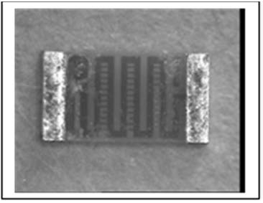1 | 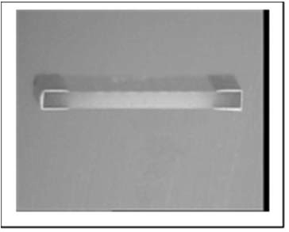  2 | 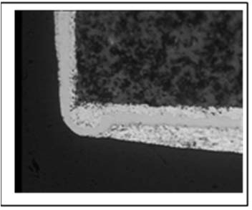3
IMAGE INDEX:
            - Example of a surface mount film resistor.
            - Microsection of a surface mount film resistor.
            - Microsection of a surface mount film resistor termination.

APPENDIX A14.1 - MINIMUM DPA FLOW REQUIREMENTS FOR SWITCHES, MECHANICAL (TOGGLE, PUSH BUTTON, MICROSWTICHES)
Test  Sequence | Test Description | Test Method | Sample  Allocation
1 | External Visual Inspection | ESCC Basic Specification  No. 20500 | 3 Parts
2 | Photographic Record | Appendix A14.1 | 1 Part
3 | Verification of Lead  Material Finish | ESCC Basic Specification  No. 25500 Note 7 | 1 Part
4 | Hermetic Seal Test  Note 2 | MIL-STD-202 Method 112 | 3 Parts
5 | Marking Permanence  Test | ESCC Basic Specification  No. 24800 | 3 Parts
6 | Radiographic Inspection | ESCC Basic Specification  No. 20900 | 3 Parts
7 | Solderability Test | MIL-STD-202 Method 208 | 3 Parts
8 | Terminal Strength Test | Detail Specification | 3 Parts
9 | De-encapsulation  Notes 3, 4, 5 | - | 3 Parts
10 | Internal Visual Inspection | ESCC Basic Specification  No. 20400  Note 6 | 3 Parts
11 | Photographic Record | Appendix A14.1 | 1 Part
12 | Microsectional Analysis  Note 5 | ESCC Basic Specification  No. 20400  Note 6 | 3 Parts
13 | Photographic Record | Appendix A14.1 | 1 Part
14 | DPA Report | Para. 6.3 | 3 Parts
NOTES:
            - The example used contains two discreet microswitches but the flow shall be applied to any type of switch.
            - When appropriate.
            - For hermetically encapsulated switches one or more sides of the switch shall be ground away until the remaining material can be cut away with a sharp blade. Care must be taken to avoid introducing material in the cavity.
            - Non-hermetic switches generally have plastic cases with epoxy or similar bonding. Cutting through the epoxy with a sharp blade is recommended.
            - Alternatively the whole assembly shall be embedded in a suitable epoxy resin or similar and microsectioned. Note once the cavity of the switch has been breached it shall be necessary to fill the cavity with more epoxy resin.
            - The inspection shall also ensure that:
- There are no loose particles in the cavity of the switch or on the piece parts.
- Any loose particles are identified and debris from the de-encapsulation process is eliminated from the DPA.
- There are no loose, broken or damaged piece parts.
- There is no evidence of corrosion or peeling of plating or finish of the piece parts.
- There is no evidence of contamination.
            - Operation not required if it has been already performed as part of the Incoming Inspection, or any other previous validation step.
A14.1 - IMAGES REQUIRED FOR DPA REPORT
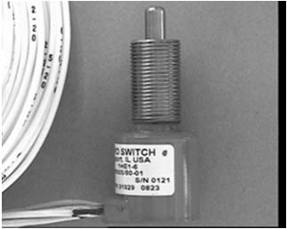  1 | 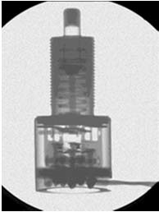  2 | 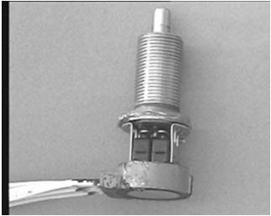  3
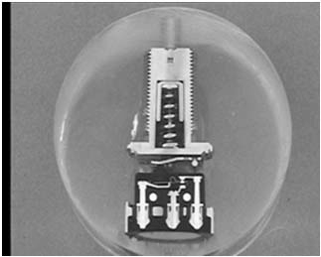  4 | 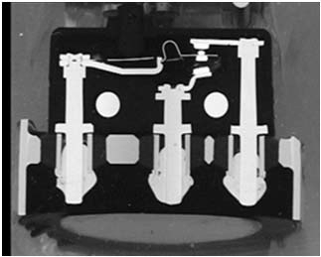  5 | 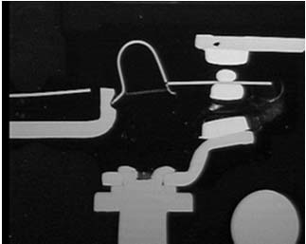  6
IMAGE INDEX:
            - Example of an hermetically enclosed microswitch.
            - Radiographic image of an hermetically enclosed microswitch.
            - Hermetic enclosure removed showing two discreet microswitches.
            - Microsection through the complete hermetic microswitch assembly.
            - Microsections through the individual microswitch.
            - Microsections through the individual microswitch.

APPENDIX A14.2 - MINIMUM DPA FLOW REQUIREMENTS FOR SWITCHES, THERMAL
Test  Sequence | Test Description | Test Method | Sample  Allocation
1 | External Visual Inspection | ESCC Basic Specification  No. 20500 | 3 Parts
2 | Photographic Record | Appendix A14.2 | 1 Part
3 | Verification of Lead  Material Finish | ESCC Basic Specification  No. 25500 Note 3 | 1 Part
4 | Radiographic Inspection | ESCC Basic Specification  No. 20900 | 3 Parts
5 | Marking Permanence Test | ESCC Basic Specification  No. 24800 | 3 Parts
6 | Solderability Test | IEC Pub. 60068-2-20 Test Ta | 3 Parts
7 | Terminal Strength Test | Detail Specification | 3 Parts
8 | De-encapsulation  Note 1 | - | 3 Parts
9 | Internal Visual Inspection | ESCC Basic Specification  No. 20400  Note 2 | 3 Parts
10 | Photographic Record | Appendix A14.2 | 1 Part
11 | DPA Report | Para. 6.3 | 3 Parts
NOTES:
            - Removal of the flange retaining the insulating disc supporting the terminals/contact assembly will allow removal of the disc and the piece parts of the switch including the bi-metallic disc and the push rod. Removal shall be done with great care to prevent debris entering the cavity of the switch.
            - The inspection shall also ensure that:
- There are no loose particles in the cavity of the switch or on the piece parts.
- Any loose particles are identified and debris from the de-encapsulation process is eliminated from the DPA.
- There are no loose, broken or damaged piece parts.
- There is no evidence of corrosion or peeling of plating or finish of the piece parts.
- There is no evidence of contamination.
            - Operation not required if it has been already performed as part of the Incoming Inspection, or any other previous validation step.
A14.2 - IMAGES REQUIRED FOR DPA REPORT
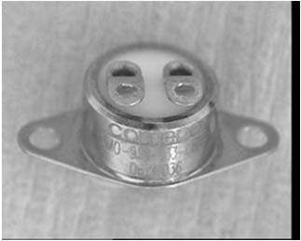  1 | 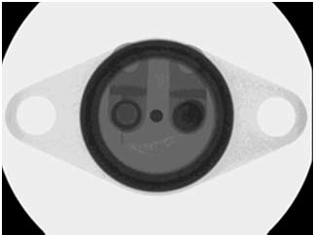  2 | 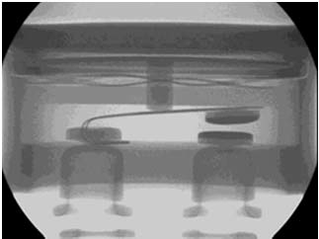  3
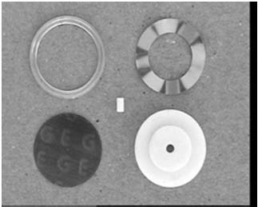  4 | 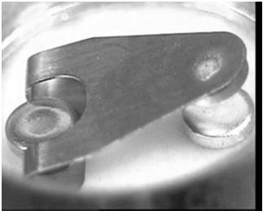  5
IMAGE INDEX:
            - Example of a thermal switch.
            - Radiographic image of a thermal switch.
            - Radiographic image of a thermal switch contacts (open).
            - Piece parts removed during disassembly of a thermal switch.
            - Thermal switch fixed and moving contacts.

APPENDIX A15.1 - MINIMUM DPA FLOW REQUIREMENTS FOR THERMISTOR, SOLID STATE
Test  Sequence | Test Description | Test Method | Sample  Allocation
1 | External Visual Inspection | ESCC Basic Specification  No. 20500 | 3 Parts
2 | Photographic Record | Appendix A15.1 | 1 Part
3 | Verification of Lead  Material Finish | ESCC Basic Specification  No. 25500 Note 3 | 1 Part
4 | Radiographic Inspection | ESCC Basic Specification  No. 20900 | 3 Parts
5 | Marking Permanence Test | ESCC Basic Specification  No. 24800 | 3 Parts
6 | Solderability Test | MIL-STD-202 Method 208 | 3 Parts
7 | Terminal Strength Test | Detail Specification | 3 Parts
8 | De-Encapsulation or Microsectional Analysis Note 1 | ESCC Basic Specification  No. 20400  Note 2 | 3 Parts
9 | Internal Visual Inspection  Note 1 | ESCC Basic Specification  No. 20400  Note 2 | 3 Parts
10 | Photographic Record | Appendix A15.1 | 1 Part
11 | DPA Report | Para. 6.3 | 3 Parts
NOTES:
            - Alternatives are proposed to deal with the common types of assembly:
- For radial lead parts, the thermistor is a disc with the lead outs soldered to the surfaces of the disc. The assembly is encapsulated by dipping in a liquid which is then cured. This type of thermistor is best de-encapsulated. See images 1 to 3 below.
- For axial lead parts the thermistor element is mounted on a ceramic substrate and the lead outs are soldered to this assembly. This type of thermistor is best subjected to microsectional analysis. See images 4 to 6 below.
            - The inspection shall also ensure that:
- There are no cracks in the body of the thermistor.
- There are no cracks in the semiconductor material.
- There is no discolouration or distortion of the thermistor body or the semiconductor material.
- There is no evidence of “cold” solder or loose solder in the attachment of the leads to the semiconductor material.
            - Operation not required if it has been already performed as part of the Incoming Inspection, or any other previous validation step.
A15.1 - IMAGES REQUIRED FOR DPA REPORT
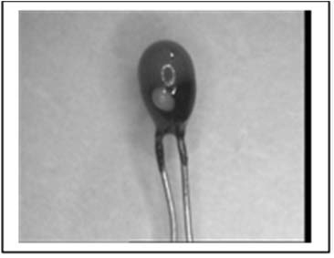  1 | 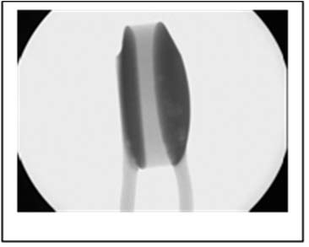  2 | 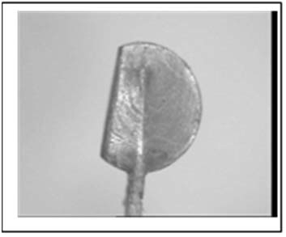  3
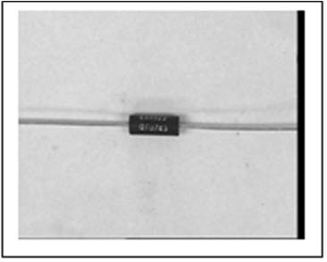  4 | 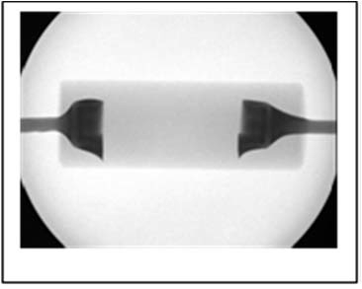  5 | 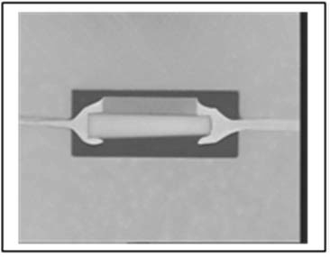  6
IMAGE INDEX:
            - A simple radial lead disc thermistor with the encapsulant applied by dipping.
            - Radiographic image of the radial lead disc thermistor.
            - De-encapsulated radial lead disc thermistor.
            - Axial lead thermistor.
            - Radiographic image of an axial lead thermistor.
            - Microsectioned axial lead thermistor showing the thermistor element mounted on a ceramic substrate.

APPENDIX A15.2 - MINIMUM DPA FLOW REQUIREMENTS FOR THERMISTOR, PLATINUM RESISTANCE
Test  Sequence | Test Description | Test Method | Sample  Allocation
1 | External Visual Inspection | ESCC Basic Specification  No. 20500 | 3 Parts
2 | Photographic Record | Appendix A15.2 | 1 Part
3 | Verification of Lead  Material Finish | ESCC Basic Specification  No. 25500 Note 4 | 1 Part
4 | Radiographic Inspection | ESCC Basic Specification  No. 20900 | 3 Parts
5 | Marking Permanence Test | ESCC Basic Specification  No. 24800 | 3 Parts
6 | Solderability Test | MIL-STD-202 Method 208 | 3 Parts
7 | Terminal Strength Test | Detail Specification | 3 Parts
8 | Microsectional Analysis  Note 1, 2 | ESCC Basic Specification  No. 20400  Note 3 | 3 Parts
9 | Photographic Record | Appendix A15.2 | 1 Part
10 | DPA Report | Para. 6.3 | 3 Parts
NOTES:
            - The platinum resistance thermistors commonly used in space have a glass core around which the platinum wire is wound and attached to the lead outs. Then more glass is fused homogenously around this assembly to encapsulate the part. Removal of this glass is considered impractical and microsectional analysis shall be performed, image 4 below.
            - Platinum resistance thermistors are often supplied with Kelvin connections (four terminals). This is routinely achieved by welding or brazing a pair of lead out “extensions” to the primary lead out close to the thermistor body. Microsectional analysis shall be used to assess this connection, see image 5 below.
            - The inspection shall also ensure that:
- The wire is not broken and nor is the wire diameter reduced by more than 10% of the wire diameter.
- The welds between the platinum wire and the interconnections to the lead outs, and the welds between the interconnections and the lead outs are free of cracks and voids and show evidence of weld indentation.
- There is no reduction in the diameter of the interconnection.
- The glass core is free of cracks.
            - Operation not required if it has been already performed as part of the Incoming Inspection, or any other previous validation step.
A15.2 - IMAGES REQUIRED FOR DPA REPORT
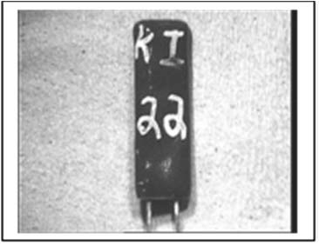  1 | 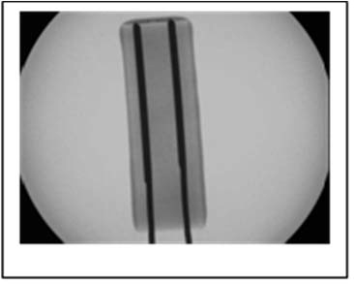  2 | 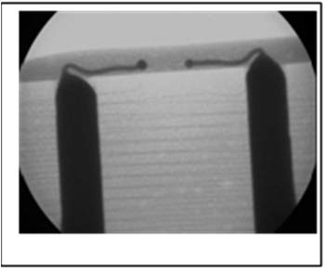  3
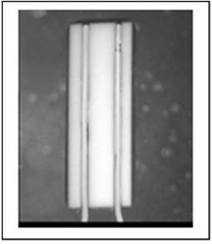  4 | 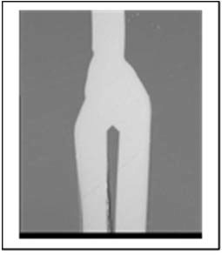  5
IMAGE INDEX:
            - Example of a platinum resistance thermistor.
            - Radiographic image of a platinum resistance thermistor.
            - Radiographic image of the connection between the lead outs and the platinum wire element.
            - Microsection of the platinum resistance thermistor.
            - Weld between the primary lead out and the extension lead outs.

APPENDIX A16.1 - MINIMUM DPA FLOW REQUIREMENTS FOR TRANSISTORS, HERMETIC, CHIP AND WIRE CONSTRUCTION
Test  Sequence | Test Description | Test Method | Sample  Allocation
1 | External Visual Inspection | ESCC Basic Specification  No. 20500 | 3 Parts
2 | Photographic Record | Appendix A16.1 | 1 Part
3 | Verification of Lead  Material Finish | ESCC Basic Specification  No. 25500 Note 8 | 1 Part
4 | Hermetic Seal Tests | MIL-STD-750 Method 1071 | 3 Parts
5 | Particle Impact Noise  Detection Test | MIL-STD-750 Method 2052 | 3 Parts
6 | Radiographic Inspection | ESCC Basic Specification  No. 20900 | 3 Parts
7 | Marking Permanence Test | ESCC Basic Specification  No. 24800 | 3 Parts
8 | Solderability Test | MIL-STD-750 Method 2026 | 3 Parts
9 | Terminal Strength Test | Detail Specification | 3 Parts
10 | Residual Gas Analysis  Note 9 | MIL-STD-750 Method 1018 | 3 Part
11 | De-encapsulation  Note 1 | - | 3 Parts
12 | Internal Visual Inspection | ESCC Basic Specification  No. 20400  Notes 1, 2, 5 | 3 Parts
13 | SEM Inspection Where  Applicable  Note 3 | MIL-STD-750 Method 2077 | 3 Parts
14 | Photographic Record | Appendix A16.1 | 1 Part
15 | Wire Bond Strength Test | MIL-STD-750 Method 2036  Note 6 | 3 Parts
16 | Die Shear Strength Test | MIL-STD-750 Method 2017  Note 7 | 3 Parts
17 | Metallisation Quality  Assessment  Note 4 | ESCC Basic Specification  No. 21400 | 1 Part
18 | Photographic Record | Appendix A16.1 | 1 Part
19 | DPA Report | Para. 6.3 | 3 Parts
NOTES:
            - De-encapsulation shall be achieved mechanically or thermally (de-soldering) depending on the type of hermetic seal used.
The DPA operative shall be aware if beryllium oxide ceramic is used in the component and must take all appropriate health and safety precautions.
Every care shall be taken to prevent damage to the internal elements of the component during de-encapsulation.
De-encapsulation may introduce debris into the cavity and such debris shall be confirmed to be from the de-encapsulation process.
If the Particle Impact Noise Detection test has identified the presence of particles in the cavity every effort shall be made to recover and identify such particles.
            - Any die identification shall be recorded and shall be verified as being appropriate to the components submitted for DPA.
            - Scanning Electron Microscopy shall be used to support the Internal Visual Inspection of wire bonding.
            - For discrete semiconductors the applicability of SEM assessment of metallisation quality shall be identified in the detail specification. As a general rule SEM assessment of metallisation shall be applicable to power MOSFETs and microwave transistors. Transistors have single layers of metallisation and any glassivation shall be removed prior to SEM inspection by:
- Wet chemical or plasma de-glassivation. These techniques are suitable for all metallisation thicknesses but SEM aspect ratio may limit usefulness in the small deep contact windows found in some power MOSFETs.
- Alternately mechanical cross-sectioning may be used. This is more suitable for the thicker metallisations (> 3μm) found in power MOSFETs.
            - The internal inspection shall also ensure that:
- The size and position of the die is established by radiographic inspection before de-encapsulation to ensure that the die is not damaged during de-encapsulation.
            - During wire bond strength testing the bond wires are always tested in the same order and size where two different diameter wires are used i.e. emitter/base/collector or source/gate/drain as appropriate. If possible the bond pull test results should be compared to any bond pull tests performed by the component manufacture e.g. during the Customer’s Precap Inspection.
            - During die shear strength testing the die are always tested in the same direction. If possible the die shear test results should be compared to any die shear tests performed by the component manufacture e.g. during the Customer’s Precap Inspection.
            - Operation not required if it has been already performed as part of the Incoming Inspection, or any other previous validation step.
            - RGA test is optional. In case the test is performed, three (3) separate units will be used, being the acceptance criteria 0 failures. In case of one failure, two additional devices can be tested. If sample size (accept number) of 5(1) is used to pass the lot, the manufacturer shall provide a reason for the failure.
A16.1 - IMAGES REQUIRED FOR DPA REPORT
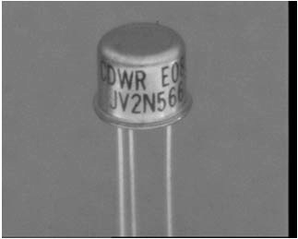  1 |   2 | 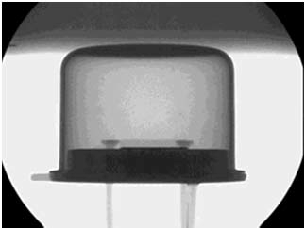  3
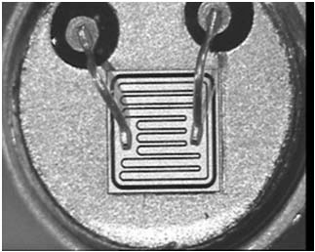  4 | 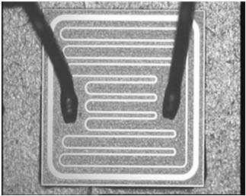  5 | 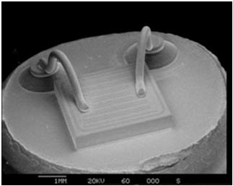  6
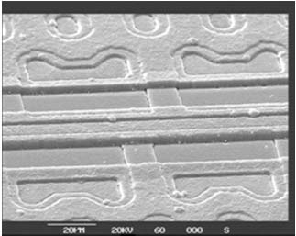  7 | 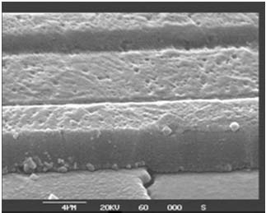  8 | 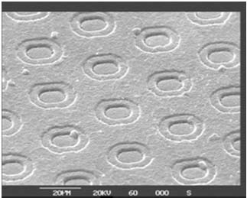  9
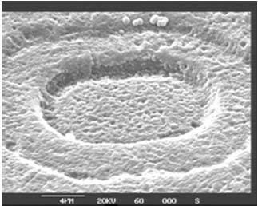
10
IMAGE INDEX:
            - Example of a hermetic transistor, TO can.
            - Radiographic image of an hermetic transistor.
            - Radiographic image of an hermetic transistor.
            - Decapped hermetic transistor.
            - Transistor die.
            - SEM image showing bond wire dressing, bonds etc..
            - Examples of the de-glassivated metallisation of a power MOSFET.
            - Examples of the de-glassivated metallisation of a power MOSFET.
            - Examples of the de-glassivated metallisation of a power MOSFET.
            - Examples of the de-glassivated metallisation of a power MOSFET.

APPENDIX A16.2 - MINIMUM DPA FLOW REQUIREMENTS FOR TRANSISTOR, PLASTIC, CHIP AND WIRE CONSTRUCTION
Test  Sequence | Test Description | Test Method | Sample  Allocation
1 | External Visual Inspection | ESCC Basic Specification  No. 20500 | 3 Parts
2 | Photographic Record | Appendix B16.2 | 1 Part
3 | Verification of Lead  Material Finish | ESCC Basic Specification  No. 25500 Note 10 | 1 Part
4 | Radiographic Inspection | ESCC Basic Specification  No. 20900 | 3 Parts
5 | Scanning Acoustic  Microscopy | ESCC Basic Specification  No. 25200 | 3 Parts
6 | Marking Permanence Test | ESCC Basic Specification  No. 24800 | 3 Parts
7 | Solderability Test | MIL-STD-750 Method 2026 | 3 Parts
8 | Terminal Strength Test | Detail Specification | 3 Parts
9 | De-Encapsulation  Notes 1, 2, 3 | ESCC Basic Specification  No. 25300 | 3 Parts
10 | Internal Visual Inspection  Notes 2, 3, 4, 5, 6, 8 | ESCC Basic Specification  No. 20400  Notes 6, 9 | 3 Parts
11 | SEM Inspection Where  Applicable  Note 6, 7 | MIL-STD-750 Method 2077  Note 6 | 3 Parts
12 | Photographic Record | Appendix B16.2 | 1 Part
13 | Wire Bond Strength Test  Notes 2, 4, 5 | MIL-STD-750 Method 2037 | 3 Parts
14 | Metallisation Quality  Assessment  Note 3 | ESCC Basic Specification  No. 21400  Note 6 | 1 Part
15 | Die Shear Strength Test  Note 8 | MIL-STD-750 Method 2017 | 3 Parts
16 | Photographic Record | Appendix B16.2 | 1 Part
17 | DPA Report | Para. 6.3 | 3 Parts
NOTES:
            - De-encapsulation involves a mixture of fuming nitric and sulphuric acid and shall be handled with appropriate care and safety equipment. Every care shall be taken to prevent damage to the internal elements of the component during de-encapsulation.
It shall be noted that most plastic encapsulated transistors have silver plating on the bonding area of the lead frame. This silver plating will be rapidly degraded if exposed to the acid.
            - It shall be noted that some product, particularly power MOSFETs are being encapsulated in a material which is not effected by the fuming nitric/sulphuric acid mix. Some success is being reported using only sulphuric acid at higher temperatures, but although the die may be revealed all exposed aluminium (the aluminium bond wires found in some MOSFET) and the die bond pads will be severely degraded.
Physical examination of the wire bonding shall only be achieved by microsectional analysis, see images below.
            - It shall also be noted that some product does not have glassivated die i.e. a silicon oxide/nitride die coating. There may be no die coating or a silicone conformal coating. The fuming nitric/sulphuric acid mix will severely degrade or destroy the die surface metallisation.
            - Physical examination of the die surface metallisation shall only be achieved by microsectional analysis, see images below. It shall also be noted that some plastic encapsulated microcircuits have copper bond wires which will be rapidly degraded by the acid.
Again physical examination of the wire bonding can only be achieved by microsectional analysis.
            - It should also be noted that some plastic encapsulated microcircuits have copper bond wires which will be rapidly degraded by the acid.
Again physical examination of the wire bonding can only be achieved by microsectional analysis.
            - Any die identification shall be recorded and shall be verified as being appropriate to the components submitted for DPA.
Scanning Electron Microscopy (SEM) shall be used to support the Internal Visual Inspection of wire bonding, see images below.
            - For discrete semiconductors the applicability of SEM assessment of metallisation quality is identified in the detail specification. As a general rule SEM assessment of metallisation is applicable to power MOSFET and microwave transistor. Transistors have single layers of metallisation and any glassivation must be removed prior to SEM inspection by:
- Wet chemical or plasma de-glassivation. These techniques are suitable for all metallisation thicknesses but SEM aspect ratio may limit usefulness in the small deep contact windows found in some power MOSFET.
- Alternately mechanical cross-sectioning may be used. This is more suitable for the thicker metallisations (> 3μm) encountered in power MOSFETs.
            - It shall be noted that many small signal plastic encapsulated transistors have an epoxy or polymer die attach which may be degraded by the acid used in de-encapsulation process.
            - The inspection shall also ensure that:
- The position and size of the die and the lead out bonds is established by radiographic inspection before the de-encapsulation etching is commenced.
- Only sufficient encapsulant is removed to expose the internal elements to be inspected. It may be impractical to expose any or all of the wire bonds to the lead outs, see above.
- The wire bonding materials are identified. The common technique for plastic encapsulation is to have gold ball bonds to the aluminium die metallisation and gold wedge bonding to silver plated copper lead outs. This assembly technique may result in the formation of undesirable intermetallics. SEM is the preferred technique for examining the gold ball bond to aluminium die metallisation interface, see images below.
- There is no corrosion of the die surface metallisation. The inclusion of sulphuric acid in the etch used to de-encapsulate the part should buffer the aluminium of the bond pads.
- Any gold ball bonds which lift from the die during wire bond strength testing shall be investigated for the presence of gold aluminium intermetallics.
- Any gold wedge bonds which lift from the lead outs during wire bond strength testing shall be investigated to establish if the silver plating or the copper base material of the lead out had been degraded by acid used to de-encapsulate the sample.
            - Operation not required if it has been already performed as part of the Incoming Inspection, or any other previous validation step.
A16.2 - IMAGES REQUIRED FOR DPA REPORT
EXAMPLE 1
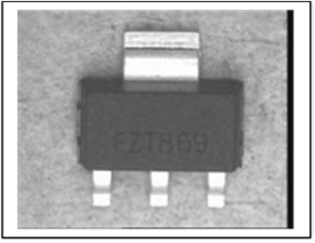  1 | 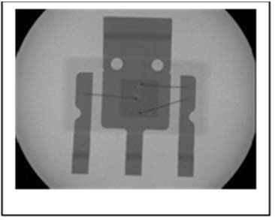  2 | 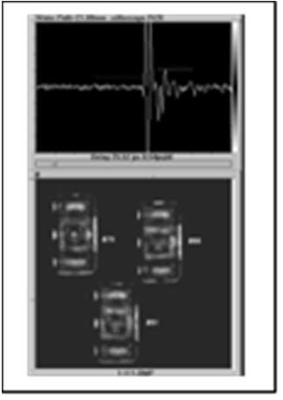  3
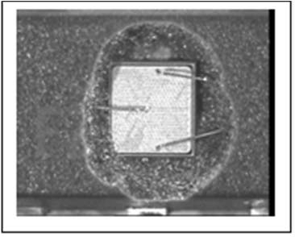  4 | 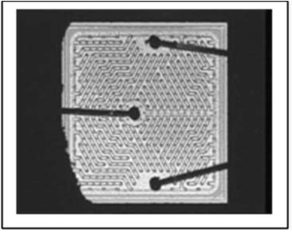  5 | 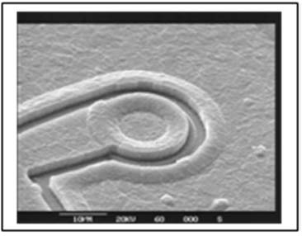  6
IMAGE INDEX:
            - Example of a plastic encapsulated transistor.
            - Radiographic image of a plastic encapsulated transistor.
            - CSAM image of three plastic encapsulated transistors.
            - De-encapsulated transistor showing the die and wire bonding.
            - De-encapsulated transistor die surface.
            - SEM image of the die metallisation.
EXAMPLE 2
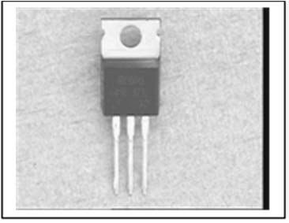  1 | 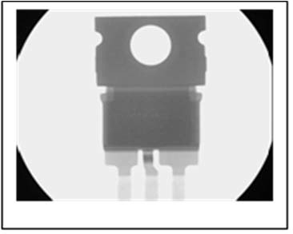  2 | 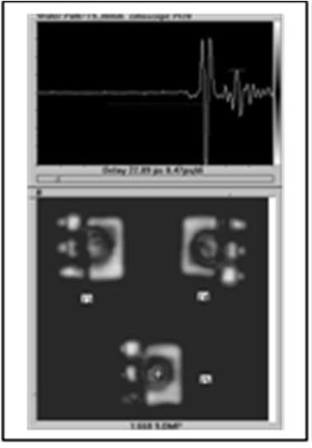  3
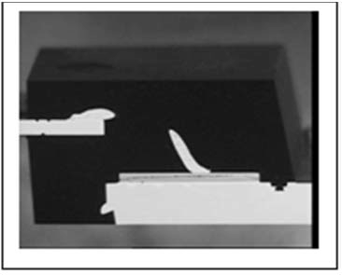  4 | 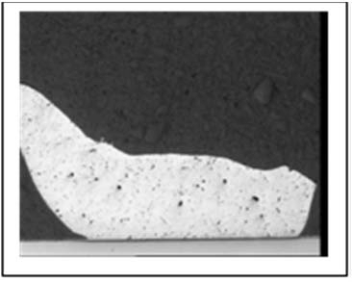  5 | 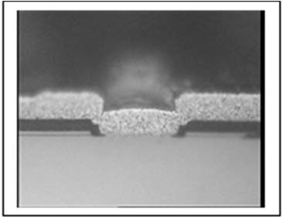  6
IMAGE INDEX:
            - Example of a plastic encapsulated transistor not affected by the de-encapsulation acid mix.
            - Radiographic image of a plastic encapsulated transistor.
            - CSAM image of three plastic encapsulated transistors.
            - Microsection showing the assembly and wire bonding.
            - Microsection showing wire bonding at the die surface.
            - Microsection showing the metallisation quality.
EXAMPLE 3
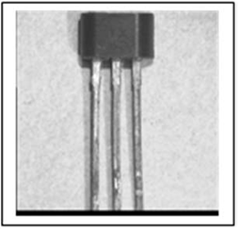  1 | 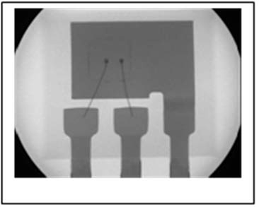  2 | 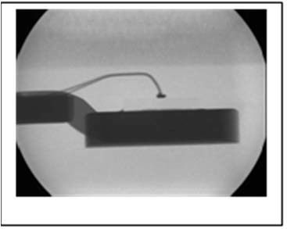  3
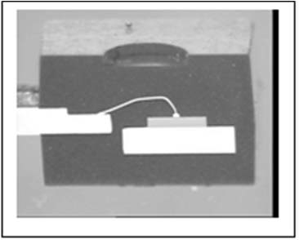  4 | 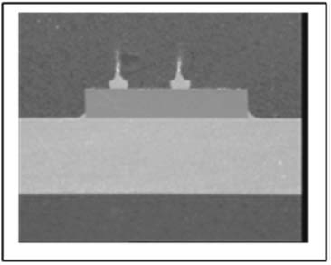  5 | 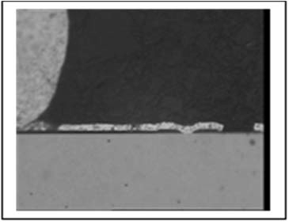  6
IMAGE INDEX:
            - Example of a plastic encapsulated transistor found to have an unglassivated die, note the rounded edges of the encapsulant will limit the usefulness of acoustic microscopy.
            - Radiographic image of a plastic encapsulated transistor.
            - Radiographic image of a plastic encapsulated transistor.
            - Microsection showing the assembly and wire bonding.
            - Microsection showing wire bonding at the die surface.
            - Microsection showing the metallisation quality.

APPENDIX A16.3 - MINIMUM DPA FLOW REQUIREMENTS FOR TRANSISTOR, PLASTIC, SOLDERED CONSTRUCTION
Test  Sequence | Test Description | Test Method | Sample  Allocation
1 | External Visual Inspection | ESCC Basic Specification  No. 20500 | 3 Parts
2 | Photographic Record | External View | 1 Part
3 | Verification of Lead  Material Finish | ESCC Basic Specification  No. 25500 Note 4 | 1 Part
4 | Radiographic Inspection | ESCC Basic Specification  No. 20900 | 3 Parts
5 | Scanning Acoustic  Microscopy  Notes 1, 2 | ESCC Basic Specification  No. 25200 | 3 Parts
6 | Marking Permanence Test | ESCC Basic Specification  No. 24800 | 3 Parts
7 | Solderability Test | MIL-STD-750 Method 2026 | 3 Parts
8 | Terminal Strength Test | Detail Specification | 3 Parts
9 | De-Encapsulation  Note 3 | ESCC Basic Specification  No. 25300 | 3 Parts
10 | Internal Visual Inspection | ESCC Basic Specification  No. 20400 | 3 Parts
11 | SEM Inspection Where  Applicable  Note 3 | MIL-STD-750 Method 2077 | 3 Parts
12 | Photographic Record | As applicable | 1 Part
13 | Die Shear Strength Test | MIL-STD-750 Method 2017 | 3 Parts
14 | Metallisation Quality  Assessment  Note 3 | ESCC Basic Specification  No. 21400 | 1 Part
15 | Photographic Record | As Applicable | 1 Part
16 | DPA Report | Para. 6.3 | 3 Parts
NOTES:
            - This type of construction is found in bipolar power transistors and some MOSFETs. The emitter/base or source/gate connections from the lead outs are directly soldered to the die surface. A solder die attach is normal for this type of construction.
            - The shape of the solder joints between the connections and the die may affect the images achieved during scanning acoustic microscopy and scanning from the back side of the component may be more useful.
            - See notes to plastic encapsulated chip and wire transistors in Appendix A16.2.
            - Operation not required if it has been already performed as part of the Incoming Inspection, or any other previous validation step.

APPENDIX A17 - MINIMUM DPA FLOW REQUIREMENTS FOR WIRES AND CABLES
Test  Sequence | Test Description | Test Method | Sample  Allocation
1 | External Visual Inspection | ESCC Basic Specification  No. 20500 | 1 Sample  (Note 1)
2 | Photographic Record | Appendix A17 | 1 Sample
3 | Verification of Surface  Material Finish | ESCC Basic Specification  No. 25500 Note 3 | 1 Sample
4 | Marking Permanence | ESCC Basic Specification  No. 24800 | 1 Sample
5 | Solderability (Where  Applicable)  Crimp Test (Where  Applicable) | MIL-STD-202 Method 208  ECSS-Q-ST-70-26 | 1 Sample
6 | Visual Inspection | ESCC Basic Specification  No. 20500 | 1 Sample
7 | Microsectional Analysis  Note 2 | ESCC Basic Specification  No. 20400 | 1 Sample
8 | Photographic Record | Appendix A17 | 1 Sample
9 | DPA Report | Para. 6.3 | 1 Sample
NOTES:
            - A representative sample shall be cut from the wire or cable.
            - The sample shall be embedded in a thermo-setting resin and shall be microsectioned at right angles to the longitudinal axis of the wire or cable.
            - Operation not required if it has been already performed as part of the Incoming Inspection, or any other previous validation step.
A17 - IMAGES REQUIRED FOR DPA REPORT
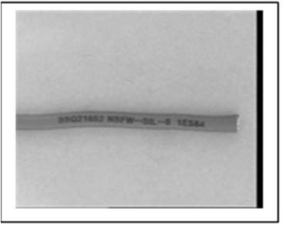  1 | 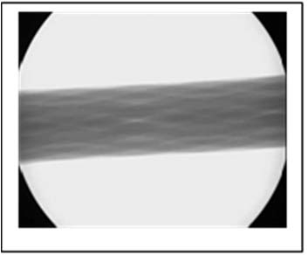  2 | 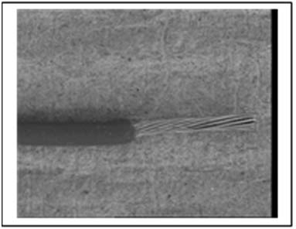  3
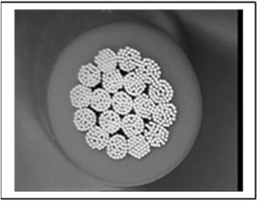  4 | 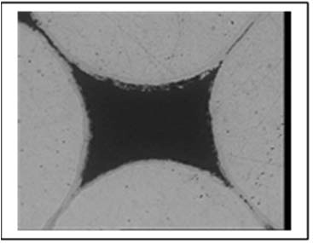  5
IMAGE INDEX:
            - Cable external view.
            - Radiographic image.
            - Core view.
            - Microsection showing cable structure.
            - Microsection showing core wires and finish.

